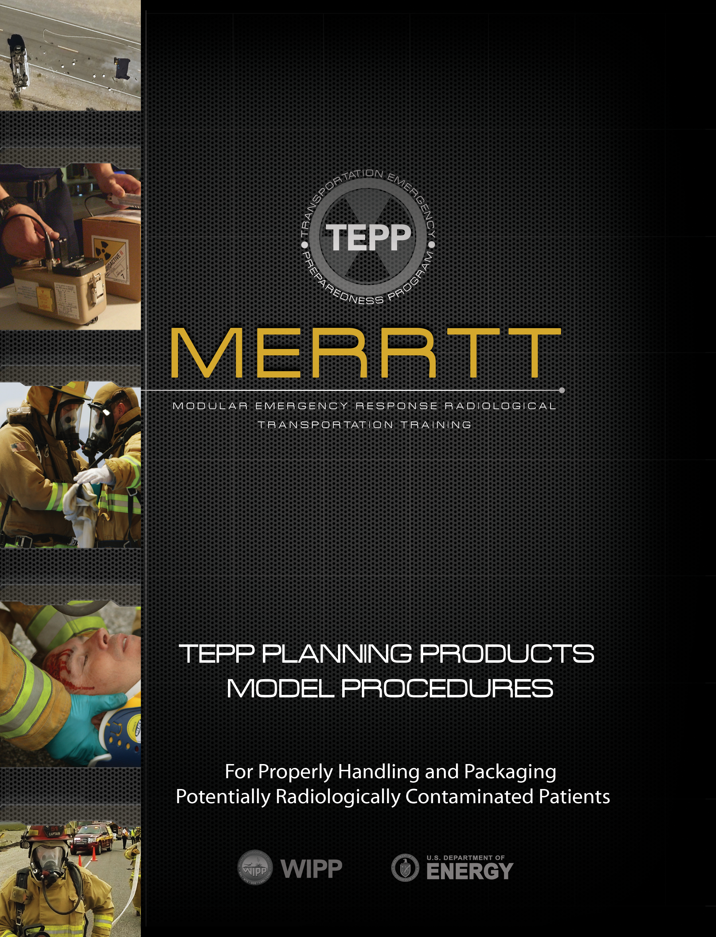
Contents
Assumptions 2
1.0 Purpose 2
2.0 Scope 2
3.0 Responsibilities 2
4.0 Records 3
5.0 Frequency 3
6.0 Refrences and Resources 3
7.0 Equipment 3
8.0 Location 3
9.0 Safety 3
10.0 Terms/Definitions 3
11.0 Procedure 4

ASSUMPTIONS
This Transportation Emergency Preparedness Program (TEPP) Model Procedure contains information that Emergency Medical Service (EMS) care providers can use to develop local procedures for response to transportation incidents involving radioactive material.

The following assumptions are to be considered when reviewing this Model Procedure:

- This procedure is not all-inclusive. When federal, state, tribal, or local regulatory requirements are more stringent than the model procedure, then the more stringent requirements should apply.
- This procedure is designed as a guide for trained and qualified Emergency Medical Service care providers. It is expected that each EMS organization review and develop a unique procedure based on organizational requirements.
- All Emergency Medical Service care providers have been trained to the appropriate level for hazardous material response.
- All Emergency Medical Service care providers have been trained in the use of an incident management system such as the Incident Command System.
- Incident scene decisions regarding operations in the hot zone shall be approved by the Incident Commander.
- All Emergency Medical Service care providers are knowledgeable in the use of the Emergency Response Guidebook (ERG) as a tool in determining appropriate response actions.

1.0 PURPOSE

The purpose of this procedure is to provide guidance to EMS care providers for properly handling and packaging potentially radiologically contaminated patients.

2.0 scope

This procedure applies to Emergency Medical Service care providers who respond to a radioactive material transportation incident that involving potentially contaminated patients.

3.0 responsibilities
Emergency responders who respond to a transportation incident involving potentially radiologically contaminated patients should perform the following:
3.1 Size up accident scene using appropriate reference information and sources
3.2 Initiate response actions as outlined in the ERG
3.3 Maintain accident scene contamination control until relieved by a higher authority
3.4 Provide accident scene turnover to the relieving authority
3.5 Promptly treat and transport injured patients to a medical care facility

4.0 Records
Insert your jurisdictional policy for records retention here.

5.0 FREQUENCY
Use this procedure as needed.

6.0 REFERENCES and resources

6.1 U.S. Department of Transportation Emergency Response Guidebook (ERG)
6.2 U.S. Department of Energy Modular Emergency Response Radiological Transportation Training (MERRTT)
6.3 Hazardous Materials for First Responders, latest edition
6.4 To clarify procedural steps, reference the pictures in the MERRTT Patient Handling module

7.0 EQUIPMENT
As outlined in the ERG and/or as required by federal, state, tribal or local procedures, plans, or policies.

8.0 LOCATION
Use this procedure as needed based upon incident/accident location.

9.0 SAFETY

9.1 Respond and perform duties within safety guidelines specified within the ERG
9.2 Involve appropriate federal, state, tribal, Radiation Authority, or local officials as soon as possible for assistance with disposition of any contaminated/radiological material

10.0 TERMS/DEFINITIONS

Body Substance Isolation Clothing (BSIC) - Involves the use of protective barriers such as gloves, gowns, aprons, masks, or protective eyewear, which can reduce the risk of exposure of the EMS care provider’s skin or mucous membranes to potentially infective materials (e.g., bloodborne pathogens).

Contamination Reduction Zone - An isolation zone that is typically set up around a hazardous incident site to control the spread of hazardous substances. Also known as the warm zone.

Emergency Response Guidebook (ERG) - A booklet that provides guidance during the initial phases of transportation emergencies involving hazardous material.

Gross Decon - A method of reducing contamination levels on a contaminated patient. Gross decontamination is accomplished by carefully cutting a patient’s clothing away from their body.

Hazardous Material - A substance capable of harming people, the environment, or property.

Hot Zone - Also referred to as the exclusion zone in some jurisdictions. According to the ERG, the initial hot zone for radiological material should be established 75 feet around the spilled material. Access to the hot zone should be controlled for accountability and contamination control purposes.

Incident Commander (IC) - The person responsible for all decisions relating to the management of the incident.

Incident Command System (ICS) - An organized approach to control and manage operations at an emergency incident.

Radiation Authority - A federal, state, tribal or local agency designated official. Responsibilities include evaluating radiological hazard conditions during normal operations and emergencies.

11.0 PROCEDURE

11.1 Utilize the ERG to conduct a scene size-up. Establish contamination control zones and, without entering the hot zone, determine which essential treatment equipment is needed. Not

11.2 Notify hospital they may be receiving patients involved in a radioactive material accident.

Note: If Incident Command has already been established, EMS care providers report to the Incident Commander for a scene size-up and briefing. If response actions are being initiated, care providers can minimize the spread of contamination by carrying only essential medical equipment into the hot zone.

11.3 Prior to entry into the hot zone, prepare the backboard or other device that will be used to remove the patient from the hot zone as follows:
A. Spread a blanket (or other protective barrier, sheet, etc.)
B. Spread a second blanket or other barrier on top of the first blanket
C. Place the backboard or other device in the center of the blanket
D. Roll up the edges of the blankets and fold blankets over the top of the backboard
E. Place essential medical response equipment on top of the covered backboard.

11.4 Don appropriate protective clothing. Fire fighting gear or Body Substance Isolation Clothing (BSIC) are recommended, including multiple pair of medical exam gloves and respiratory protection if available (such as Self-Contained Breathing Apparatus, Air Purifying Respirator, or N95 Particulate Mask).

11.5 Enter the hot zone and place the backboard or other device adjacent to the patient leaving enough space to unroll the protective blanket barriers on the ground.

Note: The double blanket method will minimize the spread of contamination. The outer-blanket will reduce/eliminate inner blanket contact with contaminated surfaces. The inner blanket, when wrapped around the patient will encapsulate any contamination to the patient helping to prevent further spreading of the contamination.

Life threatening injuries such as exsanguinating hemorrhage and compromised airway should be corrected immediately. Cardiopulmonary resuscitation should not be attempted in the hot zone; the patient should be promptly packaged and transferred to the clean area for further care. As stated in the ERG: “medical problems take priority over radiological concerns.”

11.6 Evaluate the need for reducing contamination on the patient.

Note: Contamination should only be suspected if radioactive material packages appear to be breached. As stated in the ERG: “undamaged packages are safe.”

11.7 If warranted, you can reduce contamination by carefully cutting the patient’s clothing away from the body (gross decon).

Note: Cut clothing from head to toe on the center of all body extremities and the trunk. Carefully lay cut clothing open, exposing the patient’s body.

11.8 Responders should carefully remove their outer pair of medical exam gloves.

11.9 Treat non life-threatening injuries as necessary. If contamination is suspected in or near a wound, the primary option is to treat the wound and prevent additional spread of contamination.

Note: If cleaning of injured area is to be conducted, wipe away from all open wounds or the airway. Only use the wipe(s) one time and handle all waste as potentially contaminated material. Place the wipe(s) in a controlled disposal container until the contents have been monitored by the Radiation Authority.

11.10 Load the patient onto the backboard using standard medical protocols and wrap the inner protective barrier around the patient.

Note: Removed clothing, gloves, and outer blanket should remain in the hot zone. The removed clothing and gloves should be considered as waste. The outer blanket provides protection against the spread of contamination. The Radiation Authority will coordinate the packaging and removal of all waste excluding personal belongings.

11.12 EMS care providers should hand-carry the patient to the hot zone contamination control line.

11.13 A second team of care providers should have an appropriate transportation device waiting at the contamination control line. This device should also be covered with a protective barrier.

11.14 At the hot zone contamination control line, responders should pass the patient across the control line to waiting EMS care providers.

Note: Care providers within the hot zone should not cross the contamination control line until monitored by the Radiation Authority or other qualified individual.

Based on local procedures, and the number of contamination control zones set up, the patient may require additional transfers at each contamination control zone boundary. If additional responders are not available, the treating responders should remove their protective clothing at the hot zone contamination control boundary and provide transportation of the patient to the appropriate medical facility. Additional PPE may need to be donned prior to entering the ambulance with the contaminated patient.

11.15 After transferring the patient to the clean area, the EMS care providers should cover the patient with the protective barrier that was placed over the transport device.

11.16 Load patient into the ambulance and transport to hospital. EMS care providers inside the ambulance should wear appropriate protective clothing.

Note: To reduce/prevent possible contamination of the ambulance, consider the following additional precautions: open the protective barrier covering patient only to administer necessary treatment, place floor covering (paper, plastic, etc.) on ambulance floor, and handle all items used in the treatment of the patient as potentially contaminated.

11.17 EMS care providers transporting the patient should verify the receiving hospital has the capability to treat and care for potentially contaminated patients.

11.18 Upon confirmation, EMS care providers should notify the receiving hospital of patient status, radiological contamination concerns, estimated time of arrival, and the need for monitoring of themselves and the ambulance.

11.19 Upon arrival at the hospital, EMS care providers should follow the hospital’s radiological control protocol. Once the patient has been removed from the ambulance, a contamination control zone should be established in and around the ambulance until both the ambulance and crew can be surveyed for contamination.

Note: The ambulance should not be returned to regular service until the crew, vehicle, and equipment have been surveyed for radiological contamination. Before being surveyed by Radiation Authority, the Incident Commander has the authority to reuse the ambulance for transport of additional contaminated patients.

11.20 Do not eat, drink, smoke, or chew until personnel have been surveyed and released by the Radiation Safety Officer at the hospital or other qualified individual, such as the Radiation Authority.

