Contents
Assumptions 2
1.0 Purpose 2
2.0 Scope 2
3.0 Records 2
4.0 Frequency 3
5.0 References 3
6.0 Equipment 3
7.0 Location 3
8.0 Safety 3
9.0 Terms/Definitions 4
10.0 Response Procedure 4
Attachment 1: Initial Arrival Response Flow Chart 5
Attachment 2: Accident Involving Victims Response Flow Chart 6
Attachment 3: Accident Involving Fire Response Flow Chart 7
Attachment 4: Accident Involving Radiological Material Response Flow Chart 8

Assumptions
This Transportation Emergency Preparedness Program (TEPP) Model Procedure contains the recommended actions for response to transportation incidents involving radioactive material.

The following assumptions are to be considered when reviewing this Model Procedure for initial response:
- The procedure outlined in this document is not all-inclusive but was developed to meet the minimum national guidance for responding to a transportation accident involving radioactive material.
- This Model Procedure is designed for use by trained and qualified emergency responders. Additional procedural requirements may be implemented according to appropriate federal, state, tribal, or local requirements.
- This Model Procedure should be utilized appropriately, according to the conditions encountered, when arriving at a transportation accident involving radioactive material.
- All emergency response personnel have been trained in the use of an incident management system such as the Incident Command System.
- All emergency response organizations are knowledgeable in the use of the Emergency Response Guidebook (ERG) as a tool in determining appropriate response actions.

1.0 Purpose
The purpose of these response flow charts is to provide first responders with guidance for response to a transportation accident involving radioactive material.

2.0 Scope
Emergency responders who respond to a transportation accident involving radioactive material should perform the following:
2.1 Establish Incident Command and size up accident scene using appropriate reference information and sources.
2.2 Initiate response actions as outlined in the ERG.
2.3 Relay information to state, tribal, or local officials as required by jurisdictional policies, plans, and procedures.
2.4 Maintain accident scene control until relieved by a higher authority.
2.5 Provide accident scene turnover briefing to the relieving authority.

3.0 Records
Insert your jurisdictional policy for records retention here.

4.0 Frequency
Use the flow charts as needed.

5.0 References
5.1 NFPA 472 - Standard for Competence of Responders to Hazardous Materials/Weapons of Mass Destruction Incidents, latest edition
5.2 NFPA 473 - Standard for Competencies for EMS Personnel Responding to Hazardous Materials/Weapons of Mass Destruction Incidents, latest edition
5.3 10 CFR 835.1302 - Emergency Exposure Situations
5.4 29 CFR 1910.120 - Hazardous Waste Operations and Emergency Response
5.5 U.S Department of Transportation Emergency Response Guidebook (ERG)
5.6 U.S. Environmental Protection Agency - Standard Operating Safety Guide
5.7 Radioactive Materials and Transportation and Response Q&A –Transportation Emergency Preparedness Program/Federal Emergency Management Agency, latest edition
5.8 U.S. Department of Energy Quick Response Flatsheet
5.9 Hazardous Materials for First Responders, latest edition

6.0 Equipment
As outlined in the ERG and/or as required by state, tribal or local procedures, plans, or policies.

7.0 Location
Use this Model Procedure as appropriate based upon incident location.

8.0 Safety
8.1 Respond and perform duties within safety guidelines specified within the ERG and standard operating procedures or guides.
8.2 Involve appropriate state, tribal, Radiation Authority or local officials as soon as possible for assistance with response considerations and disposition of any contaminated/radiological material.

9.0 Terms/Definitions
Contamination - As referred to in this document, contamination is undesired radioactive material that is deposited on the surface of or inside structures, areas, objects, or people.

Decontamination - The reduction or removal of contaminating radioactive material from a structure, area, object, or person.

Incident Commander (IC) - The person responsible for all decisions relating to the management of the incident.

Incident Command System (ICS) - An organized approach to control and manage operations at an emergency incident.

National Incident Management System (NIMS) - A comprehensive, national approach to incident management applicable to all jurisdictional levels.

Radiation Authority - A federal, state, tribal or local agency designated official. Responsibilities include evaluating radiological hazard conditions during normal operations and emergencies.

10.0 Response Procedure
See the following First Response Flow Charts for Transportation Accidents Involving Radioactive Material (Attachments 1 through 4).

Attachment 1: Initial Arrival Response Flow Chart
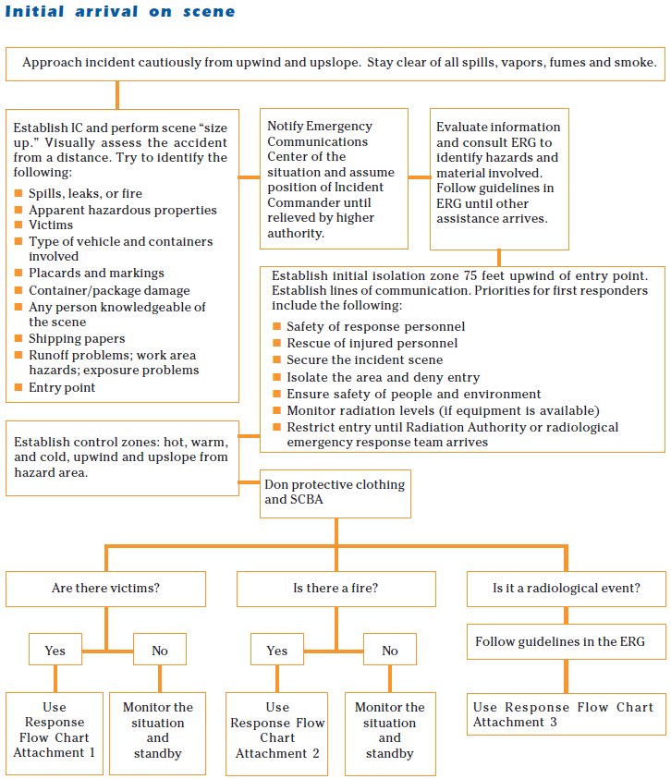

Attachment 2: Accident Involving Victims Response Flow Chart
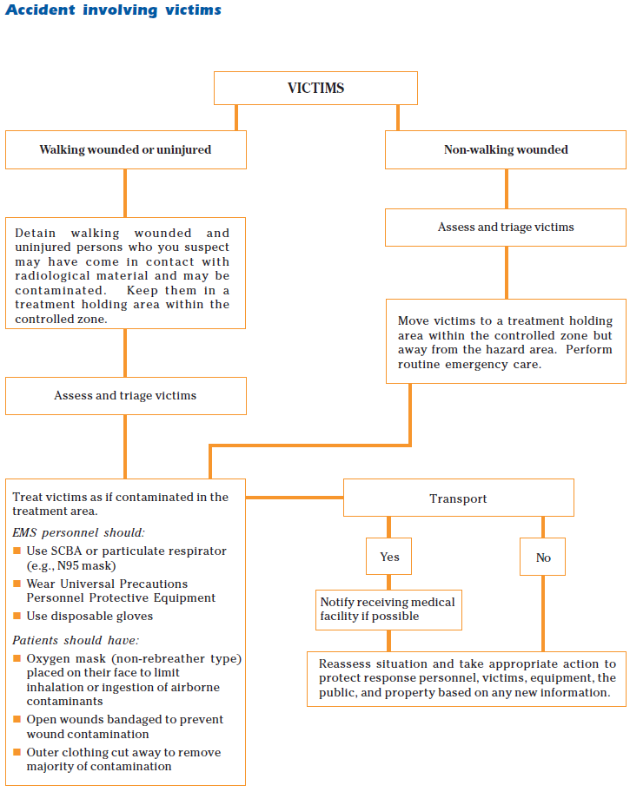

Attachment 3: Accident Involving Fire Response Flow Chart
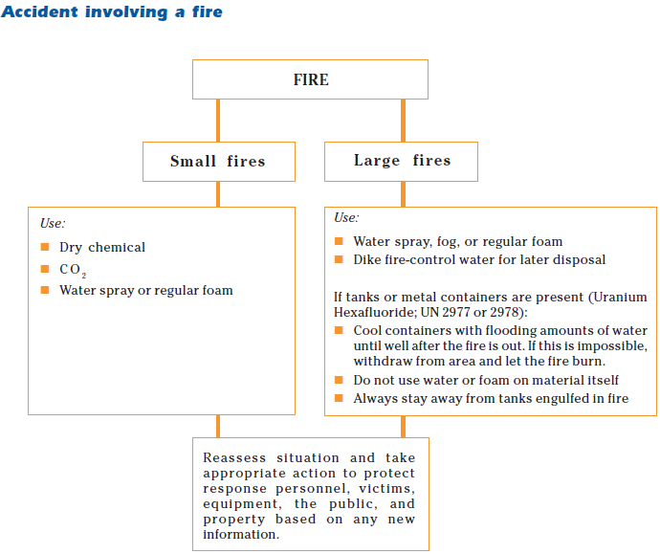

Attachment 4: Accident Involving Radiological Material Response Flow Chart
