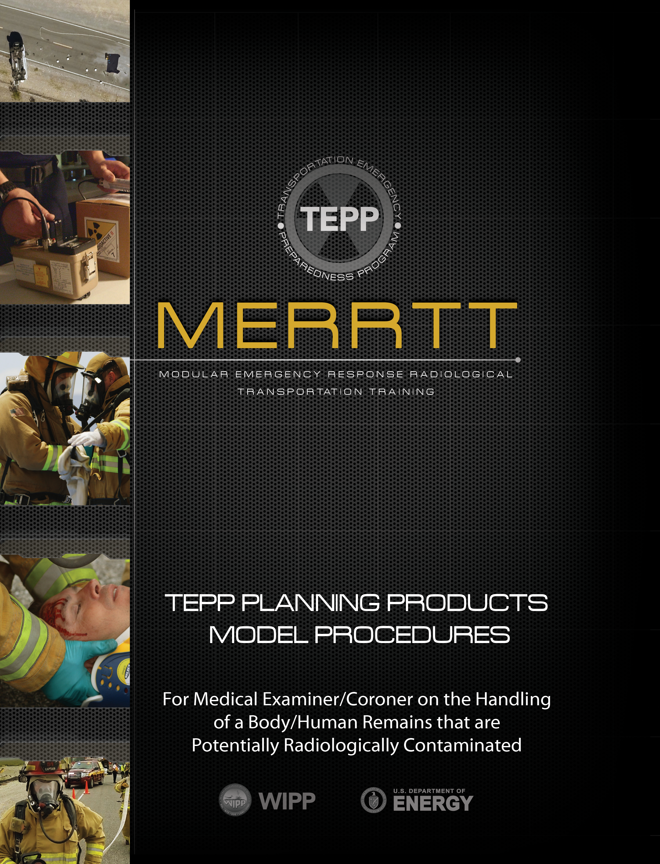
Contents
1.0 Purpose 2
2.0 Scope 2
3.0 Responsibilities 2
4.0 Records 2
5.0 Frequency 3
6.0 References 3
7.0 Safety 4
8.0 Terms/Definitions 4
9.0 Procedure where Evidence Preservation is not a concern 5
10.0 Procedure where Evidence Preservation is a concern 8
ATTACHMENT 1: Radioactivity tag 11
ATTACHMENT 2: Radioactivity Report Form 12
ATTACHMENT 3: Survey Data Sheet 13

1.0 PURPOSE
The purpose of this Model Procedure is to identify precautions and provide guidance to Medical Examiners/Coroners on the handling of a body or human remains that are potentially contaminated with radioactive material from a transportation incident involving radioactive material.

2.0 SCOPE
This procedure outlines precautions and provides guidance to protect personnel involved in the recovery and disposition of a potentially radiologically contaminated body/human remains at a transportation incident involving radioactive material. The precautions and guidance outlined in this procedure are general and should not be aware of necessary precautions when handling a body/human remains which may have been exposed to hazardous materials. The documents referenced in Section 6.0 are resources for additional information on precautions for handling and decontaminating human remains.

3.0 RESPONSIBILITIES
Medical Examiners/Coroners who respond to a transportation incident involving a body/human remains that are potentially radiologically contaminated should perform the following:
3.1 Report to the Incident Command Post and integrate Medical Examiner/Coroner duties as required to operate within a national incident management system to coordinate identification, collection, and packaging activities of the body/human remains with the Incident Commander.
3.2 Maintain established incident scene contamination control boundaries as established by the Incident Commander.
3.3 Utilize available monitoring resources provided by the Radiation Authority or other qualified person/agency to determine radiological contamination levels of the body/human remains.
3.4 Do not remove body/human remains or personal belongings from the area until the appropriate label/tag has been applied.

4.0 RECORDS
Follow local or jurisdictional procedures for records retention. The following items, included in this Model Procedure, should be recorded:

4.1 Radioactivity Tag (Attachment 1).
4.2 Radioactivity Report Form Accompanying Body/Human Remains
(Attachment 2).
4.3 Contamination Survey Data Sheet (Attachment 3).

5.0 FREQUENCY
Use this procedure as needed.

6.0 REFERENCES
6.1 Medical Management of Radiological Casualties; Fourth Edition, July 2013 Military Medical Operations Armed Forces Radiobiology Research Institute Bethesda, MD 20889-5603 www.usuhs.edu/afrr
6.2 Guidelines for Handling Decedents Contaminated with Radioactive Materials Prepared by Charles M. Wood, Radiation Studies Branch, Office of Environmental Hazards and Health Effects, National Center for Environmental Health, Centers for Disease Control and Prevention, Atlanta, GA; Frank DePaolo, Office of Chief Medical Examiner, New York, NY; R. Doggett Whitaker, National Funeral Directors’ Association https://stacks.cdc.gov/view/cdc/5823
6.3 A Reference Guide for Certification of Deaths in the Event of a Natural, Human-induced, or Chemical/Radiological Disaster Vital Statistics Reporting Guidance Report No. 1; October 2017 U.S. Department of Health and Human Services, Centers for Disease Control and Prevention, National Center for Health Statistics, National Vital Statistics System https://stacks.cdc.gov/view/cdc/49294
6.4 Medical Examiner/Coroner Guide for Mass Fatality Management of Chemically Contaminated Remains Prepared by Department of Justice, Office of Justice Programs, Office of State & Local Domestic Preparedness, Department of Defense, US Army Soldier and Biological Chemical Command, Improved Response Program
6.5 Providing Relief to Families After a Mass Fatality: Roles of the Medical Examiner’s Office and the Family Assistance Center Ray L. Blakeney, U.S. Department of Justice, Office of Justice Programs, Office for Victims of Crime; OVC Bulletin November 2002 https://www.hsdl.org/?abstract&did=437348
6.6 What to do When Faced with Victims of a Criticality Accident Alain Miele and Laurence Lebaron-Jacobs, Coordinators 17, avenue du Hoggar Parc d’ Activite´ de courtaboeuf, BP 112 91944 Les Ulis Cedex A,France https://www.radioprotection.org/articles/radiopro/abs/2008/06/rad43600/rad43600.html
6.7 The Medical Examiner/Coroner’s Guide for Contaminated Deceased Body Management Randy Hanzlick, MD, Kurt Nolte, MD, Joyce deJong, DO, and The National Association of Medical Examiners Bioterrorism and Infectious Disease Committee; The American Journal of Forensic Medicine and Pathology • Volume 30, Number 4, December 2009
6.8 Review: The radioactive autopsy: safe working practices M. Singleton, R. D. Start, W. Tindale, C. Richardson. and M. Conway; Histopathology 2007, 51, 289–304
6.9 US Department of Health and Human Services Radiation Emergency Medical Management, Medical Examiners/Coroners: Information for Radiation Emergencies https://www.remm.nlm.gov/remm_Coroner.htm

7.0 SAFETY
7.1 Respond and perform duties within boundaries identified by the Incident Commander.
7.2 Utilize protective clothing precautions as outlined by organizational procedures or as identified by the Incident Commander.

8.0 TERMS/DEFINITIONS
Cold Zone - Also referred to as the support zone, the cold zone is a contamination-free zone established around the warm zone where emergency operations can be directed and supported. The cold zone is normally established in an area where radiation levels are at natural background levels.

Contamination - As referred to in this document, contamination is undesired radioactive material that is deposited on the surface of or inside structures, areas, objects, or people.

Contamination Control Zone - An isolation zone that is typically set up around a hazardous incident site to control the spread of hazardous substances. See hot zone, warm zone, cold zone.

Decontamination - The reduction or removal of contaminating radioactive material from a structure, area, object, or person. Decontamination may be accomplished by: use of a tape press or wiping the surface (dry decon); washing or flushing the surface with water or other solution (wet decon); or allowing the material involved to decrease in radioactivity through natural radioactive decay.

Hot Zone - Also referred to as the exclusion zone in some jurisdictions. According to the ERG, the initial hot zone for radiological material should be established 75 feet around the spilled material. Access to the hot zone should be controlled for accountability and contamination control purposes.

Incident Commander (IC) - The person responsible for all decisions relating to the management of the incident.

Radiation Authority - A federal, state, or tribal agency designated official. Responsibilities include evaluating radiological hazard conditions during normal operations and emergencies.

Radioactivity - The spontaneous emission of radiation, generally alpha or beta particles, often accompanied by gamma rays, from the nucleus of an unstable isotope. Also, the rate at which radioactive material emits radiation.

Radioisotope (Radionuclide) - An unstable isotope of an element that decays or disintegrates spontaneously, emitting radiation. Approximately 2600 natural and artificial radioisotopes have been identified.

Radiological Survey – Usually performed by the Radiation Authority, a radiological survey is performed using a radiation detection instrument specially adapted for inspecting an area or individual to establish the existence and amount of radioactive material present.

Warm Zone - Also referred to as the contamination reduction zone, the warm zone is usually established around the hot zone to provide a buffer between the hot and cold zones. Decontamination often takes place in the warm zone.

9.0 Procedure where Evidence Preservation is not a concern
9.1 Upon your arrival at the scene, contact the Incident Commander for a briefing on the incident scene hazards, location of control zones, and activities that have already taken place.
9.2 If you are not informed of the radiation hazards and persons that will provide your assistance in disposition of the body/human remains, inquire about radiation/contamination monitoring services that are available from the local hazardous materials team, state Radiation Authority, or federal resources.
9.3 Discuss with the Radiation Authority the need for protective clothing. If protective clothing is recommended, the clothing will more than likely be similar to the clothing worn for protection of air and bloodborne pathogens.
9.4 As directed by the Incident Commander, enter the incident scene with a Radiation Authority escort. The Radiation Authority should monitor the incident scene as you enter and inform you of any radiation/contamination hazard present.
9.5 Conduct necessary incident/accident investigation procedures (pictures, identification, damage assessments, cause, etc.). Do not touch the body/human remains at this time.
9.6 Have the Radiation Authority escort conduct a radiological survey of the body/human remains as well as the surrounding area. Upon completion of the radiological survey and identification of radiological concerns (if any), complete the incident/accident investigation.
9.7 If radiological contamination is confirmed or suspected, conduct a gross decontamination of the contaminated body/human remains at the scene. This will reduce the potential for spreading contamination to the morgue. The gross decontamination process includes the removal of all outer clothing (shirt, shoes, pants, etc.). Consider leaving the removed clothing at the incident scene to limit contamination spread. The clothing will then be properly disposed of by the cleanup team. To assist in the identification of the body/human remains, all pockets shall be searched and any personal belongings (wallet, jewelry, watches, etc.) found, should be placed in a plastic bag. If the Medical Examiner/Coroner determines the clothing could assist in the investigation, the clothing can be shipped with the body/human remains, Step 9.12 outlines how the removed clothing can be placed in a plastic bag and shipped with the body/human remains.
Note: The Radiation Authority will use standard contamination control practices (monitoring, double gloving, tagging, etc.) when bagging potentially contaminated items.

9.8 If radiation background levels permit, have the Radiation Authority conduct a radiological survey after clothing has been removed from the body/human remains to determine if contamination is present. If no contamination is found, the Radiation Authority can release the body/human remains as “radiologically clean” and custody of the body/human remains can be turned over to the Medical Examiner/Coroner for routine processing. If contamination is present or if background levels are too high to confirm the absence of contamination, continue with the remaining steps of this procedure.
9.9 The Radiation Authority should tag the body/human remains with a radioactivity tag or provide such a tag to the Medical Examiner/Coroner (see Attachment 1).
9.10 The body/human remains should be placed in a body bag/pouch at this time. A blanket should be placed on the ground before laying the body bag/pouch down; this will help prevent contamination, which may be present on the ground, from getting on the outside of the body bag/pouch.
9.11 Any personal belongings removed from the body/human remains and previously placed in a plastic bag in step 9.7 should be transported with the body bag/pouch.
9.12 If the clothing removed during the gross decontamination process will be useful in the forensic investigation, the contaminated clothing should now be placed in a plastic bag and tagged with a radioactive tag (see Attachment 1). This bag should also be transported with the body bag/pouch.
9.13 The Radiation Authority should also tag the body bag/pouch with a radioactivity tag (see Attachment 1) identifying the contents, radiation/contamination levels. The Radiation Authority may provide such a tag for application to the body bag/pouch.
9.14 Move the body bag/pouch containing the body/human remains to the incident scene hot zone control line.
9.15 Have the Radiation Authority perform a contamination survey on the body bag/pouch before transferring the body bag/pouch to the warm zone.
9.16 Transfer the body bag/pouch to the warm zone.
9.17 The Radiation Authority will need to survey the external surfaces of the body bag/pouch for contamination again before it transfers to the clean area. If contamination levels exceed acceptable limits, the exterior of the body bag/pouch will need to be wiped down (decontaminated) or double bagged before it can be released to the clean area.
9.18 Once the Radiation Authority determines that the outside of the body bag/pouch is free of contamination, the Medical Examiner/Coroner can take possession of the body/human remains and transport them to the appropriate facility for additional decontamination.
Note: The Radiation Authority will need to ensure that transport of the body is done in compliance with state and federal transportation requirements. The Radiation Authority will provide escort, or special instructions, for transfer to the selected decontamination facility. A morgue, because of its inherent equipment and accessibility, will be the most likely location for additional decontamination to take place.

9.19 The Radiation Authority will assist in decontamination of the body/human remains. This includes preparation of the decontamination facility and radiological monitoring. Dry decontamination is the preferred method and should be attempted first. If wet decontamination is used, special care should be taken to collect all run-off solution. All material from decontamination efforts will need to be properly packaged, labeled, and disposed of. If it is determined that the body/human remains are internally contaminated, the Medical Examiner/Coroner should work very closely with the Radiation Authority to determine exposure risk and the best method to conduct embalming. Determining the type of radioactive contamination (radioisotope) can also be very useful. Once identified, the Radiation Authority can determine if radioactive decay should be considered as a method of decontamination.
Note: If necessary, the Radiation Authority can take samples from the body/human remains and with the use of specialized equipment, determine the radioisotope(s) present.

9.20 Once the radiation/contamination levels are at or below acceptable levels, the Radiation Authority will release the body/human remains for embalming and burial. If radiation/contamination levels are determined to be above regulatory limits, the Radiation Authority should ensure the embalming process is carried out in an appropriate facility and necessary precautions are taken to protect persons performing the embalming.

9.21 The Radiation Authority or designated disposal contractor will be responsible for proper disposal of all waste generated from the decontamination effort, autopsy, or embalming.
9.22 The Radiation Authority and Medical Examiner/Coroner should determine or consult with a higher medical authority (REAC/TS) on the need to attach a Radioactivity Report (see Attachment 2) to the death certificate.

10.0 Procedure where Evidence Preservation is a concern
10.1 Upon your arrival at the scene, contact the Incident Commander for a briefing on the incident scene hazards, location of control zones, and activities that have already taken place.
10.2 If you are not adequately informed or have questions about the radiological hazards and persons that will provide your assistance in disposition of the body/human remains, question the Incident Commander about radiation/contamination monitoring services that are available from the local hazardous materials team, state Radiation Authority, or federal resources.
10.3 Discuss with the Radiation Authority the need for protective clothing. If protective clothing is recommended, the clothing will more than likely be similar to the clothing worn for protection from air and bloodborne pathogens.
10.4 As directed by the Incident Commander, enter the incident scene with a Radiation Authority escort. The Radiation Authority should monitor the incident scene as you enter and inform you of any radiation/contamination hazard present.
10.5 Conduct necessary incident/accident investigation procedures (pictures, identification, damage assessments, cause, etc.).
10.6 Have the Radiation Authority escort conduct a radiological survey of the body/human remains as well as the surrounding area. Upon completion of the radiological survey and identification of radiological concerns (if any), complete the incident/accident investigation.
10.7 Because evidence preservation is a concern, the body/human remains need to be packaged and shipped with minimal scene disturbance (outer clothing remaining on body).
10.8 If radiation background levels permit, have the Radiation Authority conduct a radiological survey of the body/human remains to determine if contamination is present. If no contamination is found, the Radiation Authority can release the body/human remains as “radiologically clean” and custody of the body/human remains can be turned over to the Medical Examiner/Coroner for routine processing. If contamination is present or if background levels are too high to confirm the absence of contamination, continue with the remaining steps of this procedure.
10.9 The Radiation Authority should tag the body/human remains with a radioactivity tag or provide such a tag to the Medical Examiner/Coroner (see Attachment 1).
10.10 The body/human remains should be placed in a body bag/pouch at this time. A blanket should be placed on the ground before laying the body bag/pouch down; this will help prevent contamination, which may be present on the ground, from getting on the outside of the body bag/pouch.
10.11 The Radiation Authority should also tag the body bag/pouch with a radioactivity tag (see Attachment 1) identifying the contents, radiation/contamination levels. The Radiation Authority may provide such a tag for application to the body bag/pouch.
10.12 Move the body bag/pouch containing the body/human remains to the incident scene hot zone control line.

10.13 Have the Radiation Authority perform a contamination survey on the body bag/pouch before transferring the body bag/pouch to the warm zone.
10.14 Transfer the body bag/pouch to the warm zone.
10.15 The Radiation Authority will need to survey the external surfaces of the body bag/pouch for contamination again before it transfers to the clean area. If contamination levels exceed acceptable limits, the exterior of the body bag/pouch will need to be wiped down (decontaminated) or double bagged before it can be released to the clean area.
10.16 Once the Radiation Authority determines that the outside of the body bag/pouch is free of contamination, the Medical Examiner/Coroner can take possession of the body/human remains and transport them to the appropriate facility for additional decontamination.

Note: The Radiation Authority will need to ensure that transport of the body is done in compliance with state and federal transportation requirements. The Radiation Authority will provide escort, or special instructions, for transfer to the selected decontamination facility. A morgue, because of its inherent equipment and accessibility, will be the most likely location for additional decontamination to take place.

10.17 The Radiation Authority will assist in decontamination of the body/human remains. This includes preparation of the decontamination facility and radiological monitoring. Dry decontamination is the preferred method and should be attempted first. If wet decontamination is used, special care should be taken to collect all run-off solution. All material from decontamination efforts will need to be properly packaged, labeled, and disposed of. If it is determined that the body/human remains are internally contaminated, the Medical Examiner/Coroner should work very closely with the Radiation Authority to determine exposure risk and the best method to conduct embalming. Determining the type of radioactive contamination (radioisotope) can also be very useful. Once identified, the Radiation Authority can determine if radioactive decay should be considered as a method of decontamination.

Note: If necessary, the Radiation Authority can take samples from the body/human remains and with the use of specialized equipment, determine the radioisotope(s) present.
10.18 Once the radiation/contamination levels are at or below acceptable levels, the Radiation Authority will release the body/human remains for embalming and burial. If radiation/contamination levels are determined to be above regulatory limits, the Radiation Authority should ensure the embalming process is carried out in an appropriate facility and necessary precautions are taken to protect persons performing the embalming.
10.19 The Radiation Authority or designated disposal contractor will be responsible for proper disposal of all waste generated from the decontamination effort, autopsy, or embalming.
10.20 The Radiation Authority and Medical Examiner/Coroner should determine or consult with a higher medical authority (REAC/TS) on the need to attach a Radioactivity Report (see Attachment 2) to the death certificate.

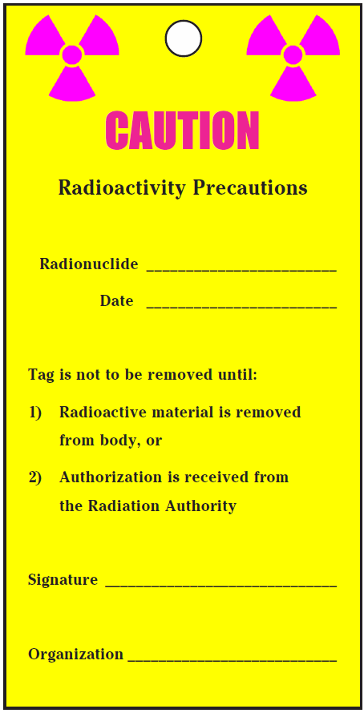
ATTACHMENT 1: Radioactivity tag

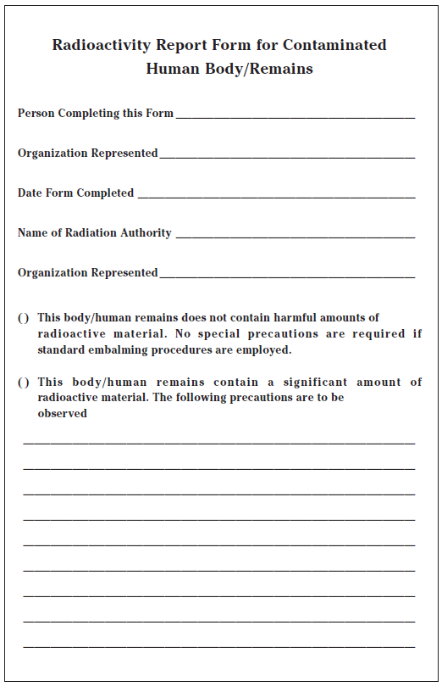
ATTACHMENT 2: Radioactivity Report Form

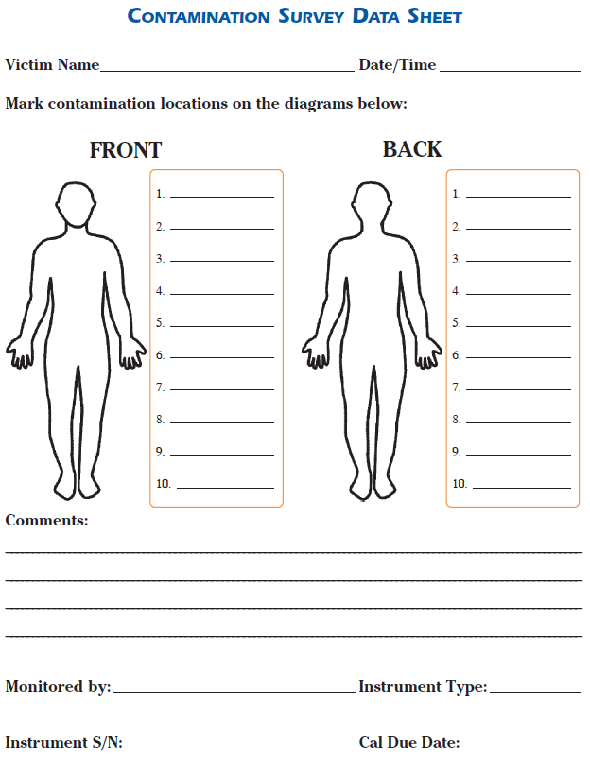
ATTACHMENT 3: Survey Data Sheet

