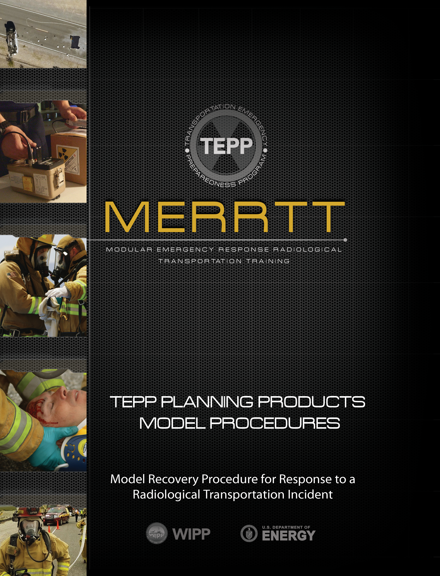
Contents
1.0 ASSUMPTIONS 2
2.0 PURPOSE 2
3.0 SCOPE 2
4.0 RESPONSIBILITIES 2
5.0 RECORDS 3
6.0 FREQUENCY 3
7.0 ADDIDITIONAL REFERENCES 3
8.0 SAFETY 4
9.0 RECOVERY PROCEDURE 4

1.0 ASSUMPTIONS
This Model Procedure will be used by responders trained in an incident management system. The Incident Commander will consult will appropriate federal, state, tribal, and local officials to ensure all regulatory policies and requirements are identified and complied with during incident recovery planning and mitigation.

2.0 PURPOSE
This Transportation Emergency Preparedness Program (TEPP) Model Recovery Procedure contains the recommended elements for developing and conducting recovery planning at a transportation incident scene involving radiological material. This model procedure was developed to assist in the recovery planning for an incident involving radioactive material.

3.0 SCOPE
This procedure applies to those personnel who have responsibilities listed in the following section.

4.0 RESPONSIBILITIES
4.1 Emergency Communications Center
4.1.1 Make notifications as requested by the Incident Commander.
4.1.2 Record information as required by the Emergency Communications Center Spill Response Report Forms/Procedures.
4.2 Hazardous Materials Response Team Senior Officer
4.2.1 Assist Incident Commander with incident scene communications including: shipper, carrier representatives, local fire department and state Radiation Authority or environmental protection representatives.
4.2.2 Assist with recovery planning and support private clean up contractor activities
4.2.3 Conduct proper turnover if a Contractor Spill Response Team is requested.
4.2.4 Assist in the completion of all incident documentation.
4.3 Incident Commander
4.3.1 Notify the local and/or state Radiation Authority of the incident
4.3.2 Identify stakeholders and responsible parties
4.3.3 List site restoration organizations and roles
4.3.4 Identify radioactive material release issues
4.3.5 Identify potential impacts to the environment
4.3.6 Identify waste handling and transport requirements
4.3.7 Consult with the Radiation Authority and assign roles and responsibilities for coordinating incident recovery planning and mitigation
4.3.8 Complete all incident documentation.

5.0 RECORDS
All information, records, and logs accumulated during the incident should be completed, distributed, and filed for future reference. Proper event documentation is essential when attempting to recoup equipment and material costs associated with the incident.

6.0 FREQUENCY
Use this procedure as needed.

7.0 ADDIDITIONAL REFERENCES
7.1 NFPA 472 - Standard for Competence of Responders to Hazardous Materials/Weapons of Mass Destruction Incidents, latest edition
7.2 NFPA 473 - Standard for Competencies for EMS Personnel Responding to Hazardous Materials/Weapons of Mass Destruction Incidents, latest edition
7.3 CFR 835.1302 - Emergency Exposure Situations
7.4 CFR 1910.120 - Hazardous Waste Operations and Emergency Response
7.5 DOT Emergency Response Guidebook, latest edition
7.6 US Environmental Protection Agency - Standard Operating Safety Guide
7.7 Radioactive Materials and Transportation and Response Q&A – Transportation Emergency Preparedness Program/Federal Emergency Management Agency, latest edition

8.0 SAFETY
8.1 Work within federal regulations, safety guidelines, and standard operating procedures.
8.2 Involve appropriate shipper, carrier, federal, state, tribal, or local officials to assist in incident evaluation and mitigation.
8.3 The scene Safety Officer has the authority to stop any work in which safety related items may be an issue.

9.0 RECOVERY PROCEDURE
1. List the type, isotope, quantity, form, and extent of hazardous material (radioactive material)
released.
_________________________________________________________________________________________________________________________________________________________________________________________________________________________________________________________________________________________________________________________________________________________________________________________________________________________________________________________________________________

2. Document the location, isolation, and collection techniques used to contain all
released/spilled hazardous material (radioactive material).
_________________________________________________________________________________________________________________________________________________________________________________________________________________________________________________________________________________________________________________________________________________________________________________________________________________________________________________________________________________

3. Identify sampling procedures, processes, methods, and analyses including identification
of analytical labs and protocols that are being used to mitigate the accident.
_________________________________________________________________________________________________________________________________________________________________________________________________________________________________________________________________________________________________________________________________________________________________________________________________________________________________________________________________________________

4. Develop a listing of key agencies, responsible persons, and stakeholders that are
participating in the recovery planning and mitigation process.
_________________________________________________________________________________________________________________________________________________________________________________________________________________________________________________________________________________________________________________________________________________________________________________________________________________________________________________________________________________
5. List monitoring and dosimetry needs and agency(ies) providing support.
____________________________________________________________________________________________________________________________________________________________________________________________________________________________________________________________________________________________________________________________________________________________________________________
_______________________________________________________________________________________________________________

6. List organizations participating in incident scene restoration (cleanup contractors or
other agencies that have radiological experience and necessary licensing).
____________________________________________________________________________________________________________________________________________________________________________________________________________________________________________________________________________________________________________________________________________________________________________________
_______________________________________________________________________________________________________________

7. Identify the potential impact to the environment and address special concerns relative to
location and proximity to sensitive cultural, ecological, or population areas.
____________________________________________________________________________________________________________________________________________________________________________________________________________________________________________________________________________________________________________________________________________________________________________________
_______________________________________________________________________________________________________________

8. During the restoration activities, document any identified secondary contamination of
soil, water, plants, and/or other adverse environmental conditions.
____________________________________________________________________________________________________________________________________________________________________________________________________________________________________________________________________________________________________________________________________________________________________________________
_______________________________________________________________________________________________________________

9. List waste handling and transportation regulatory requirements, including permits,
manifest requirements, and the disposal site(s) locations.
____________________________________________________________________________________________________________________________________________________________________________________________________________________________________________________________________________________________________________________________________________________________________________________
_______________________________________________________________________________________________________________

10. List cleanup contractor or state implementing procedure objectives for handling, storing,
and transporting contaminated waste to a disposal location.
____________________________________________________________________________________________________________________________________________________________________________________________________________________________________________________________________________________________________________________________________________________________________________________
_______________________________________________________________________________________________________________

11. Identify if original packaging can be reused or identify the need for repacking of damaged original packaging. If additional packaging is needed, list package size requirements, equipment needed for lifting, handling waste containers, and hauling requirements.

Note: Work with shipper/Radiation Authority to ensure that any repackaged radioactive material is packaged and transported in compliance with applicable state and federal regulations.
____________________________________________________________________________________________________________________________________________________________________________________________________________________________________________________________________________________________________________________________________________________________________________________
_______________________________________________________________________________________________________________

12. Consult with federal, state, tribal, and local authorities and determine organizations responsible for completion and proper maintenance of incident scene documentation including accident response activities reports, personnel accountability, and exposure records.
_______________________________________________________________________________________________________________________________________________________________________________________________________________________________________________________________________________________________________________________________________________________________________________________________________________________________________________________________________

13. Consult with the state, tribal, or local Radiation Authority and emergency medical service director to identify the need for follow-up actions including bioassay sampling to detect internal contamination or assistance from specialized professionals for continued medical surveillance.
_______________________________________________________________________________________________________________________________________________________________________________________________________________________________________________________________________________________________________________________________________________________________________________________________________________________________________________________________________

14. Work with the state, tribal, or local Radiation Authority to develop a listing of equipment that requires replacement because it cannot be decontaminated.
_________________________________________________________________________________________________________________________________________________________________________________________________________________________________________________________________________________________________________________________________________________________________________________________________________________________________________________________________________________

