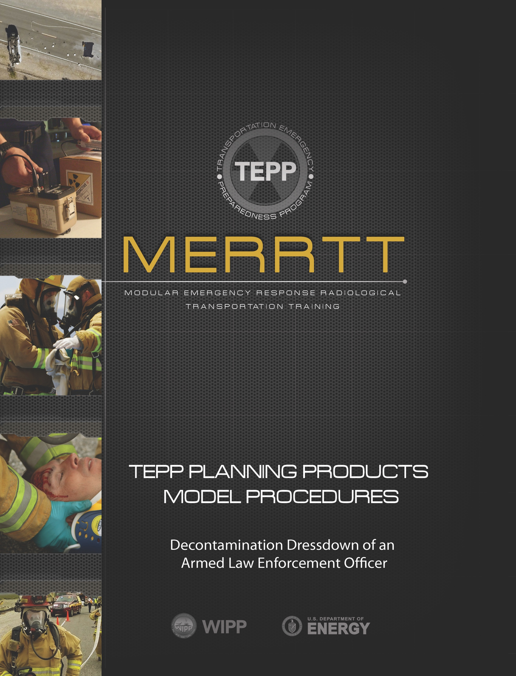

Contents
Assumptions 3
1.0 Purpose 3
2.0 Scope 3
3.0 Records 4
4.0 Frequency 4
5.0 References 4
6.0 Equipment 4
7.0 Location 4
8.0 Safety 4
9.0 Terms/Definitions 5
10.0 Response Procedure 6
Attachment 1: Personnel Contamination Location Report 9

ASSUMPTIONS
This Transportation Emergency Preparedness Program (TEPP) Model Procedure contains the recommended actions for weapon handling when processing an armed law enforcement officer through decontamination. This procedure assumes that entry into the contaminated or potentially contaminated area is made by first-arriving law enforcement officers before the nature of the hazard has been identified or realized.

The following assumptions are to be considered when reviewing this model procedure for initial response:
- The model procedure outlined in this document is not all-inclusive but was developed to meet the minimum national guidance for exiting a transportation accident scene involving radioactive material.
- This model procedure is designed for use by trained and qualified emergency responders. Additional procedural requirements may be implemented according to appropriate federal, state, tribal, or local requirements.
- This model procedure should be utilized appropriately, according to the conditions encountered, when exiting a transportation accident scene where radioactive material may have been released.
- All emergency response personnel have been trained in the use of an incident management system such as the Incident Command System.
- The responding authorities have a chain of custody process for securing and maintaining control of a contaminated or potentially contaminated officer’s weapons belt.

1.0 PURPOSE
The purpose of this model procedure is to provide law enforcement agencies guidance on how the existence of radioactive material from a transportation accident may affect weapon chain of custody procedures

SCOPE
  - This model procedure applies only to radioactive material contamination
  - Other hazardous materials are beyond the scope of this procedure
  - This model procedure applies to situations where armed law enforcement officers enter a transportation accident scene or other side-of-the-road emergency where radioactive materials may be present
  - This model procedure does not apply to contamination resulting from a nuclear detonation or terrorism-related dispersion of radioactive material
  - This model procedure does not apply to high threat situations where disarming the officer would not be prudent

3.0 RECORDS
Insert your jurisdictional policy for records retention here.

4.0 FREQUENCY
Use as needed.

5.0 REFERENCES
5.1 NFPA 472 - Standard for Competence of Responders to Hazardous Materials/Weapons of Mass Destruction Incidents
5.2 10 CFR 835.1302 - Emergency Exposure Situations
5.3 29 CFR 1910.120 - Hazardous Waste Operations and Emergency Response
5.4 U.S. Department of Transportation Emergency Response Guidebook (ERG)
5.6 U.S. Department of Energy Modular Emergency Radiological Response Transportation Training (MERRTT)
5.7 U.S. Department of Energy Quick Response Flatsheet

6.0 EQUIPMENT
As outlined in the ERG and/or as required by federal, state, tribal or local procedures, plans, or policies.

7.0 LOCATION
Use this model procedure as appropriate at a transportation incident.

8.0 SAFETY
8.1 Respond and perform duties within safety guidelines specified within the ERG and organizational standard operating procedures or guides
8.2 Involve appropriate federal, state, tribal, local officials, or Radiation Authority as soon as possible for assistance with response considerations and disposition of any contaminated weapons and/or equipment
8.3 All weapons should be handled in accordance with departmental safety policy
8.4 If it is safe and practicable, allow the weapon to remain in the holster
8.5 Only properly trained law enforcement officers, or another investigators, should handle or take physical possession of weapons

9.0 TERMS/DEFINITIONS
Contamination - As referred to in this document, contamination is undesired radioactive material that is deposited on the surface of or inside structures, areas, objects, or people.

Decontamination - The reduction or removal of contaminating radioactive material from a structure, area, object, or person.

Dry Decontamination – The careful or systematic removal of the outer layer of clothing or protective clothing as a means to remove the majority of the radioactive material that may be present.

Incident Commander (IC) - The person responsible for all decisions relating to the management of the incident.

Incident Command System (ICS) - An organized approach to control and manage operations at an emergency incident.

National Incident Management System (NIMS) - A comprehensive, national approach to incident management applicable to all jurisdictional levels.

Radiological Survey – The evaluation and quantification of the radiation/contamination hazards present. When conducted on a person, this is often referred to as a contamination survey.

Radiation Authority - A federal, state, tribal or local agency designated official. Responsibilities include evaluating radiological hazard conditions during normal operations and emergencies.

Stand-in-Place Dressdown - A method of dry decontamination that involves standing in place, inside of a large plastic bag, while carefully and systematically removing of the outer layer of clothing/gear. These items remain in the large plastic bag. Clothing is not pulled over head but either cut off or carefully removed from the top down, in order to prevent radioactive dust or particles from shaking loose.

Weapon - For the purpose of this procedure, weapon means those items carried by law enforcement officers in their day-to-day functions including, but not limited to, handguns, knives, batons, pepper spray/tear gas, and Tasers or any other item that the law enforcement agency would not want to have outside of their control or custody.

Law Enforcement Sensitive Items - For the purpose of this procedure, law enforcement sensitive items mean those items carried by law enforcement officers in their day-to-day functions that the law enforcement agency would not want the public to access. These items may include, but are not limited to, duty weapon(s), ammunition, radio, hard badge, work cell phone, ballistic vest, and body camera.

10.0 RESPONSE PROCEDURE
Utilize the ERG to conduct a scene size-up. Establish contamination control zones. If the officer entered the incident scene (hot zone) to perform lifesaving actions or accidentally entered the hot zone and there is potential that the officer is contaminated from the release of radioactive material, appropriate decontamination is necessary.

Stand-in-place Dressdown/Dry decontamination
Responding officials will need to establish a decontamination process that uses barricades or other identifying features to ensure that the decontamination area is obvious to responders. Barricade tape, traffic cones, or a tarp should be used to identify the decontamination area.
10.1 Officers who entered the hot zone should notify responding officials that they are potentially contaminated with radioactive material from the accident scene and should then implement self-protection measures until they can be processed through the decontamination area:
- Do not eat, drink, smoke, or chew
- As possible, limit activities/movement to control the spread of contamination
10.2 If radiological survey equipment is on scene, a qualified person should conduct a full-body radiological survey of the officer to monitor for radioactive material contamination.
10.3 If no radiological material contamination is detected, the officer can return to normal duties once the officer, the vehicle, and other equipment has been cleared by the Radiation Authority. If radiological survey equipment is not available or contamination is detected, proceed with the remaining steps of this procedure.
    - Consider one of the options below to secure the officer’s weapons
      - Option 1: If officer’s response vehicle is located inside the hot zone, the officer may elect to secure their law enforcement sensitive items (specifically, guns, ammunition, radios, body camera, department issued phone, and hard badges) in their vehicle. The officer should lock the response vehicle and prepare to exit the incident scene through the decontamination area.
      - Option 2: Have the officer continue to decontamination area wearing their weapons belt and back up weapons/holster.
    - At the entrance to the decontamination area/control zone boundary, if the weapon(s) was not secured inside the response vehicle, have the officer remove their weapon/tactical/utility belt and back up weapon/holster.
Note: Maintaining a chain of custody of the weapon is required. Ensure that a law enforcement official who did not enter the hot zone and can act as the evidence custodian and is available to take possession of law enforcement sensitive items (specifically, guns, ammunition, radios, body camera, department issued phone, and hard badges).
    - At the entrance of the decontamination area/control zone boundary, the officer will select one of the following three options to properly handle law enforcement sensitive items. Consider the chain of custody for all law enforcement sensitive items removed from the officer during the decontamination process.
      - Option 1: If the items were locked in the vehicle, the vehicle keys will be placed in a large clear plastic bag and sealed. The bag will then be placed in a second large clear plastic bag and sealed to ensure good contamination control practices (double bagged).
      - Option 2: According to agency protocol, the officer will clear their weapon(s), and make it safe before placing their weapon(s) and other law enforcement sensitive items in a large clear plastic bag and sealed. The bag will then be placed in second large clear plastic bag and sealed to ensure good contamination control practices (double bagged).
      - Option 3: The weapons belt and backup weapon/holster and law enforcement sensitive items should be placed in a large clear plastic bag and sealed. The bag will then be placed in second large clear plastic bag and sealed to ensure good contamination control practices (double bagged).
10.3.4 The evidence custodian is now in control of the law enforcement sensitive items.
10.3.5 At this point, the potentially contaminated officer is ready to enter the decontamination area for stand-in-place decontamination.
10.4 With the assistance of responders on the scene, have the officer step into the decontamination area where an oversized trash bag has been placed on the ground in a manner where the sides of the bag are rolled down.
10.5 Have the officer step into the oversize trash bag. Have the officer remove any jewelry and valuables and place them into a small plastic bag. This bag will be under the control of the evidence custodian. Decontamination workers will then assist the officer with removal of outer clothing in the following order. As these items are removed, they are carefully left inside the oversized trash bag:
- Bag personal effects in separate bag (wallet, jewelry, cell phone, etc.)
- Any gloves including medical exam gloves
- Glasses and head gear
- Ballistic vest (if worn outside shirt)
- Outer jacket and/or shirt
- Ballistic vest (if worn inside shirt)
- Untie or unzip shoes/boots to make it easier for removal (leave on at this time)
- Loosen officer’s belt, unbutton and unzip pants
- Carefully slide pants down toward ankles, trying to roll them outward so that outside surface of pants does not touch bare skin
10.6 With pants at ankles, have the officer step out of their pants/shoes/boots while stepping out of the trash bag.
10.7 At this point, stand-in-place decontamination is complete and the officer can be dressed in modesty clothing (disposable coveralls) and given some type of footwear as available. The officer should then be directed to the survey station.

At the radiological survey station, the officer will need to remove their modesty clothing so that the Radiation Authority, or other authorized person, can conduct a radiological survey. The Radiation Authority will determine if:
10.7.1 If the officer is contaminated, the Radiation Authority will designate the necessary steps to ensure the officer is properly decontaminated and the spread of contamination is minimized. Attachment 1 can be used to annotate locations of contamination on a body. Upon completion of the whole-body survey, the officer should be provided with clean modesty clothing.
10.7.2 If the officer is not contaminated, proceed with the remainder of this procedure
Note: The Radiation Authority and Incident Commander will decide if the officer is released to continue normal work

10.8 The evidence custodian will maintain custody of the bagged items at a designated location near the decontamination area. The receiving officer will brief the Incident Commander on the number, type, and location of items (vehicle keys, weapons, and law enforcement vehicles) needing survey or possible decontamination.
10.9 The Incident Commander will work with the evidence custodian and the Radiation Authority to determine the best location for the final contamination survey and decontamination of personal and law enforcement sensitive items.

ATTACHMENT 1: PERSONNEL CONTAMINATION LOCATION REPORT
