

Contents
Assumptions 3
1.0 Purpose 4
2.0 Scope 4
3.0 Responsibilities 4
4.0 Records 4
5.0 Frequency 4
7.0 Equipment 5
8.0 Location 5
9.0 Safety 6
10.0 Terms/Definitions 6
11.0 Procedure 7
12.0 Dressing Up (Donning) Disposable Protective Clothing 7
13.0 Dressing Down (Doffing) Disposable Protective Clothing Stand-in-Place Method 9
Attachment 1: 24-Hour Assistance Telephone Numbers 12
Attachment 2: Example Decon Cooridor Setup Guide 13
Attachment 3: Example 1 Personnel Dosimetry Report 14
Attachment 3: Example 2 Personnel Dosimetry Report 15
Attachment 4: Personnel Contamination Location Report 16

Assumptions
This Transportation Emergency Preparedness Program (TEPP) model procedure provides guidance for performing decontamination of emergency responders wearing disposable type clothing exiting the “hot zone” at a transportation incident involving only radioactive material. Response organizations can modify this procedure to ensure that the dress up and dressdown process described is consistent with their organization’s existing guides or procedures. Using different levels (A, B, C and D) of personal protective clothing are options available to trained, qualified, and equipped response teams. Using varying types of respiratory protection and different levels of protective clothing are part of the incident response consideration.

The following assumptions are to be considered when reviewing this Model Procedure:
- This procedure is not all-inclusive but was developed to meet the minimum guidance for decontaminating responders at a radioactive hazardous material incident involving only radioactive material.
- This procedure is designed for use by responders that have been trained to standards acceptable by their jurisdictions. Additional procedural requirements may be implemented according to appropriate local, state, or tribal requirements.
- This procedure assumes that all responders and response equipment leaving the hot zone are potentially contaminated. A personnel and equipment decontamination system/method must be implemented to control the spread of radioactive material contamination (or cross contamination) onto personnel or equipment.
- All emergency response personnel have been trained in the use of an Incident Management System such as the Incident Command System.
- A Radiation Authority from a state, federal, or tribal agency will be contacted and may respond and assist in the disposition of contaminated items and final clearance of personnel for an incident involving radioactive material.
- This procedure assumes that waste minimization practices are an important consideration during incident management.

1.0 Purpose
The purpose of this model procedure is to provide guidance for performing decontamination of individuals wearing a disposable protective clothing ensemble who have entered a “hot zone” during hazardous material incidents involving only radioactive material. These personnel may be first responders or resources such as hazardous materials response teams that have been requested by the local jurisdiction.

2.0 Scope
This model procedure applies to emergency responders who have the responsibility for performing emergency response activities that require entry into a hot zone that is potentially contaminated with only radioactive material.

3.0 Responsibilities
3.1 Decontamination Worker – carry out the appropriate decontamination process to remove potentially contaminated or contaminated disposable protective clothing from the entry team members as necessary.
3.2 Responder – follow appropriate decontamination steps and comply with requests made by decontamination workers.
3.3 Incident Commander – as needed, ensure that no personnel or equipment leave the hot zone/decontamination corridor/warm zone without proper radiation contamination surveys and decontamination.

4.0 Records
4.1 24-hour Assistance Telephone Numbers (Attachment 1)
4.2 Example Decon Corridor Setup Guide (Attachment 2)
4.3 Example Personnel Dosimetry Report/Log 1 and 2 (Attachment 3)
4.4 Personnel Contamination Location Report (Attachment 4)

5.0 Frequency
Use this model procedure as needed.

6.0 References and resources
6.1 NFPA 472 (2017) – Standard for Competence of Responders to Hazardous Materials/Weapons of Mass Destruction Incidents.
6.2 10 CFR 835.1302 – Emergency Exposure Situations
6.3 29 CFR 1910.120 – Hazardous Waste Operations and Emergency Response
6.4 DOT Emergency Response Guidebook (ERG)
6.5 U.S. Environmental Protection Agency – Standard Operating Safety Guide
6.6 Radioactive Materials – Transportation and Incident Response Q&A (10/2014) – Transportation Emergency Preparedness Program/Federal Emergency Management Agency
6.7 To clarify procedural steps, pictures for each step are shown in Module 4 of the TMERRTT Program and are available from TEPP Central Operations
6.8 Hazardous Materials for First Responders 5th Edition

7.0 Equipment
The following equipment may be necessary based on the type and method of decontamination required.
7.1 Banner tape or safety cones to identify incident boundary and control zones.
7.2 Decontamination tarp or items to establish the decontamination corridor/warm zone.
7.3 Numerous four-foot square plastic sheets or drum liners/oversized (recommend 95-gallon size) plastic bags for stand-in-place method.
7.4 Multiple large (recommend 55-gallon size) trash cans.
7.5 Protective clothing as determined and required by the local, regional, or state hazardous materials response teams:
7.5.1 Appropriate type of disposable coveralls.
7.5.2 Appropriate type of disposable gloves.
7.5.3 Appropriate type of boots/shoe covers.
7.5.4 Appropriate respiratory protection: self-contained breathing apparatus (SCBA), air-purifying respirator (APR), powered air purifying respirator (PAPR).
7.5.5 Appropriate type of tape to seal the PPE ensemble.
7.6 Personnel dosimetry.
7.7 Radiological contamination survey instruments.
7.8 Step-off pads.
7.9 Plastic bags for collecting personnel dosimetry, radio equipment, etc.
7.10 Pens and permanent markers.
7.11 Personnel Dosimetry Report.
7.12 Personnel Contamination Location Report.

8.0 Location
Use this procedure as needed based upon incident location. Positioning of the decontamination system/corridor should be upwind and upslope from the incident scene and located in the warm zone (decontamination corridor). See attachment 2 for example setup for a decontamination corridor.

9.0 Safety
9.1 Keep respiratory protection in place until primary decontamination is complete or advised otherwise by the Radiation Authority.
9.2 As needed, package all contaminated materials (tools, coveralls, etc.) and maintain them inside the hot zone until ready for disposal or decontamination later. The responsible party must confer, along with appropriate state, federal, or tribal officials and the Radiation Authority, on the method of disposal.
9.3 Report all injuries or unusual incidents to the Safety Officer or Incident Commander.
9.4 Verify that Emergency Medical Service (EMS) personnel are on the scene for emergencies requiring medical assistance.
9.5 Prior to setting up the decontamination corridor, survey the selected location to verify that the area is free of radioactive contamination and that the radiation levels are at or near natural background levels.

10.0 Terms/Definitions
Cold Zone – Also referred to as the support zone, the cold zone is a contamination-free zone established around the warm zone where emergency operations can be directed and supported. The cold zone is normally established in an area where radiation levels are at natural background levels.

Contamination – As referred to in this document, contamination is undesired radioactive material that is deposited on the surface of or inside structures, areas, objects, or people.

Contamination Control Zone – An isolation zone that is typically set up around a hazardous incident site to control the spread of hazardous substances. See hot zone, warm zone, cold zone.

Decontamination – The reduction or removal of contaminating radioactive material from a structure, area, object, or person. Decontamination may be accomplished by: use of a tape press or wiping the surface (dry decon); washing or flushing the surface with water or other solution (wet decon), or allowing the material involved to decrease in activity through natural radioactive decay.

Hot Zone – Also referred to as the exclusion zone in some jurisdictions. The hot zone is usually set up in the immediate area surrounding the spilled material or incident scene. Access to the hot zone should be controlled for accountability purposes as well as contamination control purposes.

Incident Commander (IC) - The person responsible for all decisions relating to the management of the incident.

Radiation Authority - A federal, state, or tribal agency designated official. Responsibilities include evaluating radiological hazard conditions during normal operations and emergencies.

Radioactivity - The spontaneous and random emission of radiation, generally alpha or beta particles, often accompanied by gamma rays, from the nucleus of an unstable isotope. Also, the rate at which radioactive material emits radiation.

Radioisotope (Radionuclide) - An unstable isotope of an element that decays or disintegrates spontaneously emitting radiation. Approximately 2600 natural and artificial radioisotopes have been identified.

Radiological Survey – Usually performed by the Radiation Authority or other qualified resources. A radiological survey is performed using radiation detection and measurement instrumentation especially adapted for inspecting an area or individual to establish the existence and amount of radioactive material present.

Step-off Pad - Transition area between contaminated and non-contaminated areas that may be used to allow exit of personnel and removal of equipment.

Warm Zone - Also referred to as the contamination reduction zone, the warm zone is usually established at or near background radiation and contaminations levels and provides a buffer between the hot and cold zones. Decontamination often takes place in the warm zone.

11.0 Procedure
Different types and levels of personal protective clothing are worn by response organizations. When conducting decontamination operations, you may need to adjust the decontamination process to satisfy the type and level of personal protective clothing being worn by responders. This procedure specifically pertains to disposable protective clothing ensembles.

12.0 Dressing Up (Donning) Disposable Protective Clothing
Preparing responders to work inside the contamination zone requires an appropriate personal protective clothing ensemble. Following a systematic approach to dressing up in the protective clothing will help minimize the potential for spreading contamination during the dressdown (doffing) procedure

The following sequence is recommended for dressing up in a disposable protective clothing ensemble. The entry responder begins the dress up process by:
12.1 Select the appropriate type of protective clothing (coverall, gloves, boots, respiratory protection), and inspect the protective clothing for damage (holes, tears, split seams, broken zippers, etc).
12.2 Put on two pair of gloves, alternate colors if possible.
12.3 Step into the coveralls.
12.4 Pull boots on over the coverall footy. Tape the coverall to the boot top. Tab the tape end (one end folded back) to facilitate dressdown if needed.

Note: Make sure the tape is loose enough that the foot can be removed without removing the tape. Tab the tape end (one end folded back) to facilitate dressdown if needed.

12.5. Continue to dress up into the disposable coverall. Insert both arms and zip up the coverall as appropriate.
12.6 Put on a third outer pair of gloves and loosely tape the glove wrist to the coverall.

Note: When putting on third outer pair of gloves use glove rings, if available. If glove rings are not available, make sure the tape is loose enough that the hand can be removed without removing the tape. Tab the tape end (one end folded back) to facilitate dressdown if needed.

12.7 As determined, put on respiratory protection (SCBA or APR).
12.8 Put on or pull hood/coverall head protection over the responder’s head. Tape the hood to the respiratory protection and coverall zipper as needed.
12.9 Put on communication equipment and personnel dosimetry (if worn) on the upper front torso.

Note: Electronic dosimetry is typically worn on the outside of your protective clothing for easy access and reading. TLD/OSLD dosimetry is typically worn on the inside of your protective clothing to prevent contamination.

12.10 Put on head protection (helmet).
12.11 Before entry, have Entry or Safety Officer inspect the responder’s dress up ensemble to ensure all exposed skin areas are covered, appropriate tape has been applied, and needed equipment has been assigned. Document the time the responder goes on respiratory protection and enters into the incident scene.

13.0 Dressing Down (Doffing) Disposable Protective Clothing Stand-in-Place Method
Remove the contaminated or potentially contaminated disposable protective clothing ensemble in the decontamination dressdown corridor according to the following sequence:

13.1 Approach the decontamination corridor. Place equipment and/or tools in the designated drop area.

Note: The established tool drop area should provide some type of containment for equipment that may be contaminated. Examples of an appropriate tool drop area include a plastic cover placed on the ground that equipment/tools can be placed on or a lined can that equipment/tools can be placed in. Equipment and tools placed in the drop area will need to be surveyed and decontaminated as needed by the state, federal, or tribal Radiation Authority before they can be released as “clean.” Items that cannot be declared as clean shall be properly disposed of as directed by the Radiation Authority.

13.2 At the decontamination corridor, wipe feet on the step-off pad and step on to the decontamination tarp and proceed to the four-foot square protective ground covering or step into an oversized collapsed drum liner/plastic bag.

Note: Typical absorbent pads are acceptable to use as step-off pads. Decontamination workers should replace damaged step-off pads as necessary. Replacement pads should be placed on top of existing pads.

13.3 The decontamination worker will carefully remove the responder’s head protection (helmet). The decontamination worker will place the responder’s helmet into the appropriate waste container.
13.4 The decontamination worker will carefully remove and separately bag the responder’s radio equipment and personnel dosimetry. Each bag should be sealed, marked with the responder’s name, and placed in a controlled area.
13.5 The decontamination worker will carefully remove the SCBA or APR harness/backplate from the responder.

Note: The responder will not remove their face piece at this time. The decontamination worker will hold the harness/backplate throughout the dressdown process.

13.6 The decontamination worker will carefully remove any tape used to secure the respiratory protection to the coverall’s hood and to secure the zipper. The decontamination worker will place the removed tape in the appropriate waste containers.
13.7 The decontamination worker will carefully unzip the coverall front zipper.
13.8 The decontamination worker will begin removing the responder’s coverall by grasping the fingertips of the outer glove and gently pulling the responders hands free from the outer gloves while remaining inside of the coverall sleeve. Repeat this step for the other hand.

Note: The outer gloves should remain taped to the coverall during the dressdown process.

13.9 To reduce the possibility of cross contamination the decontamination worker will remove an outer pair of their gloves before proceeding with this step. Now that the responder’s hands/arms have been freed from the outer gloves, the decontamination worker will gently roll, inside out, the coveralls off the responder’s shoulders, down the back, to the top of the responder’s boots.
13.10 The responder will step out of their boots, into footwear, and step completely clear of the four-foot square protective ground covering or out of the oversized collapsed plastic bag and exit to the end of the decontamination corridor.

Note: if needed the decontamination worker can hold the exterior of the responder’s boot and coverall to make it easier for the responder to step out of the boots.

13.11 The decontamination worker will gently roll up the four-foot protective ground covering square or the oversized collapsed plastic bag that includes the outer boots/shoe covers and coveralls and gently place them into a waste container.
13.12 The responder will remove the their outer most pair of inner protective gloves by pinching the backside wrist cuff and pulling the glove inside out as it is pulled off while keeping the responder’s gloved hands low and over the disposal area. Gently place the gloves in the waste container.
13.13 The responder will grasp the respiratory protection mask, and gently pull the respirator forward and up off the head. Once off, hand the respirator to the decontamination worker and they will gently place the respirator in the waste container. Document the responders off respiratory protection and exit time from the decontamination corridor.
13.14 The responder will remove the remaining protective gloves by pinching the backside wrist cuff and pulling the glove inside out as it is pulled off while keeping their gloved hands low and over the disposal area. Gently place the gloves in the waste container.
13.15 The responder will report to the contamination survey location and complete a whole-body contamination survey by the state, federal, or tribal Radiation Authority.

Note: Survey results will be documented on the appropriate personnel contamination survey form.

13.16 Decontamination workers will complete the decontamination process by conducting a self-decontamination using the aforementioned steps.

Note: Decontamination workers will assist one another in removing protective clothing and placing removed clothing into the designated waste container.

13.17 Decontamination workers should brief the Incident Commander on the number, type, and location of items (protective clothing, equipment, tools, etc.) needing decontamination. The Incident Commander will coordinate the final contamination survey of responders who entered the hot zone and decontamination of contaminated items with the state, federal, or tribal Radiation Authority.

Attachment 1: 24-Hour Assistance Telephone Numbers
Agency | 24 Hour Telephone Number
Department of Energy Emergency Operations Center | 202-586-8100
Nuclear Regulatory Commission | 301-816-5100
Federal Emergency Management Agency | 202-586-8100
National Response Center | 800-424-8802  In District of Columbia 202-267-2675
Military Shipments | 703-697-0218 (Collect Call)
CHEMTEL | 800-255-3924
CHEMTREC | 800-434-9300  In District of Columbia 202-483-7616
Environmental Protection Agency | 800-424-8802

State point of contact numbers can be found on the DOE TEPP website at: www.em.doe.gov/otem

Conference of Radiation Control Programs and Directors (CRCPD)
The CRCPD is a non-governmental professional organization dedicated to radiation protection that may serve as a point of contact or resource for radiological issues/concerns. Their mission is "to promote consistency in addressing and resolving radiation protection issues, to encourage high standards of quality in radiation protection programs, and to provide leadership in radiation safety and education." CRCPD's primary membership is made up of radiation professionals in State and local government that regulate the use of radiation sources. More information on the CRCPD can be found on their website at: http://www.crcpd.org.

Attachment 2: Example Decon Cooridor Setup Guide
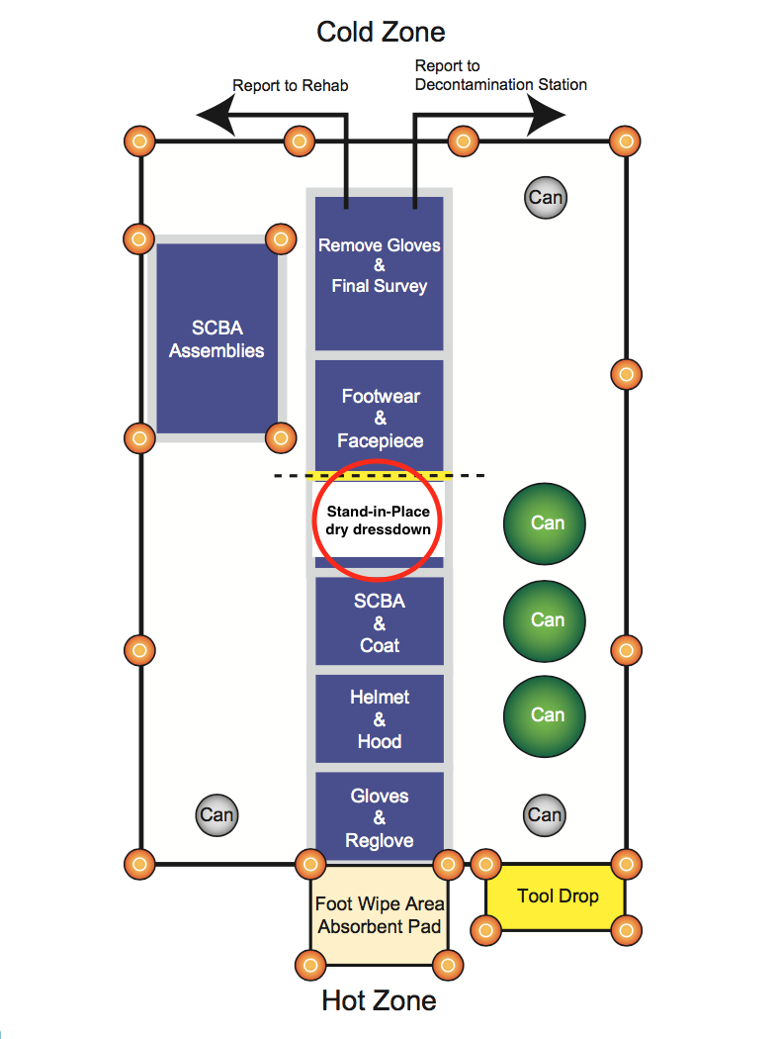

Attachment 3: Example 1 Personnel Dosimetry Report

Responder Name: ________________________________________ Date: __________

Agency or Department: ___________________________________________________

List county, state, or federal agencies supporting the response: ________________________________________________________________________________________________________________________________________________________________________________________________________________________________________________________________________________________________________________

Direct Reading Dosimeter Information Log
Assigned Task | Date | Dosimeter Serial No. | Time |  | Dosimeter Reading |  | Total Dose
Assigned Task | Date | Dosimeter Serial No. | In | Out | In | Out | Total Dose

Assigned Task | Date Issued | Serial No. | Issued By | Date Returned | Returned To
Other Dosimeter (TLD, OSLD) Information

Laboratory Reading of TLD, OSLD
Name of Laboratory | Results of Reading | Date of Reading | Results Forwarded to Responder
 | millirem |  | ( ) Yes ( ) No
 | millirem |  | ( ) Yes ( ) No

Comments or remarks: ________________________________________________________________________________________________________________________________________________________________________________________________________________________________________________________________________________________________________________

Attachment 3: Example 2 Personnel Dosimetry Report

Dosimeter # and Type | First Name | Last Name | Date/Time Issued | Initial Reading | Date Time Returned | Return Reading | Dose Estimate

Attachment 4: Personnel Contamination Location Report
