Conducted under the:
U.S. Department of Energy
Transportation Emergency Preparedness Program

National Exercise Program Formatted
Controller and Evaluator (C/E) Handbook
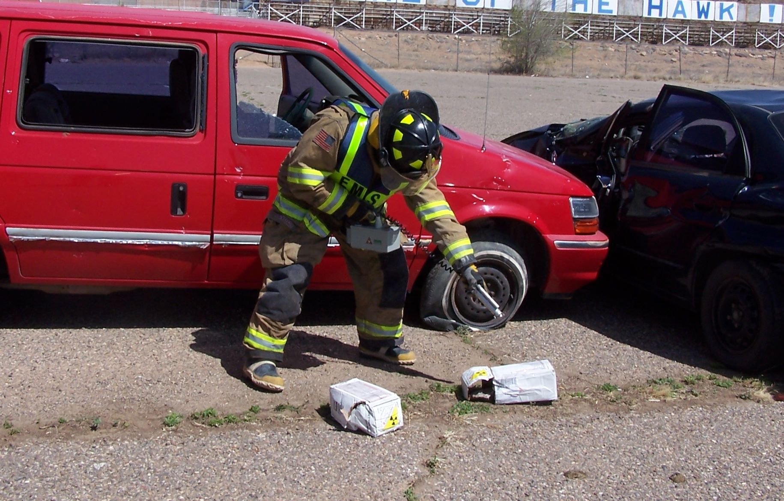
Radiopharmaceuticals Exercise

Exercise Date:

Publishing Date:
Table Of Contents
Preface 3
Handling Instructions 4
Chapter 1: General Information 5
Introduction 5
Confidentiality 5
Mission Area: Response 7
Core Capabilities 7
Exercise Objectives 8
Exercise Participants 9
Exercise Implementation and Rules 10
Site Access 11
Exercise Identification 11
Logistics 12
Public Affairs 12
Chapter 2: Scenario 13
Exercise Scenario 13
Safety 15
Chapter 3: Controller Information and Guidance 18
Exercise Controller Organization 18
Exercise Control 19
Communications Plan 20
Controller Instructions 21
Assessment, Review and Analysis of Exercise 22
Exercise Report 23
Chapter 4: Evaluator Information and Guidance 24
General Information 24
Exercise Evaluation 24
Evaluator Instructions and Guidelines 26
Assessment, Review and Analysis of Exercise 28
Exercise Report 29
Appendix A: Exercise Schedule 30
Appendix B: Exercise Site Maps/Props 31
Appendix C: Controller and Evaluator Assignments 33
Appendix D: Activity Log 34
Appendix E: Shipping Papers 36
Appendix F: Emergency Response Guidebook-Guide 163 38
Appendix G: Package Labels 38
Appendix H: Package Marking 42
Appendix I: Master Scenario Events List & Injects 43
Appendix J: Radiological Data 62
Appendix K: Signature Page 66
Appendix L: Participant Feedback Form 67
Appendix M: Evaluation Plan 69
Appendix N: Exercise Evaluation Guides 72

Preface
Name of Exercise is sponsored by the Name of Sponsoring Organization in cooperation with the Department of Energy’s Transportation Emergency Preparedness Program (TEPP). This Exercise Plan (ExPlan) follows Department of Homeland Security (DHS) guidance, but for simplicity encompasses all required DHS documents, including the Controller and Evaluator (C/E) Handbook, Master Scenario Events List (MSEL), Actor Handbook, Exercise Evaluation Guides. This manual was produced with input, advice, and assistance from the Exercise Planning Team, which followed the guidance set forth in the Federal Emergency Management Agency (FEMA), Homeland Security Exercise and Evaluation Program (HSEEP).
The ExPlan provides controllers and evaluators detailed information about the exercise scenario and their specific duties and responsibilities. Controllers and evaluators should refer to the ExPlan for basic information about the exercise, including participating agencies, schedules, briefings, and the responsibilities of various participants. The information in this document is current as of the date of publication and is subject to change as dictated by the Exercise Planning Team.
This is an unclassified exercise. The control of information is based more on public sensitivity regarding the nature of the exercise than on the actual exercise content. This document is intended for the exclusive use of exercise controllers and evaluators only.
All exercise participants should use appropriate guidelines to ensure the proper control of information within their areas of expertise and to protect this material in accordance with current jurisdictional directives. Public release of exercise materials to third parties is at the discretion of the Exercise Planning Team.

Handling Instructions
- The title of this document is Name of Exercise ExPlan
- The information gathered in this ExPlan is For Official Use Only (FOUO) and should be marked and handled as sensitive information, not to be disclosed. This document should be safeguarded, handled, transmitted, and stored in accordance with appropriate security directives. Reproduction of this document, in whole or in part, without prior approval from the Exercise Planning Team is prohibited.
- At a minimum, the attached materials will be disseminated only on a need-to-know basis and when unattended, will be stored in a locked container or area offering sufficient protection against theft, compromise, inadvertent access, and unauthorized disclosure.
- For more information, please consult the following points of contact (POCs):
Name
Title
Department
Street
City and Zip
Phone Numbers
Email address

Chapter 1: General Information

Introduction
Name of Exercise is a full-scale exercise (FSE) designed to establish a learning environment for players to exercise emergency response plans, policies, and procedures as they pertain to bioterrorism. An FSE is a complex event that requires detailed planning. To conduct an effective exercise, subject matter experts (SMEs) and local representatives from numerous agencies have taken part in the planning process and will take part in exercise conduct and evaluation.
This ExPlan was produced at the direction of the Name of Department with the input, advice, and assistance of Department of Energy Transportation Emergency Preparedness Program planners. Name of Exercise is evidence of the growing public safety partnership between State, Federal, and local jurisdictions for the response to the constant threat of terrorism our Nation and communities face.

Confidentiality
Name of Exercise is an unclassified exercise. The control of information is based more on public sensitivity regarding the nature of the exercise than on the actual exercise content. Some exercise material is intended for the exclusive use of exercise planners, controllers, and evaluators, but players may view other materials deemed necessary to their performance. Because this ExPlan was (for reasons of simplicity and elimination of redundancies) combined with exercise sensitive information usually contained only in the Controller Evaluator Handbook, only Chapter 1 of this manual should be given to Players or Observers. Chapters 2 through the end of this manual should be considered restricted and are intended for controllers and evaluators only.
All exercise participants should use appropriate guidelines to ensure the proper control of information within their areas of expertise and protect this material in accordance with current directives.
Public release of exercise materials to third parties is at the discretion of the Name of Exercise Planning Team.
Purpose
The purpose of this exercise is to evaluate player actions against current response plans and capabilities for a terrorist incident response.
Scope
The scope of play for Name of Exercise requires the establishment of an incident scene and requires responders in the field to perform those actions usually associated with a hazardous material incident. These actions include command and control, communications, victim rescue, triage and treatment, hazard identification, site security and crowd control, monitoring for contamination, contamination control, and device recovery and packaging.
The following is a list of suggested personnel/groups that may participate in the exercise, depending on the desired complexity of the exercise. (Many of these agencies may be simulated.)
Exercise Coordinators
- Lead Planner/Exercise Director
- Safety Officer
- Media Coordinator

Local Response Organizations
- Local Fire Department
- Local Municipal Police Department
- Local Emergency Operations Center (EOC)
- County Sheriff’s Office
- Emergency Medical Service/Ambulance/Hospital
- Local HazMat Response Team (if available)
- Other Mutual Aid Organizations

State/Federal Agencies
- State Hazardous Materials Response Team
- State Radiation Authority
- State Emergency Operations Center (EOC)
- Nearby DOE Facility
- DOE Regional RAP Team
- US Environmental Protection Agency
- Nuclear Regulatory Commission
- National Response Team
- National Response Center (US Coast Guard)

Commercial Organizations
- Commercial Licensed Radioactive Materials Transporter
- Commercial Contractor Trained for Radioactive Material Cleanup

Assumptions
Assumptions constitute the implied factual foundation for the exercise and, hence, are assumed to be present before the start of the exercise. The following general assumptions apply to Name of Exercise:
- The exercise will be conducted in a no-fault learning environment wherein systems and processes, not individuals, will be evaluated.
- Exercise simulation will be realistic and plausible, containing sufficient detail from which to respond.
- Exercise players will react to the information and situations as they are presented, in the same manner as if this had been a real event.
Constructs and Constraints
Constructs are exercise devices designed to enhance or improve exercise realism. Alternatively, constraints are exercise limitations that may detract from exercise realism. Constraints may be the inadvertent result of a faulty construct or may pertain to financial and staffing issues. Although there are a number of constructs and constraints (also known as exercise artificialities) for any exercise, the Name of Exercise planning team recognizes and accepts the following as necessary:
- Exercise communication and coordination will be limited to the participating exercise venues and the simulation cell (SimCell).
- Only those communication methods listed in the Communication Directory will be available for players to use during the exercise.
- The participating agencies may need to balance exercise play with real-world emergencies. It is understood that real-world emergencies will take priority.

Mission Area: Response
The Response Mission includes capabilities necessary to save lives, protect property and the environment, and meet basic human needs after an incident has occurred. This exercise template has identified the typical challenges emergency responders will face at a transportation accident involving radioactive material. The Response Mission should be reviewed during the exercise planning meetings to ensure the Response Mission is appropriate for the planned exercise objectives.

Core Capabilities
The core capabilities contained in this exercise template are the elements selected for conducting/evaluating a transportation accident involving radioactive material. The successful completion of this exercise will improve responder preparedness, promote innovation, identify improvement areas, and identify training needs.
The Name of Exercise planning team from the Name of Department has selected the Core Capabilities listed below. These capabilities provide the foundation for development of the exercise objectives and scenario, as the purpose of this exercise is to measure and validate performance of these capabilities and their associated critical tasks.
- Operational Coordination (On Scene Incident Management)
- Public Health and Medical Services (Emergency Triage and Pre-Hospital Treatment)
- Environmental Response/Health and Safety (Hazardous Materials Response and Decontamination)

Exercise Objectives
The Name of Exercise planning team selected objectives that focus on evaluating emergency response procedures, identifying areas for improvement, and achieving a collaborative attitude. This exercise will focus on the following objectives and capabilities:
First Responder Objectives
Operational Coordination (On-Scene Incident Management)
- Upon arrival on scene, provide initial scene report while beginning response operations; carry out management planning, and coordinate on-site incident
- Establish incident scene staff and make necessary assignments to rescue victims, isolate accident scene, identify hazardous materials, and establish on-site incident command
- Establish system to order, track, manage, and deploy all resources required for effective incident command management
- Develop all necessary components of the Incident Action Plan (IAP)
- Brief IAP to response organizations for their assigned operations to achieve the desired incident objectives
- Evaluate and alter plans as necessary
- Notify hospital of possible radiologically contaminated patients

Emergency Medical Services Objectives
Public Health and Medical Services (Emergency Triage and Pre-Hospital Treatment)
- Provide the overall management and coordination of the rescue as needed, triage, and pre-hospital treatment and demobilization
- Respond, mobilize, and arrive on-scene to begin emergency medical operations
- Provide gross decontamination and medical treatment appropriate to the patient’s injuries at the incident
- Confirm hospital notification of radiologically contaminated patient, transport ill and injured patients via the most appropriate mode of transport available (e.g. ambulances, helicopters, etc.) and provide ongoing medical assessment and treatment en route to the designated receiving hospital
- Upon completion of duties, clear the incident scene, restock supplies as appropriate, and return to service

Hazmat Team Objectives
Environmental Response/Health and Safety (WMD Hazardous Materials Response and Decontamination)
- Arrive at the incident scene and initiate response operation to manage and secure the incident scene using available resources like the ERG, shipping papers, or other information
- At the incident scene, begin to identify and characterize the scope and nature of the response problem, including hazardous materials involved in the incident and victims/exposures impacted
- Assess the hazards present, evaluate the level of risk to both responders and the public, and develop an IAP to address the response problem
- Based upon the results of the hazard and risk evaluation process, select the proper level of personal protective clothing, radiological survey instruments, acceptable radiation exposure guidelines, and equipment for the expected tasks as identified in the IAP
- Implement strategic goals and tactical objectives that will produce the most favorable outcome
- Identify and mitigate hazmat exposure, report radiation readings for background and increasing entry levels at the distance from the accident, and report when and at what distance the 2 mR/hr hot line is established from the accident
- Conduct onsite decontamination activities
- Throughout the incident use requisite equipment, initiate response operations to reduce the level of contamination on-scene, minimize the potential for secondary contamination beyond the incident scene, and ensure an effective transition to clean-up and recovery operations
- Terminate emergency response activities and initiate post-emergency response operations (PERO), including transfer of command, restoration of supplies and equipment and post-incident administrative activities

Exercise Participants
The following are the categories of participants involved in this exercise; note that the term “participant” refers to all categories listed below, not just those playing in the exercise:
- Players. Players are agency personnel who have an active role in responding to the simulated emergency and perform their regular roles and responsibilities during the exercise. Players initiate actions that will respond to and mitigate the simulated emergency.
- Controllers. Controllers set up and operate the exercise site; plan and manage exercise play; and act in the roles of response individuals and agencies not playing in the exercise. Controllers direct the pace of exercise play and routinely include members from the exercise planning team. They provide key data to players and may prompt or initiate certain player actions to ensure exercise continuity. Controllers are the only participants who will provide information or direction to the players. Controllers may employ compressed time to ensure exercise continuity and completion. Any changes that impact the scenario or affect other areas of play must be coordinated through the lead controller, who will coordinate with the exercise director. All controllers will be accountable to the lead controller. A controller may also serve as an evaluator.
- Simulators. Simulators are control staff personnel who role-play as nonparticipating organizations or individuals. They most often operate out of the SimCell but may occasionally have face-to-face contact with players. Simulators function semi-independently under the supervision of SimCell controllers, enacting roles (e.g., as media reporters or next of kin) in accordance with instructions provided in the Master Scenario Events List (MSEL). All simulators are ultimately accountable to the Exercise Director and Senior Controller.
- Evaluators. Evaluators are chosen to evaluate and provide feedback on a designated functional area of the exercise. They are chosen based on their expertise in the functional area(s) they have been assigned to review during the exercise and their familiarity with local emergency response procedures. Evaluators assess and document participants’ performance against established emergency plans and exercise evaluation criteria, in accordance with HSEEP standards. Evaluators have a passive role in the exercise and only note the actions of players; they do not interfere with the flow of the exercise.
- Actors. Actors are exercise participants who act or simulate specific roles during exercise play. They are typically volunteers who have been recruited to play the role of victims or other bystanders.
- Observers. Observers visit or view selected segments of the exercise. Observers do not play in the exercise, and do not perform any control or evaluation functions. Observers will view the exercise from a designated observation area and will be asked to remain within the observation area during the exercise. VIPs are a type of observer but are frequently grouped separately. A dedicated group of exercise controllers should be assigned to manage these groups.
- Media Personnel. Some media personnel may be present as observers pending approval by exercise planners. Media interaction may also be simulated by the SimCell to enhance realism and meet related exercise objectives. A dedicated group of exercise controllers should be assigned to manage these groups.
- Support Staff. Exercise support staff includes individuals who are assigned administrative and logistical support tasks during the exercise (i.e. registration, catering).

Exercise Implementation and Rules
- The Exercise Director will initiate exercise play by transmitting the STARTEX message via the Controller Communications Network
- The decision to conclude the exercise will be determined by the Exercise Director based upon the completion of operations and attainment of the exercise objectives
- Real-world emergency actions take priority over exercise actions
- Exercise participants will comply with real-world response procedures, unless otherwise directed by control staff
- All communications (written, radio, telephone, etc.) made during the exercise will begin and end with the phrase, “This is an exercise”
- “Real-World Emergency” will be the designated phrase that indicates there is an emergency in the exercise area requiring immediate attention that may or may not stop exercise play
- “Timeout” will be the designated phrase used by controllers to temporarily stop exercise play
- Exercise players will comply with real-world response procedures unless otherwise directed by controllers. Responder rules of conduct are outlined in the ExPlan
- Exercise players placing telephone calls or initiating radio communication with the SimCell must identify the organization, agency, office, or individual with whom they wish to speak

Site Access
Security
Local law enforcement will control entry to the exercise venues. To prevent confusion and interruption of the exercise, access to the exercise sites will be limited to exercise participants only. Players should advise their venue’s controller or evaluator if an unauthorized person is present. Each organization should follow its internal security procedures, augmented as necessary to comply with exercise requirements.
Observer Coordination
Each organization with observers will coordinate with the Exercise Director for access to the exercise site. Observers will be escorted to an observation area for orientation and conduct of the exercise. All observers will be asked to remain within the designated observation area during the exercise. The Exercise Director and/or the Observer Controller will be present to explain the exercise program and answer questions for the observers during the exercise.

Exercise Identification
Identification hats and badges will be issued to exercise staff. All exercise personnel and observers will be identified by agency uniforms or identification vests and badges distributed by the exercise staff. The chart below describes identification items.
Table 1.1 Exercise Identification
Group | Vest Color | Badge Color
Exercise Director | Red | Red
Controllers | Red | Red
Evaluators | Blue | Blue
Actors | NA | NA
Observers | Green | Green
Media Personnel | NA | NA
First Responders, Uniformed | NA | NA
First Responders, Civilian Clothes | NA | NA

Logistics
This section specifies tasks to accomplish specific support exercise preparation, conduct, and/or evaluation. This plan includes notification of controllers, obtaining briefing rooms, communications requirements, meals, transportation, and facility security badging/access.
Parking and Transportation
Controllers and evaluators will be responsible for transportation coordination to their respective exercise locations. Parking will be available at the exercise sites.
Lunch
Food and refreshments will be made available by Hosting Agencies Name for the convenience of all exercise participants.
Restroom Facilities
Restroom facilities will be located onsite for use during the exercise.
Cleanup and Restoration
Following the exercise, controllers, evaluators, and players will begin cleanup operations to restore the area to pre-exercise conditions. All agencies will assist in these efforts.
Recording and Documenting Activities
Media camera crews and still photographers may be operating throughout the exercise. All participants should be advised of their presence and instructed to cooperate fully.

Public Affairs
This exercise enables players to demonstrate an increased readiness to deal with a terrorist incident. Any public safety exercise may be a newsworthy event. Special attention must be given to the needs of the media, allowing them to get as complete and accurate a story as possible while ensuring their activities do not compromise the exercise realism, safety, or objectives.
Exercise planners are responsible for disseminating public information in advance of the exercise. Exercise planners will prepare a pre-exercise news release for review by participating agencies. When finalized, the news release will be distributed.
Each venue will follow internal procedures and establish an appropriate plan to work with the media during the exercise. Media personnel will only enter the exercise play area with assigned escorts at all times.
Media personnel will always enter the exercise play area with assigned escorts.

Chapter 2: Scenario

Exercise Scenario
The following section provides a narrative summary of the exercise scenario and an approximate timeline for exercise activities. The timeline also provides anticipated points during the exercise where dissemination of the exercise messages contained in Section 8.0 are appropriate. The scenario and timeline are suggested guidelines for the exercise and may be modified to meet site-specific conditions.
Initial Conditions (which are assumed to have occurred prior to exercise commencement):
A shipment of radiopharmaceuticals (Class 7 - Radioactive) is being transported by a carrier service in a delivery van. The radiopharmaceuticals are being transported to a local hospital. At the time of the accident, there are five Type A packages of radiopharmaceuticals on the delivery van.
The delivery driver suffers a massive heart attack and loses control of the van, resulting in the van rolling. As a result of the accident, several Type A packages have been ejected from the rear of the van. Two of the five Type A packages have been crushed or damaged as a result of the accident. The delivery driver never regains consciousness and dies at the scene before EMS arrives.
Meteorological conditions summary:
- Wind direction is “as read”
- Temperature is “as read”
- Wind speed is “as read”
- Assume rain is in the immediate forecast

NOTE: The assumption of rain may be omitted at the discretion of the Lead Controller, depending on weather conditions on the day of the exercise.
Exercise play begins at this point:
A motorist (role player) in a vehicle in the vicinity of the (simulated) accident reports it, via cellular phone, to the local emergency response network (e.g., 911) dispatch center. The caller also reports that a delivery van is upside down in the road, and he/she doesn’t see the driver out of the van.
Emergency response units should be dispatched to the incident scene, based on the information available, and transmitted via the notification/communications system. Initial emergency response units notified for deployment should include, at a minimum (either real or simulated), local police/sheriff’s department, fire department, and EMS.

The units should not transit in an “emergency mode” (i.e., no lights or sirens) and should not take/perform any action that impacts the general public, such as establish unnecessary roadblocks or detours at or near the simulated accident scene. All arriving units should be timed (to determine “maximum” response time) and accounted for. Any unit arriving with radiological monitoring equipment should demonstrate radiological monitoring/survey operations.
The first emergency response unit to arrive on the scene should assume the position of Incident Commander (IC). The first unit should establish initial control of the scene, cordon off the accident area, and set up traffic control or rerouting. Shortly after the arrival of the first responder unit, the remaining response units (fire, police, EMS, etc.) should arrive. An initial hazards assessment should be made of the scene. A strategy for site safety and response actions should be developed in accordance with the guidelines set forth in the Emergency Response Guidebook (ERG). Proper site control and evacuation procedures should be implemented as outlined in ERG Guide 163. The Emergency Response Guidebook states, persons within 75 feet of the incident scene should be evacuated. The IC should brief all responders on the observed hazards at the scene prior to any response actions occurring.
Based on the accident scene assessment, responders should begin actions to rescue and treat the delivery van driver. Upon arrival at the scene, EMS should assess the scene and plan/prepare for treatment of the injured driver and potential contamination hazards. EMS personnel should determine that the driver is dead and contact the Medical Examiner or Coroner. Upon notification of the Medical Examiner or Coroner, EMS responders should assist the Medical Examiner or Coroner in properly handling the potentially radiologically contaminated fatality. Responders should retrieve the driver’s clipboard with the shipping papers on it. The shipping papers will list an emergency response telephone number.
The IC should conduct emergency notifications or request these notifications be made by the dispatcher (e.g., the emergency response phone number on the shipping papers and to the state Radiation Authority). The shipper (role player simulating DOE representative) should provide technical data and response information specific to the material involved. This information is provided to the dispatcher and passed on to the IC. The shipper will also tell the dispatcher/IC that the DOE Radiation Assistance Program (RAP) Team should be deployed to the site within 2 hours.
Upon completion of emergency response actions, the IC should direct responders to implement contamination control practices. Responders should establish a decontamination corridor and perform a survey or conduct a dry decontamination. The IC should direct that the responders who have entered the hot zone be separated and isolated until surveyed and determined to be clean. The IC will discuss response resources and actions with the state Radiation Authority and determine the need for the state or local Hazardous Materials Response Team deployment. For the purpose of this exercise, the communication between the Radiation Authority and the IC will result in a decision to deploy the state or local Hazardous Materials Response Team to the accident scene.
Upon Hazardous Materials Response Team arrival, the Team Captain should report to the Incident Command post and request an accident scene briefing. The IC should provide a status briefing and make appropriate requests for radiological monitoring.
The Hazardous Materials Response Team will verify that established contamination practices were effective and decontamination has been completed. The Hazardous Materials Response Team will assist the IC in the development of a recovery plan. The recovery plan will identify needed response actions including survey needs, cleanup plans, the documentation process, and the need for responder follow up (whole body counting, dosimetry records, etc.). The accident scene will be surveyed by the Hazardous Materials Response Team or Radiation Authority (as applicable) to verify the accident area is free of contamination.
Upon arrival, the DOE RAP Team will be briefed by the IC and the Hazardous Materials Response Team Captain explaining the status of the shipment, actions taken, and plans to complete the delivery of the packages. The onsite portion of the exercise should be terminated at this point.
An exercise debriefing should be conducted upon termination of the exercise to provide evaluation results and lessons learned to all participating players.

Safety
All participating organizations recognize the importance of conducting an exercise of this magnitude as safely as possible. A Safety Plan will be an integral portion of the exercise planning process.
General
Exercise participant safety takes priority over exercise events. Although the organizations involved in Name of Exercise come from various response agencies, they share the basic responsibility for ensuring a safe environment for all personnel involved in the exercise. In addition, aspects of an emergency response are dangerous. Professional health and safety ethics should guide all participants to operate in their assigned roles in the safest manner possible. The following general requirements apply to the exercise:
- An exercise Safety Controller will be identified and be responsible for participant safety.
- All exercise controllers, evaluators, and staff will serve as safety observers while the exercise activities are underway. Any safety concerns must be immediately reported to the Safety Controller.
- Participants will be responsible for their own and each other’s safety during the exercise. It is the responsibility of all persons associated with the exercise to stop play if, in their opinion, a real safety problem exists. Once the problem is corrected, exercise play can be restarted.
- All organizations will comply with their respective environmental, health, and safety plans and procedures, as well as the appropriate Federal, State, and local environmental health and safety regulations.
Accident Reporting
All injuries, incidents, and accidents, regardless of severity, will be reported immediately to the nearest controller. Anyone observing a participant who is seriously ill or injured will first advise the nearest controller and then render first aid, if possible, provided the aid given does not exceed his or her training. For an emergency that requires assistance, the phrase will be “Real-World Emergency.” If the nature of the emergency requires a suspension of the exercise at the venue/function, all exercise activities at that facility will immediately cease. Exercise play may resume at that venue/function once the “Real-World Emergency” situation has been addressed. If a real emergency occurs that affects the entire exercise, the exercise may be suspended or terminated at the discretion of the Exercise Director and Senior Controller. The notification will be made from the SimCell.
Alcohol
Alcohol consumption will not be allowed during the exercise. If a controller detects the presence of alcohol on a participant or if a participant is believed to be under the influence, the controller will remove the participant from the exercise and report the participant to his or her supervisor for appropriate follow-on action.
Prescription Medication
Participants taking prescription medication will report this information through their chain of command. Supervisors should inform the exercise safety controller of the decision to allow such an individual to participate.
Illegal Drugs
The use of illegal drugs is strictly prohibited. If a controller detects the presence of drugs on a participant or if a participant is believed to be under the influence, the controller will remove the participant from the exercise and report the participant to his or her supervisor for appropriate follow-on action.
Activity-Specific Safety Requirements
Local law enforcement will provide access control to exercise areas to ensure that unauthorized non-participants are denied access and that authorized non-participants transiting the exercise area to reach other work areas do so without deviating from established routes or reasonable travel times. Those personnel performing exercise site security are not direct participants in the exercise and will not be exposed (as part of the exercise) to any scenario-related play.

Weapons Safety
It is the policy of the U.S. Department of Homeland Security, TEPP, state, and local government response organizations to ensure every effort is made to provide a safe and secure environment at all TEPP sponsored exercises for the participants, observers/VIPs, controller/evaluator staff, volunteers, and the general public.
Federal, state, local and contract exercise planners, controllers and evaluators will plan for and promulgate the following control measures regarding weapons, whether introduced as a simulated device during exercise play or used by law enforcement officers in their normal scope of duties:
- For the purpose of this policy, a weapon means all firearms, knives, explosive devices, less than lethal weapons/tools/devices, and any object capable of causing bodily harm.
- Qualified personnel (e.g., law enforcement, security, military) with the legal authority to carry weapons who have an assigned exercise role (e.g., responder and tactical team) and have the potential for interaction with other exercise participants will NOT carry a loaded weapon within the confines of the exercise play area. They may continue to carry their weapons only after they have been properly cleared and rendered safe (i.e., no ammunition in chamber, cylinder, breach, or magazines) and only after being marked or identified in a conspicuous manner (i.e., bright visible tape around the visible stock or holster). The use of an area clearly marked as “off limits” and with assigned armed personnel to secure weapons in a container, vehicle, or other security area is acceptable, and should be consistent with host jurisdiction weapons security policies.
- Qualified personnel (e.g., law enforcement, security, military) with the legal authority to carry weapons who are used to provide “real-world” perimeter security for the exercise and have no assigned or direct interaction with exercise participants may continue to carry loaded weapons as part of their normal scope of duty.
- All other personnel with no legal authority to carry weapons will not bring, introduce, or have in their possession any weapon of any type in any area associated with the exercise. Safety briefings will be provided to all exercise participants specifying provisions and policies regarding weapons before the start of the exercise.
- Simulated explosive devices, such as flash bangs, pyrotechnics, flares, smoke grenades, etc., will be handled and/or detonated only by qualified exercise staff, designated persons, or bomb technicians as required by exercise play.
- Aggressive behavior will not be tolerated during exercise conduct, except in matters of self-defense. Examples of aggressive behavior may include, but are not limited to, excessive speeding; uncontrolled animals (e.g., K-9s and horses); employment of defense products (e.g., mace, pepper spray, stun guns, tasers, batons); and forceful use of operational response equipment or tools (e.g., pike poles and hose lines used at full stream on victims).

Chapter 3: Controller Information and Guidance

Exercise Controller Organization
Controllers, evaluators, and personnel essential to the exercise are collectively referred to as the Exercise Staff Organization. A suggested Exercise Staff Organization, as of the publication of this document, is shown in Figure 3.1. Control of the exercise will be established through use of an Exercise Controller Organization. This organization may vary depending on the direction of the Exercise Director. For example, the Senior Field Controller may also be the Incident Command Controller. This organization will control all exercise activities at all exercise locations.
Figure 3.1 Exercise Staff Organization

Exercise Control
Exercise Start, Suspension, and Termination Instructions
Name of Exercise will be conducted on XX/XX/XX beginning at XX:XX. Exercise play is scheduled for three hours or until the Exercise Director and Senior Controller determine that the exercise objectives have been met at each venue. The Exercise Director will announce the start of the exercise. The Exercise Director will announce any exercise suspension or termination and will instruct participants to stop in place safely.
If an actual emergency occurs, the exercise may be suspended or terminated at the discretion of the Exercise Director, depending on the nature of the incident. The designated emergency phrase in case of a medical emergency is “Real-World Emergency.” The Exercise Director will announce restart of the exercise.
Controller Responsibilities
Table 3.1 Controller Responsibilities (For specific controller assignments, see Appendix C)
Controller Responsibilities
Exercise Director
- Oversees all exercise functions
- Oversees and remains in contact with controllers and evaluators
- Debriefs controllers and evaluators following the exercise
- Oversees setup and cleanup of exercise and positioning of controllers and evaluators
- Becomes the safety officer for his/her site
Venue/Facility Security (Venue Supervisor)
- Establishes and maintains security at the exercise venue
- Oversees the site security detail
- Enforces site access procedures
- Becomes the safety officer for his/her site
Public Information Officers
- Provides escort for observers
- Provides narration/explanation during exercise events as needed
- Performs pre-exercise and post-exercise public affairs duties
- May act as media briefer and escort at the exercise site
- Becomes the safety officer for his/her site
Venue Controllers
- Issues exercise materials to players as required
- Monitors exercise timeline
- Provides input to players (i.e., injects) as described in the MSEL
- Becomes the safety officer for his/her site
Simulation Cell Controller
- Issues exercise materials to players as required
- Monitors exercise timeline
- Provides input to players (i.e., injects) as described in the MSEL

Controller Package
Controllers and evaluators will be issued their exercise materials at the Controller and Evaluator Briefing. The controller package will consist of the ExPlan, including activity logs, badges, and other exercise tools (e.g., MSEL) as determined is necessary. Controllers may reorganize the material so the information critical to their specific assignment is readily accessible. Controllers must bring their packages to the exercise. Controllers may also bring additional professional materials specific to their assigned exercise activities.
Incident Simulation
Because the exercise is of limited duration and scope, the physical description of what would fully occur at the incident site and surrounding areas will be relayed to the players by controllers. Controllers will “paint the picture” for players—verbally or with limited written materials—of what is happening in and around the incident scene.
Scenario Tools
The MSEL outlines benchmarks and injects that drive exercise play and provide realistic input to exercise players. It provides information expected to emanate from simulated organizations (e.g., those non-participating organizations, agencies, and individuals that would usually respond to a situation). The MSEL consists of the following two parts:
- The timeline is a list of key exercise events including scheduled injects and expected player actions. The timeline is used to track exercise events relative to desired response activities.
- An individual event inject is a detailed description of each exercise event. The inject includes six items of information: inject time, intended recipient, responsible controller, inject type, a detailed description of the event, and the expected player action.

Communications Plan
All spoken and written communication will start and end with the statement, “This is an Exercise.”
Controller Communications
The principal method of communications for controllers during the exercise will be radios and cell phones. A list of key telephone and fax numbers, and radio call signs will be available as a Communication Directory before the start of the exercise. Controller communications will link control personnel at all play areas and will remain separate from the player communications. In no case, will controller communications interfere with, or override, player communications.
Player Communications
Players will use routine, in-place agency communication systems. Additional communication assets may be made available as the exercise progresses. The need to maintain capability for a real-world response may preclude the use of certain communication channels or systems that would usually be available for an actual emergency incident. In no instance, will exercise communication interfere with real-world emergency communications. Each venue will coordinate its own internal communication networks and channels.

Controller Instructions
Before the Exercise
- Review the appropriate emergency plans, procedures, and protocols.
- Review appropriate exercise package materials including the objectives, scenario, injects or implementers, safety and security plans, and evaluator instructions.
- Attend required briefings.
- Review the exercise objectives and controller package for your area of responsibility.
During the Exercise
- Report to the exercise check-in location at the time designated in the exercise Schedule of Events and meet with exercise staff and present Player Briefing.
- Be at the appropriate location at least 15 minutes before the start of the exercise. If you are not assigned to a specific site, be in place to meet the participants at least 15 minutes before the start of the exercise.
- Obtain or locate necessary communications equipment and test it to ensure satisfactory communication between controllers and the Exercise Director.
- Wear controller identification (distinctive badge). Controller badges will be issued at the Controller and Evaluator Briefing.
- During exercise play, avoid personal conversations with any exercise players.
- If you have been given injects, deliver them to appropriate players at the time indicated in the MSEL (or as directed by the Exercise Director). Caution: If the information depends on some action to be taken by the player, do not deliver the inject until the player has earned the information by successfully accomplishing the required action.
- When you deliver an inject, notify the Exercise Director and note the time delivered and player actions.
- Receive and record exercise information from players that would be directed to non-participating organizations.
- Record all significant events observed.
- Observe and record exercise artificialities that interfere with exercise realism. If artificiality interferes with exercise play, report it to the Exercise Director.
- Begin and end all exercise communications with the phrase, “This is an exercise.” This precaution is taken so anyone overhearing the conversation will not inadvertently mistake exercise play for an actual emergency.
- During the exercise, do not prompt a player regarding what a specific response should be unless an inject directs you to do so. Clarify information as long as it does not provide coaching.
- Ensure all observers and media personnel stay out of the exercise activity area during the exercise. If you need assistance, notify the Exercise Director.
- Do not give information to the players regarding scenario event progress or resolution of problems encountered by others. Players are expected to obtain information through their own resources.
- The Exercise Director will notify you when the exercise has been suspended or terminated. The exercise will be terminated when the Exercise Director determines that all exercise objectives have been met or enough time has elapsed for objectives to have been demonstrated.
Following the Exercise
- Distribute and collect copies of Participant Feedback Forms and pertinent documentation. This information should be given to the Exercise Director. Coordinate this task with the evaluator in your area.
- All controllers are expected to conduct a Player Hotwash at their venue and, in coordination with venue evaluator, take notes on findings identified by exercise players. Before the, if controllers or evaluators are asked for their impressions of how things went, specific issues or problems should not be discussed. At exercise termination, summarize your notes and prepare for the Controller and Evaluator Debriefing. Have the summary ready for the Exercise Director

Assessment, Review and Analysis of Exercise
Player Hotwash
Immediately following the completion of exercise play, controllers will facilitate a hotwash with players from their assigned location. This meeting is primarily geared toward participants and their supervisors. The hotwash is an opportunity for players to voice their opinions on the exercise and their own performance while the events are still fresh in their minds. At this time, evaluators can also seek clarification on certain actions and what prompted players to take them. All participants may attend, however observers are not encouraged to attend this meeting. The hotwash should not last more than 30 minutes. Evaluators should take notes during the hotwash and include these observations in their analysis.
Controller and Evaluator Debriefing
Controllers, evaluators, and selected exercise participants will attend a facilitated Controller and Evaluator Debriefing on XX/XX/XX. During the debriefing these individuals will discuss their observations of the exercise in an open environment to clarify actions taken during the exercise. Evaluators should take this opportunity to complete their Exercise Evaluation Guides (EEGs) for submission to the lead evaluator as well as begin the analysis process outlining the issues to be included in the After Action Report (AAR).
Evaluations
All evaluations are preliminary and may be revised based on information from other evaluators, controllers, or players. If an evaluator or controller did not observe specific aspects of an organization’s performance, exercise players may be asked to comment. These aspects should be indicated in the evaluation as being provided by players.
Participant Feedback Forms
Participant Feedback Forms will be used for documenting participant information about the exercise. The controller will distribute these forms during the hotwash. They will be collected afterward along with attendance or participation rosters. Controllers should emphasize to the players that the forms provide the opportunity to comment candidly on emergency response activities and effectiveness of the exercise.
After Action Conference
The After Action Conference is a forum for jurisdiction officials to hear the results of the evaluation analysis, validate the findings and recommendations in the draft AAR, and begin development of the IP. The After Action Conference will be announced at a later date.

Exercise Report
An exercise AAR/IP will be prepared to document evaluation of overall exercise performance. This AAR/IP will cover the schedule, scenario, players’ activities, evaluations, issues, opportunities, and best practices. The AAR will contain the following:
- A brief summary with introductory and general statements noting exercise scope, purpose, objectives, players, and an overall performance assessment
- Assessments for each capability observed
- Issues and recommendations as suggested by controller, evaluator, or player comments
- A draft AAR will be provided to participating organizations for comment before the After Action Conference is held

Chapter 4: Evaluator Information and Guidance

General Information
The goal of exercise/event evaluation is to validate strengths and identify improvement opportunities for the participating organization(s). In Name of Exercise, evaluation will attempt to validate plans, procedures, and protocols of Name of City/County/Tribe and the participating agencies and determine their level of capability in regard to the exercised Core Capabilities. Validation attempts to answer the questions:
- Were established plans, procedures, and protocols followed during the exercise?
- Did the agencies do what they said they were going to do?
- Were the plans, procedures, and protocols effective?
- What level of capability do the plans, policies, and procedures establish?
This is accomplished by:
- Observing the event and collecting supporting data.
- Analyzing the data to compare performance against expected outcomes.
- Determining what changes need to be made to the procedures, plans, staffing, equipment, communications, organizations, and interagency coordination to ensure expected outcomes.
The evaluation results will serve as an opportunity to identify ways to build on strengths and improve capabilities. Since jurisdictions are testing new and emerging plans, skills, resources, and relationships in response to a changed homeland security environment, every exercise or event can be expected to result in multiple findings and recommendations for improvement.

Exercise Evaluation
Name of Exercise uses the EEGs formulated by FEMA and the evaluation methodologies established in HSEEP as the guide for conducting all exercise evaluation. The resultant AAR/IP will be formatted so that it conforms to the current FEMA guidance.
After Action Report and Improvement Plan
The AAR/IP will be organized by capability, with a section of the AAR/IP being devoted to each of the exercised capabilities. For each capability and sub-ordinate activity, the Lead Evaluator will provide an assessment of how well the executing agency or personnel performed, to include best practices and areas for improvement. Specific issues and observations will be identified for each capability and activity, and recommendations for resolving issues will be provided, based on the input of the controllers, exercise planners, and evaluators.
Finally, the Lead Evaluator will assign a performance rating for each capability (or activity) based on standard criteria. The ratings represent various degrees of capability. Definitions of performance ratings for each capability or activity will be provided.

Exercise Evaluation Guides
The content for the AAR/IP will be drawn from the EEGs. Each evaluator will be provided with an EEG from this manual that will provide specific guidance on what data to collect during the exercise, how to record it, and how to analyze it prior to submission to the Lead Evaluator. The Lead Evaluator and his/her counter-part Lead Controller will compile all evaluator submissions into the first working draft of the AAR.
Each EEG provides a list of sub-ordinate activities and tasks that players are expected to perform during the exercise in order to demonstrate the given capability. These tasks, drawn primarily from the Universal Task List (UTL) and the Target Capabilities List (TCL), will be divided into Critical Tasks (those tasks that are required in order to demonstrate the capability) and Supporting Tasks (those tasks that enhance performance, but are not required). The observations of the evaluators regarding the level of performance of these tasks will inform the performance ratings assigned by the Lead Evaluator in the AAR/IP.
Evaluator Responsibilities
Player performance must be observed and analyzed against plans, policies, procedures, and practices using criteria established before the event. Evaluators document the player performance using EEGs as well as information obtained during the Player Hotwash. The evaluations, documentation, hotwash, and debriefing discussion(s) provide important information that substantiates exercise/event conduct and performance. An AAR will be written that summarizes the overall results of the exercise and provides a comprehensive assessment of the capabilities and plans that were demonstrated. Specific evaluator activities include the following.
Before the exercise:
- Review the appropriate plans, procedures, and protocols
- Attend required Evaluator Training and other briefings
- Review appropriate event materials including the event plan and evaluator instructions.
- Review the EEGs and other supporting material for your area of responsibility
- Report to the event location at the time designated in the Schedule of Events. Report arrival to check-in and meet with event staff
- Be at the appropriate location at least 15 minutes before the start of the event. If you are not assigned to a specific site, be in place to deploy as necessary at least 15 minutes before the start of the event
- Obtain or locate necessary communications equipment and test it to ensure satisfactory communication between controllers and the Exercise Director
- Wear evaluator identification (distinctive badge). Badges will be issued at the Evaluator Training
During the exercise, the evaluators’ primary duty is documenting player performance. After the event, that data will be used to determine whether the exercised capabilities and plans were effectively implemented or demonstrated and to identify strengths and improvement items.
Documenting the Event
It is essential that evaluators keep accurate records and notes because these will form the basis for evaluation of performance. The value of evaluation is its ability to provide constructive feedback (positive and/or negative) to improve the effectiveness of an organization’s response to emergencies. Accurate and detailed documentation is critical to facilitate a full record of all the events in an exercise/event and to understand player actions.
Evaluators will document the event by using the appropriate EEGs for actions in their area. The EEGs are provided separately as part of the Evaluator Package. Evaluators should document key activities and those that require a timely response for later evaluation.
Evaluators will review their forms and notes immediately following the event to ensure an accurate reconstruction of events and activities for discussion at the Controller and Evaluator Debriefing. Evaluation materials, including notes and forms, become part of the event documentation. Checklists and evaluation forms must be completed as thoroughly and accurately as possible.
Evaluator Package
Evaluators will receive their materials for review at the Evaluator Training briefing. The evaluator package contains this ExPlan, which includes the EEGs, and other items as necessary. Evaluators should bring the package to the event. Evaluators may reorganize the material so the information critical to their specific assignment is readily accessible. Evaluators may bring additional professional materials specific to their assigned activities.
Evaluator Training Briefing
This briefing will assist in preparing evaluators for performance of their functions. It will include a detailed review of event activities. This briefing is the time for evaluators to ask questions and ensure they completely understand their roles and responsibilities. Evaluator questions should be addressed and information clarified so controllers and evaluators feel confident they can effectively perform their assignments.

Evaluator Instructions and Guidelines
General
During the exercise, evaluators should not interact with players in such a way that interferes with player performance and/or results in prompting players regarding what a specific response should be. Evaluators should generally avoid personal conversations with any player.
Evaluators should not give information to the players regarding event progress or resolution of problems encountered by others. Players are expected to obtain information through their own resources.

Evaluation Basics
Remember, your experience and expertise are your most important tools. Experienced evaluators use the following techniques for effective evaluation:
- Use the EEGs to confirm that evaluation objectives are met
- Take detailed notes concerning significant activities observed, including the time they were initiated and/or completed
- When more than one evaluator is assigned to an area, divide responsibilities to ensure detailed evaluation of player activities
- Stay in proximity to player decision-makers
- Focus on Critical Tasks, as specified in the EEG
Recording Important Events
Although numerous events may occur simultaneously, evaluators do not need to record all the action. Knowing which events are important eliminates superfluous information and provides the kind of data most useful for evaluation. Important events evaluators should record include the following:
- Initiation of scenario events
- Actions of players in relation to the event
- Key decisions made by managers and the times these decisions are made
- Deviations from plans and implementation procedures
- Times when significant actions are completed
- Equipment used
What to Look For
Individuals preparing the evaluation report will analyze the results provided by all evaluators to achieve an integrated evaluation of the exercised plans and capabilities. Their analysis will focus on the timing of key events, decisions made, and actions taken. Potential areas you should focus on to assist in that analysis include the following:
- Timeliness in actions
- Communication among players and organizations
- Direction and coordination of field activities
- Monitoring and assessing events
- Command and control
- Creative player problem solving, potentially beyond current plans and implementation procedures
- Plans or procedures that affect player efforts
- Equipment issues in relation to player efforts

Placement and Monitoring
Evaluators should be located so they can observe player actions and hear conversations without interfering with those activities. Certain conditions may warrant more than one evaluator being located in a setting or area.
For exercise site maps highlighting key locations, please see Appendix B.
For specific evaluator assignments, please see Appendix C.
Post-Exercise Activities
The Lead Evaluator will notify you when the evaluation of the event has been suspended or terminated. The evaluation will be terminated when the Exercise Director determines that all objectives have been met or enough time has elapsed for objectives to have been demonstrated.
All evaluators are expected to participate in a Player Hotwash and take notes on findings identified by players. Before the hotwash, if evaluators are asked for their impressions of how things went, specific issues or problems should not be discussed. At event termination, summarize your notes and prepare for the Controller and Evaluator Debriefing. Have your summary ready for the Lead Evaluator.

Assessment, Review and Analysis of Exercise
Player Hotwash
Immediately following the completion of exercise play, controllers will facilitate a hotwash at Location of Debriefing with players from their assigned location. This meeting is primarily geared toward participants and their supervisors. The hotwash is an opportunity for players to voice their opinions on the exercise and their own performance while the events are still fresh in their minds. At this time, evaluators can also seek clarification on certain actions and what prompted players to take them. All participants may attend however observers are not encouraged to attend this meeting. The hotwash should not last more than 30 minutes. Evaluators should take notes during the hotwash and include these observations in their analysis.
Controller and Evaluator Debriefing
Controllers, evaluators, and selected exercise participants will attend a facilitated Controller and Evaluator Debriefing at the Time/Location of Debriefing. During the debriefing these individuals will discuss their observations of the exercise in an open environment to clarify actions taken during the exercise. Evaluators should take this opportunity to complete their EEGs for submission to the lead evaluator as well as begin the analysis process outlining the issues to be included in the AAR.

Evaluations
All evaluations are preliminary and may be revised based on information from other evaluators, controllers, or players. If an evaluator or controller did not observe specific aspects of an organization’s performance, exercise players may be asked to comment. These aspects should be indicated in the evaluation as being provided by players.
Participant Feedback Forms
Participant Feedback Forms will be used for documenting participant information about the exercise. The controller will distribute these forms during the hotwash. They will be collected afterward along with attendance or participation rosters. Controllers should emphasize to the players that the forms provide the opportunity to comment candidly on emergency response activities and effectiveness of the exercise.
After Action Conference
The After Action Conference is a forum for jurisdiction officials to hear the results of the evaluation analysis, validate the findings and recommendations in the draft AAR, and begin development of the IP. The After Action Conference will be held at a later date to be announced.

Exercise Report
An exercise AAR/IP will be prepared to document evaluation of overall exercise performance. This AAR/IP will cover the schedule, scenario, players’ activities, evaluations, issues, opportunities, and best practices. The AAR will contain the following:
- A brief summary with introductory and general statements noting exercise scope, purpose, objectives, players, and an overall performance assessment
- Assessments for each capability observed
- Issues and recommendations as suggested by controller, evaluator, or player comments
A draft AAR will be provided to participating organizations for comment before the After Action Conference is held.

Appendix A: Exercise Schedule
Table A.1 Name of Exercise Schedule
Time | Personnel | Activity
[XX-XX-XX]
XX:XX – XX:XX | Controllers, Evaluators, Exercise Planning Team | Controller and Evaluator Briefing and Training
[XX-XX-XX]
XX:XX | Select Controllers and Exercise Staff | Setup of exercise site
XX:XX | Controllers and Evaluators | Check In
XX:XX | Participants (Players, Observers, Actors) | Arrive and register
XX:XX | Controllers and Evaluators | Communications Check
XX:XX | Participants | Receive participant briefings
XX:XX | All | Exercise Play Start (STARTEX)
XX:XX | All | Exercise Play End (ENDEX)
XX:XX | Participants, Controllers, Evaluators | Lunch and Hotwash
[XX-XX-XX]
XX:XX – XX:XX | Controllers, Evaluators, Exercise Planning Team | Controller and Evaluator Debriefing

Appendix B: Exercise Site Maps/Props
Figure B.1 Accident Site Photo – Suggested Scene Layout and Props
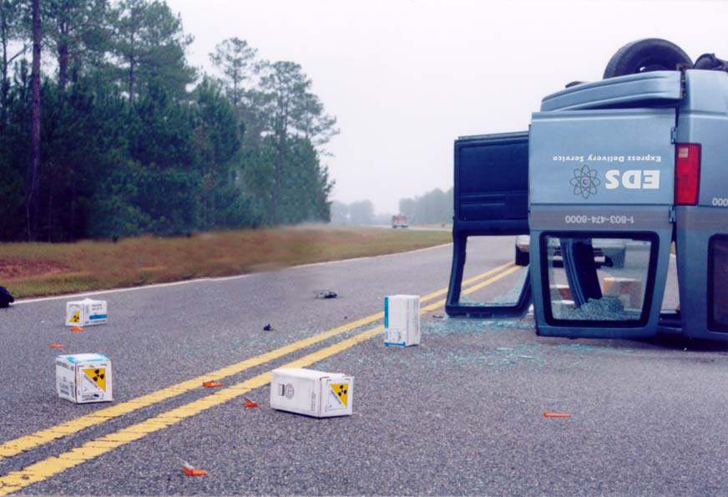
Suggested Props:
You may decide to use signs, flags, and/or traffic cones as “props” in lieu of an actual vehicle, based on your budget and logistical considerations.
- Delivery Van
- Container/package to simulate case for density device
- Shipping papers, markings, labels, placards, and the Emergency Response Guidebook Guide 163, are provided in Appendix E. (Note: Radiological data is in Appendix G.)
- Five Type A packages are being used in this scenario. (One Yellow-III labeled package and four Yellow-II labeled packages). Two of the Type A packages have been crushed and are visible to the responder
- Role-player or mannequin (fatality) to simulate delivery van driver

Figure B.2 Accident Site Map

Overturned delivery van with deceased driver.

Ruptured Yellow 3 box (on left) and Yellow 2 on right with spilled radiologicalmaterial.

Unruptured boxes.

Appendix C: Controller and Evaluator Assignments
Table 1 - Controller and Evaluator Assignments (delete those that do not apply)
Name | Role | Position
Dispatch Centers
TBD | Controller | Dispatch
Simulation Cell (SimCell)
TBD | Controller | Shipper Emergency Contact
TBD | Controller | Non-Participating Agencies
Field Site
TBD | Controller/Evaluator | Exercise Director
TBD | Controller/Evaluator | Senior Controller
TBD | Controller | Safety Controller
TBD | Controller/Evaluator | Incident Command Controller
TBD | Evaluator | Incident Command Evaluation
TBD | Controller/Evaluator | Radiation Authority, DOE RAP Team &/or CST Controller
TBD | Controller | Survey Teams
TBD | Controller | Survey Teams
TBD | Controller | EMS Controller
TBD | Controller/Evaluator | Decontamination Operations
TBD | Controller | Observer, VIPs
TBD | Controller/Evaluator | WMD/HazMat Response and Decontamination
TBD | Controller/Evaluator | Public Safety, Law Enforcement and Security Response
TBD | Controller/Evaluator | Public Information Officers

Appendix D: Activity Log

Controller/Evaluator Name:

Location:

Observation Area:

Date:

TIME | ACTIVITY
Continue on reverse side

TIME | ACTIVITY

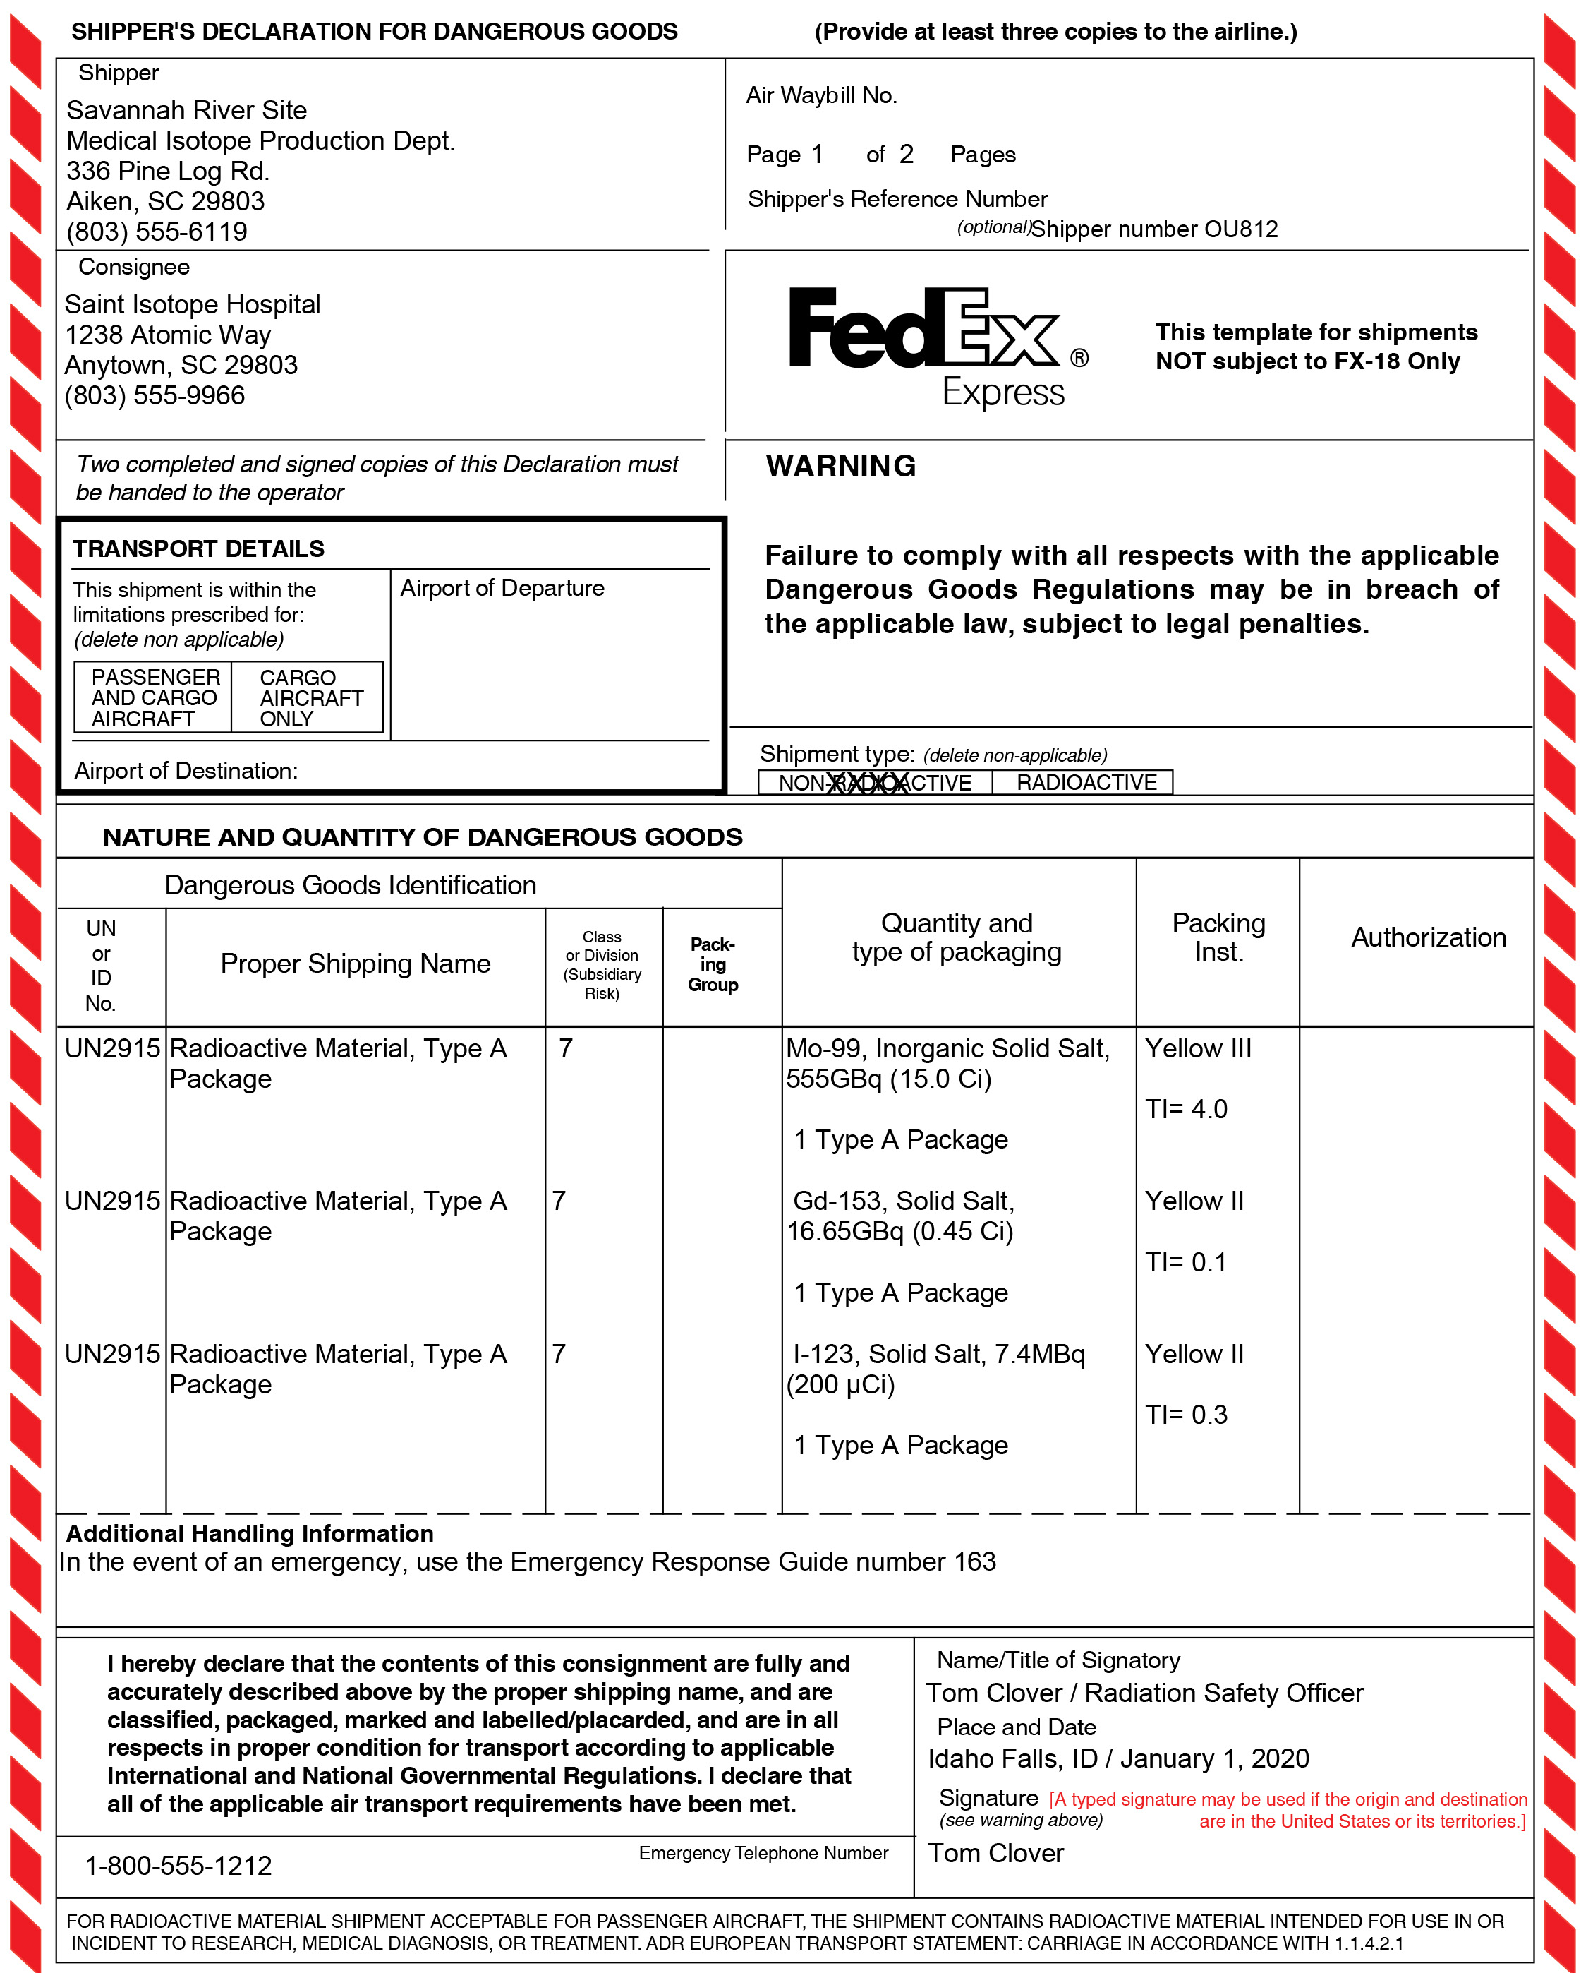
Appendix E: Shipping Papers

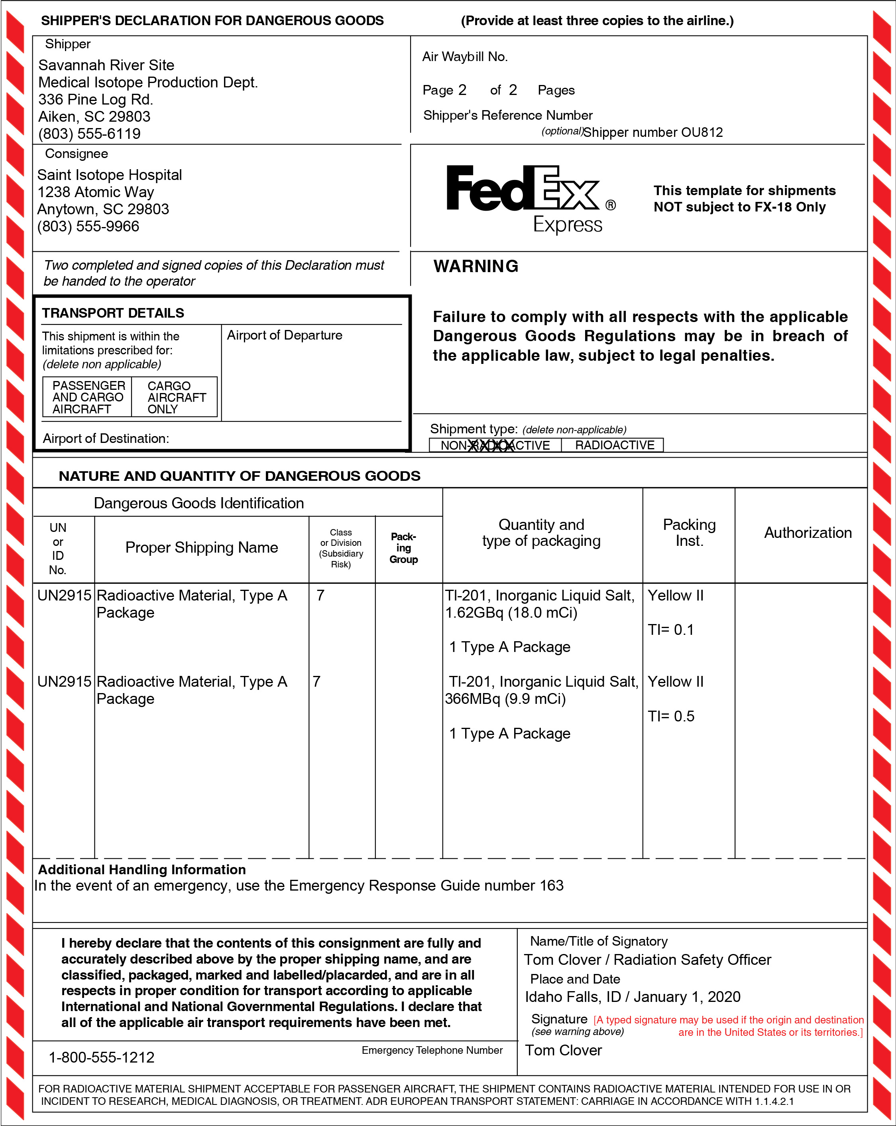

Appendix F: Emergency Response Guidebook-Guide 163

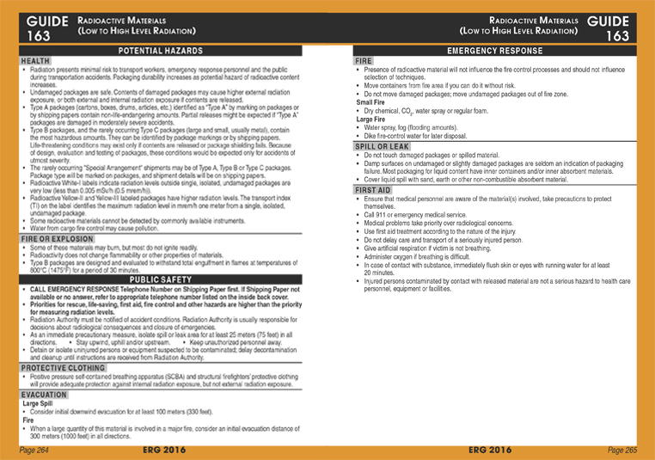
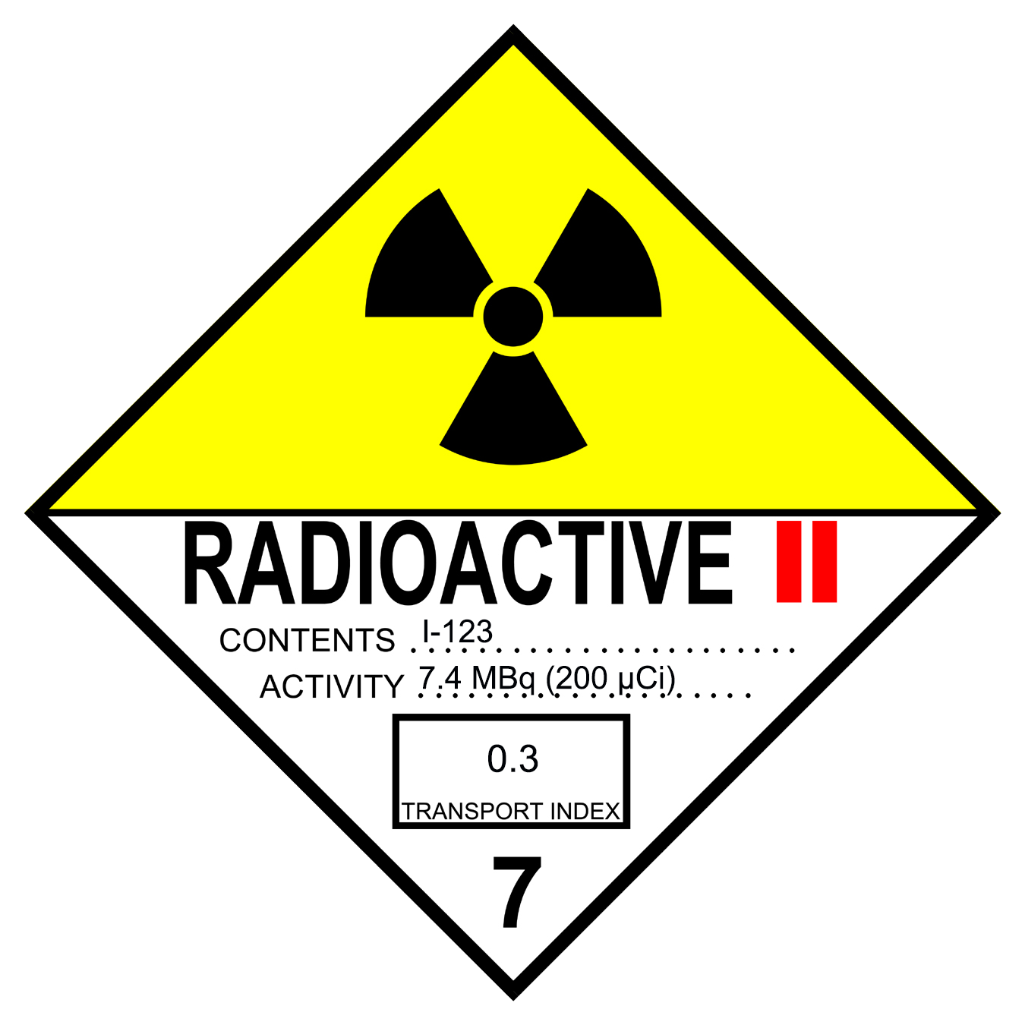
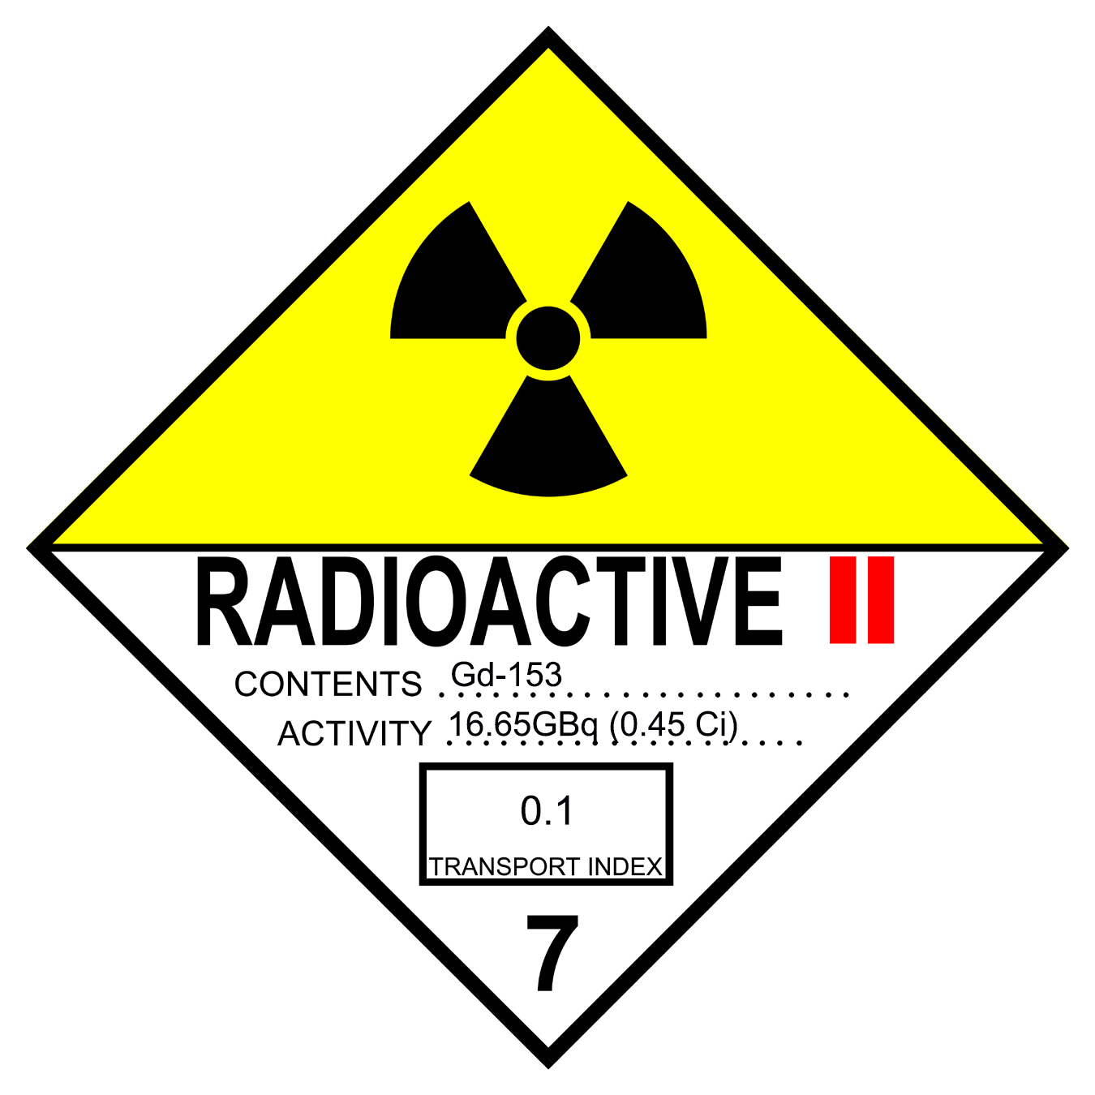
Appendix G: Package Labels

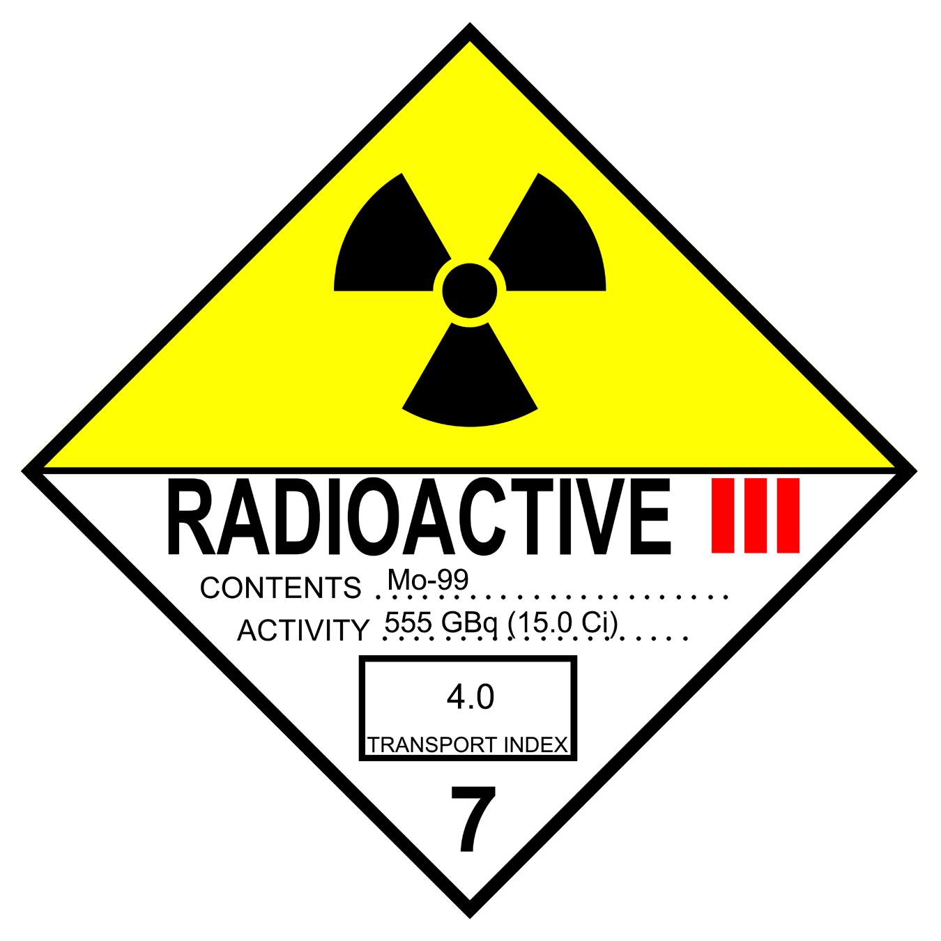
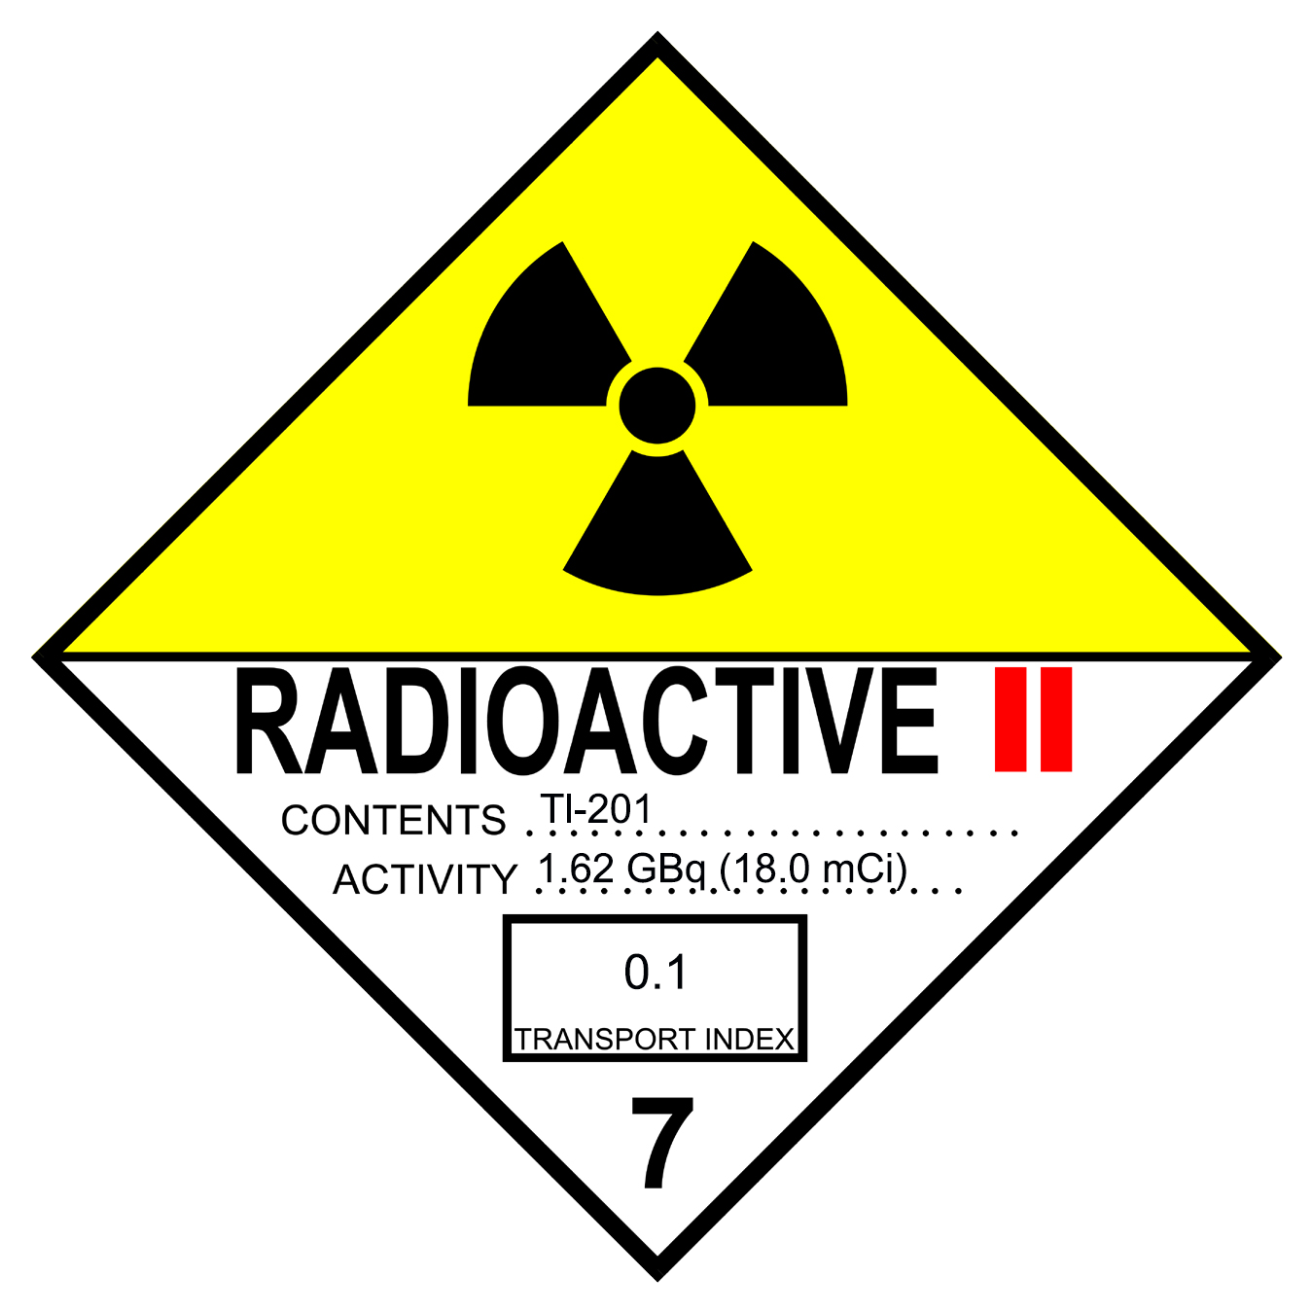
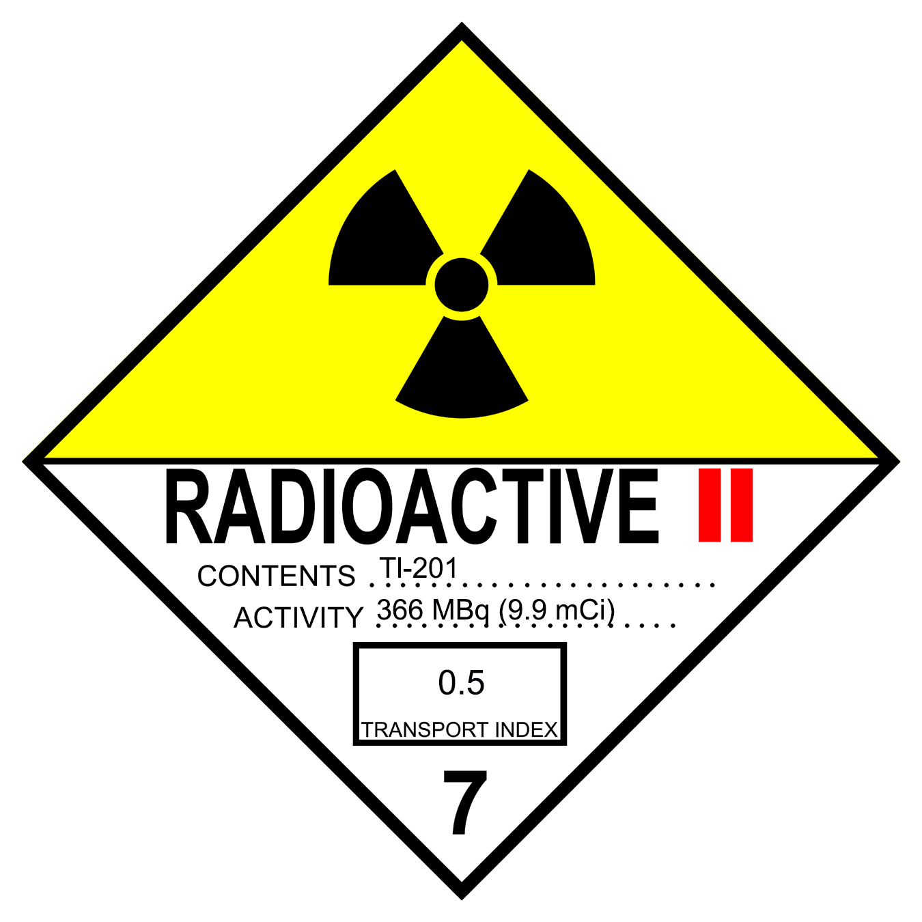


Appendix H: Package Marking

Appendix I: Master Scenario Events List & Injects
Preface
The purpose of publishing the Master Scenario Events List (MSEL) Package is to provide central exercise control team members a complete edition of the MSEL. This document is not intended to be distributed in full to field controllers, but rather they should receive those portions for which they are responsible as handouts. This would include the summary listing as well as any detailed inject forms that they will be delivering to players. Core control team members, primarily located at a Control Cell, may use this document to track exercise play, manage simulation cell (SIMCELL) functions, and maintain the situational awareness for the Exercise Director. Evaluators may also reference individual pieces of the document through teamwork with the controllers.
Exercises are the culmination of training toward a higher level of preparedness. This document was produced with the help, advice, and assistance of planning team members from various departments and agencies. As such, this document is tangible evidence of the public safety partnership in response to the threat or act of terrorism.
The information in this document is current as of the date of publication and is subject to change as dictated by the Exercise Planning Team.
This MSEL contains information about the events of the exercise and should be safeguarded from disclosure before and during the exercise. Only designated controllers should have access to this handout.

Master Scenario Events List (Summary)
Event  # | Event Time | Expected Action | Responsible Controller(s) | Recipient Player(s) | Expected Outcome  of Player Action
01 | -01:00 | Simulations ready (e.g., mannequin for deceased driver, shipping papers in the delivery truck, Controllers in place, and communications checks conducted.) |  | NA | NA
02 | -00:30 | Brief all controllers/evaluators on planned exercise activities (briefing should review all response agencies, including dispatch, law enforcement, fire, EMS and the radiation response team). Complete prop scene set-up in the field. |  | All | NA
03  Inject Msg.1 | 00:00 | Implement Message 1, which starts the exercise. Simulated vehicle accident occurs. A motorist calls (actual or simulated) the emergency communication center (e.g., 911 or controller informs IC) and reports accident/scene conditions.  “This is ____________________. I am on ___________ at the intersection with __________________, and there has been a wreck. A delivery van rolled over. You had better get help out here fast.” |  | Dispatcher | Police, Fire and EMS dispatched to scene.
04  Inject Msg. 2 | 00:01 | Implement Message 2 if the dispatcher fails to complete initial emergency response notifications.  “For the purpose of this exercise, you are directed to dispatch the following emergency response units to the incident scene” (list only the applicable units that have not already been dispatched, as shown below):  - Fire Department  - Law Enforcement  - Emergency Medical Service |  | Dispatch | Dispatching mistakes are corrected if they occur
MSEL Continued
Event  # | Event Time | Expected Action | Responsible Controller(s) | Recipient Player(s) | Expected Outcome  of Player Action
05  Inject Msg. 3 | 00:08 | Incident Command Post established and accident scene size-up/hazards assessment conducted by IC. Law Enforcement, EMS and Mutual Aid responders begin arriving at the scene. Issue Contingency Message 5 only if adequate props are not available on the day of the exercise.  Message only if needed: “Three packages with radioactive labels have been ejected from the truck and using your binoculars you see that some are broken open. One delivery van has rolled over on its side, and the cab of the vehicle is badly crushed. You can tell one person is in the vehicle but does not appear to be moving.” |  | IC | Use binoculars to size-up incident scene.
06 | 00:12 | IC conducts responder briefing on entry objectives. |  | IC | Entry teams are assigned to begin rescue and treatment of injured passengers.
MSEL Continued
Event  # | Event Time | Expected Action | Responsible Controller(s) | Recipient Player(s) | Expected Outcome  of Player Action
07  Inject Msg. 4 | 00:25 | If the IC fails to conduct an adequate size-up (i.e., fails to observe placards and labels, etc., and/or request hazmat assistance), then input Contingency Message 4.  Issue only the applicable portions of the message below:  - For the purpose of this exercise, you are directed to retrieve the shipping document information from the truck.  - You are directed to observe package markings, labels, and placards and assess the hazard.  - You are also directed to determine if available resources are adequate for thorough site assessment and site control. If responders have not discussed or considered additional resources, prompt them to discuss the need for and request the following assistance:  - Request the Hazardous Materials Team  - Request the State Radiation Authority |  | IC | Obtain shipping papers from truck and determine hazards. Request hazmat team, radiation authority, and other assistance as needed.

Event  # | Event Time | Expected Action | Responsible Controller(s) | Recipient Player(s) | Expected Outcome  of Player Action
8  Inject Msg. 5 | 00:27 | IC completes an additional accident scene assessment and determines if additional resources are needed. An incident response strategy is developed and additional resources are requested. The IC should telephone the 24-hour emergency contact number for the Shipper as indicated on the shipping papers (or if shipper needs to be simulated). Controllers should input the applicable portions of Contingency Message 5 below.  PART 1: Issue this portion to the IC if the IC does not call the shipper directly from the Command Post or ask the dispatcher to contact the shipper within a reasonable amount of time, or if the dispatcher has been asked to contact the shipper but has not done so in a reasonable amount of time. “For the purpose of this exercise, you are directed to contact the shipper using the emergency response number (as listed on shipping documents).  PART 2: Issue this portion of the message if action is taken by the IC or dispatcher to contact the shipper, but the shipper is not playing or being simulated by a role player. “The radioactive material is Tl-201, a radiopharmaceutical, UN 2915, emergency response guide 163. Cordon off the area, isolate the area 75 feet in all directions, have response personnel remain upwind, and do not try to clean up the site. Remain outside of the area of release.  The state Radiation Authority has been deployed and should arrive within 2 hours.”  PART 3: Issue this portion of the message if the dispatcher contacts the shipper (actual or role player) but the dispatcher does not relay technical information back to the IC. “For the purpose of this exercise, you are directed to contact the IC and relay technical information provided to you by the shipper.” |  | IC | Contact shipper to obtain additional information about hazard.
9 | 00:27 | Site security established. |  | LE | Establish roadblocks.
10 | 00:30 | Contamination control zones established by first responders. |  | FD | Establish hot zone 75’ from hazard based on ERG guidance.
11  Rad Data Inject | 00:42 | Accident scene emergency response actions are complete. Scene is secured and entry teams are segregated by IC, awaiting radiation authority response and surveys.  See Rad Data Map for Injects |  | FD | As FD personnel run out of air, mitigate with APRs or bottle-change, etc., until decon corridor operations are established.

MSEL Continued
Event  # | Event Time | Expected Action | Responsible Controller(s) | Recipient Player(s) | Expected Outcome  of Player Action
11  Rad Data Inject | 00:42 | Accident scene emergency response actions are complete. Scene is secured and entry teams are segregated by IC, awaiting radiation authority response and surveys.  See Rad Data Map for Injects |  | FD | As FD personnel run out of air, mitigate with APRs or bottle-change, etc., until decon corridor operations are established.
12  Inject  Msg. 6 | 00:43 | Hazardous Material Team arrives at accident scene. If the team is not briefed by the IC and integrated into the CP within 10 minutes, issue Contingency Message 6C.  “For the purpose of the exercise being conducted today, you are directed to give the members of the Hazardous Materials Response Team a briefing and then integrate them into the response activities.” |  | Hazmat | Team briefed by IC.
13 | 00:55 | Incident Commander appoints Public Information Officer. |  | PIO | Media briefing area established. PIO receives briefing from IC.
14 | 00:57 | Law Enforcement establishes perimeter around accident scene. |  | LE | Use evacuation distances from procedures or DHS guidelines.
15 | 01:00 | HazMat Team performs surveys of responders. |  | Hazmat | Contaminated responders sent to decon station as needed.

Event  # | Event Time | Expected Action | Responsible Controller(s) | Recipient Player(s) | Expected Outcome  of Player Action
16 | 01:20 | Public/Media inquiries initiated. |  | Media | All info provided to media must first be vetted by IC.
17 | 01:30 | State Radiation Authority arrives, briefing occurs, and Incident Commander integrates State Radiation into IC and scene operations. |  | State Radiation Authority | State Radiation Authority provides advice and assistance with surveys, decontamination, recovery planning
18  Rad Data Inject | 02:00 | Hazmat and State Radiation Authority Teams perform surveys at accident scene. |  | Hazmat and State Rad Authority | Scene survey map should be completed.
19 | 02:45 | PIO staff conducts press briefing |  | Media / PIOs | Information should be provided in a way public can properly understand situation and hazards, without speculation.
20 | 03:00 | Recovery activities are coordinated with IC, State RA, and other response teams. |  | IC, State RA | Information from Shipper may be simulated during recovery planning

Event  # | Event Time | Expected Action | Responsible Controller(s) | Recipient Player(s) | Expected Outcome  of Player Action
22  Inject Msgs. 7A and B | As needed | If exercise is placed on hold, input Message 7A. Input 7B to restart exercise after hold.  Part A: “Attention all personnel. Attention all personnel. The exercise has been suspended. All personnel are to remain in their current location. Emergency Responders are not to discuss exercise activities during this suspension. Stand by for further instruction regarding exercise activities.”  Part B: Message: “Attention all personnel. Attention all personnel. Exercise activities will resume in 5 minutes. The exercise controllers will provide information to players prior to continuing the exercise.” |  | Approp. participants | Ensures holds are implemented consistently and prevents player discussions during hold periods.
23  Inject Msg. 8 | 04:00 | Exercise Termination announcements to all agencies. Input Message 8.  “The exercise is now terminated. Please make all necessary termination notifications. An exercise debriefing will be conducted at _________________ at _____ (time).” (Repeat Message) |  | All participants | Pack up equipment and report to debriefing area for lunch and hot-wash.

Master Scenario Events List (Expanded)
This section provides inject messages to be used during the exercise to ensure continuity of play. The Lead Controller will direct the distribution of each inject message as the exercise develops. Each inject message provides critical scenario data that ensure the exercise flow is maintained or interrupted as directed by the Lead Controller.
MESSAGE 1
Initial Notification Call
TO: 911 Dispatcher
FROM: Motorist (Player)
TIME: (00:00)

NOTE: Call in this message via cell phone upon Lead Controller authorization to commence the exercise. This message provides a “bystander” eyewitness notification of the accident. This message will initiate exercise play.

THIS IS AN EXERCISE. DO NOT initiate actions affecting safe operations.
Message:
- This is ____________________. I am on _________________ at the intersection with ____________, and there has been a wreck.
- At delivery van rolled over and is badly damaged.
- It looks like someone is in the van who is not moving.
- I don’t see any smoke or fire.
- You had better get help out here fast.

THIS IS AN EXERCISE. DO NOT initiate actions affecting safe operations.

Expected Actions:
- Dispatch units to scene.
Expected Outcome:
- Fire, EMS and Law Enforcement dispatched to accident scene.
Notes:

MESSAGE 2 (CONTINGENCY MESSAGE)
Initial Dispatch of Units to Scene 1
TO: Emergency Response Network Dispatcher
FROM: Dispatch Controller(s)
TIME: (00:00)

NOTE: Issue this message with concurrence of the Exercise Director and/or Senior Field Controller if no actions have been or are being taken to dispatch emergency units (i.e., police, fire department, or EMS) to the incident scene.

THIS IS AN EXERCISE. DO NOT initiate actions affecting safe operations.
Message:
“For the purpose of this exercise, you are directed to dispatch the following emergency response units to the incident scene” (list only the applicable units that have not already been dispatched, as shown below):
- Fire Department
- Law Enforcement
- Emergency Medical Service

NOTE TO DISPATCHERS: If responders request wind direction, provide actual wind speed, humidity, stability class and other meteorological information based on current conditions. With approval from the exercise director, you may also indicate that rain is in the forecast within a few hours.

THIS IS AN EXERCISE. DO NOT initiate actions affecting safe operations.

Expected Actions:
- Dispatch errors are corrected.
Expected Outcome:
- Fire, EMS and Law Enforcement dispatched to accident scene.

Notes:
MESSAGE 3 (CONTINGENCY MESSAGE)
Responder Arrival to Scene, Initial Condition Assessment
TO: Responders at the Scene
FROM: Incident Scene 1 Controllers
TIME: (00:08)

NOTE: This message serves to provide players with a description of simulated incident conditions. The fire department should be first to arrive. Within 5 minutes, the remaining first responding units should arrive and be briefed. Information within this message will only be relayed to responders positioned within line of site of the specified conditions and if adequate props are not available. Use the map in Appendix B if it does not give away unearned information to players and if it helps describe the props available or the absence of props, as applicable.

THIS IS AN EXERCISE. DO NOT initiate actions affecting safe operations.
Message:

For the purpose of the exercise the following information is to be provided to responders within line of site:
- Three packages with radioactive labels have been ejected from the truck and using your binoculars you see that some are broken open.
- One delivery van has rolled over on its side, and the cab of the vehicle is badly crushed.
You can tell one person is in the vehicle but does not appear to be moving.
THIS IS AN EXERCISE. DO NOT initiate actions affecting safe operations.

Expected Actions:
- Use binoculars to conduct scene size-up.

Expected Outcome:
- Determine hazards and brief entry teams and other responders.

Notes:
MESSAGE 4 (CONTINGENCY MESSAGE)
Hazard Assessment
TO: Incident Commander
FROM: Lead Controller
TIME: (00:25)

NOTE: This message is to be given if play stalls during the hazard assessment phase. This message may be used to prompt the players to proceed with the exercise. Issue only those portions of the message that are appropriate (i.e., have not been considered or begun).

THIS IS AN EXERCISE. DO NOT initiate actions affecting safe operations.
Message:
Issue only the applicable portions of the message below:
- For the purpose of this exercise, you are directed to retrieve the shipping document information from the truck.
- You are directed to observe package markings, labels, and placards and use the information for hazard assessment purposes.
- You are also directed to determine if available resources are adequate for thorough site assessment and site control. If responders have not discussed or considered additional resources, prompt them to discuss the need for and request the following assistance:
  - Request the Hazardous Materials Team
  - Request the State Radiation Authority

THIS IS AN EXERCISE. DO NOT initiate actions affecting safe operations.

Expected Actions:
- Obtain shipping papers from truck and obtain hazard information. Request appropriate resources.
Expected Outcome:
- Obtain shipping papers, request hazmat team and State Radiation Authority

Notes:

MESSAGE 5 (CONTINGENCY MESSAGE)
Shipper Information
TO: Emergency Network Dispatcher or Incident Commander (as applicable)
FROM: Dispatcher Controller or Lead Controller (as applicable)
TIME: (00:27)

NOTE: This message serves to ensure that technical information from the shipper is received by the Incident Commander. Issue the applicable portion(s) of this message as described in italics below.
THIS IS AN EXERCISE. DO NOT initiate actions affecting safe operations.
Message PART 1: Issue this portion to the IC or dispatcher, as applicable, if the IC does not call the shipper directly from the Command Post or ask the dispatcher to contact the shipper within a reasonable amount of time, or if the dispatcher has been asked to contact the shipper but has not done so in a reasonable amount of time. “For the purpose of this exercise, you are directed to contact the shipper using the emergency response number (as listed on shipping documents or as provided to the IC).”
Message PART 2: Issue this portion of the message if action is taken by the IC or dispatcher to contact the shipper, but the shipper is not playing or being simulated by a role player. “The radioactive material is Tl-201, a radiopharmaceutical, UN 2915, emergency response guide 163. Cordon off the area, isolate the area 75 feet in all directions, have response personnel remain upwind, and do not try to clean up the site. Remain outside of the area of release.”
Message PART 3: Issue this portion of the message if the dispatcher contacts the shipper (actual or role player) but the dispatcher does not relay technical information back to the IC in a reasonable time. “For the purpose of this exercise, you are directed to contact the IC and relay the technical information provided to you by the shipper.”
CONTROLLER NOTE: The following note only applies to the controller who is role-playing the shipper. Information should only be released if the IC, dispatcher, or another player requests the information from the shipper through the emergency telephone number contact.
THIS IS AN EXERCISE. DO NOT initiate actions affecting safe operations.

Expected Actions and Outcome:
- Contact shipper using emergency contact number and obtain additional information about hazard and appropriate response actions.
MESSAGE 6
Radiological Data Inject
TO: Survey Teams
FROM: Survey Teams Controller
TIME: (00:42)

NOTE: The purpose of this message is to ensure survey teams are given data for survey readings, if taken. There will be five Type A packages in the back of the vehicle. All five packages will be ejected from the vehicle and two of them will be damaged and the inner containers will be located outside the damaged packages. The inner packages will not be breached.

THIS IS AN EXERCISE. DO NOT initiate actions affecting safe operations.
Message:

Provide responders taking radiological surveys with appropriate data from the

THIS IS AN EXERCISE. DO NOT initiate actions affecting safe operations.

Expected Actions:
- Report accurate radiological survey data to the IC.

Expected Outcome:
- Inform hazmat team of hazards, to minimize time in scene as much as possible, to report back additional information about hazard as they perform duties, to take efforts to minimize contamination, and to report to decon corridor when mission is complete.

Notes:
MESSAGE 7 (CONTINGENCY MESSAGE)
Response Team Briefing with the Incident Commander
TO: Incident Commander
FROM: Lead Controller
TIME: (00:43)

NOTE: The purpose of this message is to ensure the Hazardous Materials Response Team is integrated into the Incident Command System after their arrival. This message will be used to prompt the IC to give a situation briefing to the Hazardous Materials Response Team if the IC does not initiate this action within approximately 10 minutes of Hazardous Materials Response Team arrival.

THIS IS AN EXERCISE. DO NOT initiate actions affecting safe operations.
Message:
Issue this portion of the message ONLY if the Hazardous Materials Response Team has been at the Command Post for approximately 10 minutes and the Incident Commander has not shown any initiative to provide the team with a briefing and integrate them into the response activities: “For the purpose of the exercise being conducted today, you are directed to give the members of the Hazardous Materials Response Team a briefing and then integrate them into the response activities.”
THIS IS AN EXERCISE. DO NOT initiate actions affecting safe operations.

Expected Actions:
- Brief hazmat team.
Expected Outcome:

- Inform hazmat team of hazards, to minimize time in scene as much as possible, to report back additional information about hazard as they perform duties, to take efforts to minimize contamination, and to report to decon corridor when mission is complete.

Notes:
MESSAGE 8A
Hold Message 1
TO: All Players
FROM: Lead Controller
TIME: Upon Suspension of Exercise Play

NOTE: DO NOT issue this message without authorization from the Lead Controller. Continuation of the exercise play will occur upon coordination and concurrence between the Lead Controller and the Field Controllers. Exercise play will resume at the direction of the Lead Controller approximately 5 minutes after message 8b is issued.

THIS IS AN EXERCISE. DO NOT initiate actions affecting safe operations.
Message:
“Attention all personnel. Attention all personnel. The exercise has been suspended. All personnel are to remain in their current location. Emergency Responders are not to discuss exercise activities during this suspension. Stand by for further instruction regarding exercise activities.”

Make this announcement every 5 minutes.

THIS IS AN EXERCISE. DO NOT initiate actions affecting safe operations.

Expected Actions:
- Players put play on hold.

Expected Outcome:
- Players stop in unison.

Notes:
MESSAGE 8B
Hold Message 2
TO: All Players
FROM: Lead Controller
TIME: Upon Suspension of Exercise Play

NOTE: DO NOT issue this message without authorization from the Lead Controller. Continuation of the exercise play will occur upon coordination and concurrence between the Lead Controller and the Field Controllers. Exercise play will resume at the direction of the Lead Controller approximately 5 minutes after this message is issued. Controllers should use the 5 minutes prior to exercise continuation to remind players of what was occurring when play was suspended.

THIS IS AN EXERCISE. DO NOT initiate actions affecting safe operations.
Message:
“Attention all personnel. Attention all personnel. Exercise activities will resume in 5 minutes. The exercise controllers will provide information to players prior to continuing the exercise.”

THIS IS AN EXERCISE. DO NOT initiate actions affecting safe operations.

Expected Actions:
- Play resumes

Expected Outcome:
- Players start in unison

Notes:
MESSAGE 9
Termination Message
TO: All Key Players/Notification Locations
FROM: Lead Controller
TIME: (02:00)

NOTE: Ensure all participating agencies are notified of exercise termination via the notification system.

THIS IS AN EXERCISE. DO NOT initiate actions affecting safe operations.
Message:
“The TEPP Transportation Exercise is now terminated. Please make all necessary termination notifications. An exercise debriefing will be conducted ____________ (location) at ____________ (time). (Repeat Message)

THIS IS AN EXERCISE. DO NOT initiate actions affecting safe operations.

Expected Actions:
- Exercise is terminated

Expected Outcome:
- Players pack up equipment and report to National Guard Armory.

Notes:

Appendix J: Radiological Data
General Information
The controller should take notice of which type of detector/probe is attached to the responder’s instrument or the type of survey instrument used (radiation/contamination) as applicable. The controller should ask the responder (based upon which instrument or probe is used) how they would report their readings (i.e., in cpm or mR/hr). If a contamination survey instrument is used, readings should be requested and given in counts per minute. If a radiation survey instrument is used, the readings should be requested and given in mR/hr. Responders should realize that direct readings for contamination cannot be taken near or on the package because of the radiation penetrating through the packages. Contamination surveys should be taken by wiping or smearing the package and then checking each wipe for contamination in a low background area (i.e., away from the package).
Controllers can use a set of meter face cards showing various instrument readings, or provide indications of where the needle is located, or provide the actual instrument reading, depending on the directions from the Scene Senior Controller. Whatever method is chosen; the goal is to ensure responders know how to determine the actual instrument reading. Responders will be asked to tell the controller the reading on the card. Controllers will only give/confirm radiological data to responders if and when they use their survey equipment properly. For instance, if responders do not turn their equipment on, or are not on the proper scale, controllers should indicate to them that their instruments are reading zero/off-scale as appropriate. Controllers should take note of whether responders use their equipment properly (i.e., are instruments turned on and on the proper scale) but should not prompt them to do so.
Scene Description
There will be five Type A packages in the back of the vehicle. All five packages will be ejected from the vehicle and two of them will be damaged and the inner containers will be located outside the damaged packages. The inner packages will not be breached.
Radiation/Contamination Data
The five packages will be scattered about in close proximity to one another as shown on the following page. If/when radiological monitoring surveys are performed (by the first responding unit(s) or the Hazardous Materials Response Team) the following radiation/contamination levels will be found:
In close proximity to the packages, if a contamination survey instrument is used to directly survey the road surface, personnel will detect between 300 and 4,000 cpm (this will be due to elevated background readings from the packages, not contamination). These readings will increase dramatically as responders get closer to the packages.
Readings taken on contact with the undamaged Yellow-II labeled packages will be 100,000 to 180,000 cpm or 25 to 45 mR/hr (depending upon which probe/type of instrument the responder uses).

Readings taken on contact with the Yellow-III labeled package will be 200,000 to 400,000 cpm or 50 to 100 mR/hr (depending upon which probe/type of instrument the responder uses).
Readings taken on contact with the inner containers will be 200,000 to 400,000 cpm or 50 to 100 mR/hr (depending upon which probe/type of instrument the responder uses).
If the responder takes open/closed window readings (if applicable), there will be no difference between the open window and closed window readings.
If the road surface or any of the packages or inner containers are smeared for contamination and smears are checked in a low background area, no contamination will be found. Controllers should only give the above radiological data to players if and when they use their survey equipment properly. For instance, if players do not turn their equipment on, or are not on the proper scale, controllers should indicate to them that their instruments are reading zero/off-scale as appropriate. Controllers should take note of whether players use their equipment properly (i.e., are instruments turned on and on the proper scale) but should not prompt them to do so.

Radiological Data Map

Median

Ruptured Yellow III (left) and Yellow II (right) boxes and spilled radiological material.


Unruptured boxes.

Legend:
= 2 mR/hr

Contamination Readings, BG to 400,000 cpm

In close proximity to the packages, if a contamination survey instrument is used to directly survey the road surface, personnel will detect between 300 and 4,000 cpm (this will be due to elevated background readings from the packages, not contamination). These readings will increase dramatically as responders get closer to the packages.
Readings taken on contact with the undamaged Yellow-II labeled packages will be 100,000 to 180,000 cpm or 25 to 45 mR/hr (depending upon which probe/type of instrument the responder uses).
Readings taken on contact with the Yellow-III labeled package will be 200,000 to 400,000 cpm or 50 to 100 mR/hr (depending upon which probe/type of instrument the responder uses).
Readings taken on contact with the inner containers will be 200,000 to 400,000 cpm or 50 to 100 mR/hr (depending upon which probe/type of instrument the responder uses).
Radiation Reading for Responder Approach
Distance | Radiological Readings cpm  (contamination survey instrument) | Radiological Readings mR/hr  (radiation survey instrument)
30-20 feet | Background to 300 cpm | Background to ~ 500 millirem
15 feet | Background to ~1000 cpm | ~1 mR/hr
10 feet | ~1000 cpm to ~2000 cpm | 2 mR/hr
Contact with Yellow II packages | ~100,000 to ~180,000 cpm | ~25 to ~45 mR/hr
Contact with Yellow III packages | ~200,000 to ~400,000 cpm | ~50 to ~100 mR/hr
Contact with inner containers | ~200,000 to ~400,000 cpm | ~50 to ~100 mR/hr
Smear results on packages and containers | Background | Background (should not be using radiation survey instrument to check smears)

Note 1: All contamination readings are βγ (beta gamma) only. No alpha is present.
Note 2: Two of the walking wounded will become contaminated by coming into contact with the spill, and contamination will be tracked throughout the hot zone and to the location where they are directed to wait for treatment. One contaminated victim will attempt to assist two immobile victims, and thereby cross-contaminate them as well (contaminated victims are noted in the medical data section). Locations where contamination has been spread to are indicated by radiological symbols on the map above.
Note 3: If surveys are taken at the simulated manufacturing facility location, controllers should provide indications (10K to 20K cpm) that contamination has been tracked into the office, around the van where the bomb is located, and inside the van as well.

Appendix K: Signature Page
A copy of the completed Exercise Scenario and any final report will be filed by the host agency to document the planning and conduct of this exercise.

__________________________________________________________________
Exercise Coordinator

__________________________________________________________________
Name of Exercise Planner

__________________________________________________________________
Signature of Exercise Planner

__________________________________________________________________
Exercise Date

Listing of participating agencies provided copies of the exercise scenario and report:

• List all that apply here

Appendix L: Participant Feedback Form
Exercise Name: _______________________________ Exercise Date: ________________

Participant Name: ___________________________ Title: ___________________________

Agency: _________________________Role: __Player __Controller __Evaluator__Observer

Part I – Recommendations and Action Steps
- Based on the exercise today and the tasks identified, list the top 3 issues and/or areas that need improvement.

- Identify the action steps that should be taken to address the issues identified above. For each action step, indicate if it is a high, medium, or low priority.

- Describe the action steps that should be taken in your area of responsibility. Who should be assigned responsibility for each action item?

- List the equipment, training or plans/procedures that should be reviewed, revised, or developed. Indicate the priority level for each.

Part II – Exercise Design and Conduct

1. What is your assessment of the exercise design and conduct?
Please rate, on a scale of 1 to 5, your overall assessment of the exercise relative to the statements provided below, with 1 indicating strong disagreement with the statement and 5 indicating strong agreement.
 |  | Rating of Satisfaction with Exercise
 | Assessment Factor | Strongly Disagree |  |  |  | Strongly Agree
a. | The exercise was well structured and organized. | 1 | 2 | 3 | 4 | 5
b. | The exercise scenario was plausible and realistic. | 1 | 2 | 3 | 4 | 5
c. | The documentation used during the exercise was a valuable tool throughout the exercise. | 1 | 2 | 3 | 4 | 5
d. | Participation in the exercise was appropriate for someone in my position. | 1 | 2 | 3 | 4 | 5
e. | The participants included the right people in terms of level and mix of disciplines. | 1 | 2 | 3 | 4 | 5

2. What changes would you make to improve this exercise?
Please provide any recommendations on how this exercise or future exercises could be improved or enhanced.

Appendix M: Evaluation Plan
The Evaluation Plan (EVALPLAN) is designed to provide the essential information that you, as an evaluator, will need to successfully assist the controllers with coordinating and directing the exercise during play. Effective control and evaluation will provide immediate feedback, reinforce and validate training, and identify strengths, weaknesses, and opportunities for improved response.
Exercise information and materials should be given only to those people and organizations actually participating in the exercise. The EVALPLAN for this exercise is a restricted document intended for controllers’ and evaluators’ eyes only. Please ensure this document is safeguarded so players do not gain advance knowledge of specific exercise information.
General Information
The goal of exercise evaluation is to validate strengths and identify improvement opportunities for the participating organization(s). This is accomplished by:
- Observing the exercise and collecting supporting data
- Analyzing the data to compare performance against expected outcomes
- Determining what changes need to be made to the procedures, plans, staffing, equipment, communications, organizations, and interagency coordination to ensure expected outcomes.
The evaluation results should not be viewed by the participating agencies and jurisdictions as a “report card” that grades weakness, but as an opportunity to identify ways to build on strengths and improve capacity. Since jurisdictions are testing new and emerging plans, skills, resources, and relationships in response to a changed homeland security environment, every exercise can be expected to result in multiple findings and recommendations for improvement.
Exercise Evaluation Instructions

Exercise Evaluation
In accordance with Homeland Security Presidential Directive 8 (HSPD-8), the Homeland Security Exercise and Evaluation Program (HSEEP) each organization participating in Operation Name of Exercise will be evaluated using a capabilities and objectives analysis approach.
This analysis will involve assessing each organization’s ability to demonstrate its identified capability and objective during the exercise. As you conduct your analysis, you are to determine whether an organization performance of specific capability and objective was demonstrated sufficiently to meet the expected outcome.
Remember your analysis of strengths and improvement will assist each organizations management in developing future training plans, operating plans, budgets, and developing interagency and/or inter-jurisdictional agreements to maintain or improve existing operations.
Using Exercise Evaluation Guides (EEG)

Exercise Evaluation Guides
The primary tools you will use to document your observations are the Activity Log and the Exercise Evaluation Guides (EEG). The Activity Log is being used to document the time, organization, type of activity observed. A copy of the Activity Log is in Appendix C. EEGs will assist each evaluator by providing a consistent set of standards and guidelines for observation, data collection, analysis, and report writing. The EEGs that have been selected for this exercise are included in Appendix B. The EEGs are designed to streamline data collection; enable a thorough assessment of the exercising organizations capabilities and objectives; as well as support the development of the AAR/IP. Appendix A is the EEG Assignment List.
Use your assigned EEGs and Activity Log during the exercise to assist you in documenting exercise observation. Remember accurate and complete EEGs facilitate the creation of effective AAR/IPs. Be thorough in your documentation and as necessary explain in detail any observation that requires discussion about a strength or improvement recommendation.
You have been provided copies of three supporting plans for use during the exercise. The Exercise Plan documents the exercise scenario, the MSEL documents the events, and the Controller Evaluator handbook provides a listing of Controllers, Evaluators, inject messages and radiological data.
Remember Evaluators should not interfere with exercise play. However, it may be necessary for an evaluator to interact with players during the exercise if he or she has a question about something observed. Evaluators should not interrupt play to ask such questions but should wait until there is a break in activity. These questions must not prompt or lead players in any way, and conversation should remain brief and focused.
Player Hotwash
Immediately after the exercise, each evaluator will debrief the players and controllers in his/her observed discipline. Players will also be encouraged to participate in a self-assessment of their exercise play and provides a general assessment of how their organization performed in the exercise. You are encouraged to use the hotwash as an opportunity to clarify points or collect any missing information from players before they leave the exercise venue.
During the hotwash, the Lead Evaluators will distribute Participant Feedback Forms to obtain information on perceptions of the exercise, how well each player thought his/her unit performed, and how well the unit integrated performance with other agencies and other exercise components. Participant Feedback Forms will be collected at the end of the hot wash and reviewed by the evaluation team to augment existing information. Participant Feedback Forms will also be used to solicit general feedback on exercise quality to help implement improvements in future exercises. A summary of Participant Feedback Forms will be included as an appendix within an AAR/IP.
After Action Report Content
Following the hot wash, evaluators will review their notes of the discussion and begin to develop preliminary analyses of the exercise. Preliminary analyses involve developing a chronological narrative of relevant discussion for each capability as well as its associated activities, if possible. The evaluation team will jointly develop all required preliminary analyses. These narratives will highlight strengths and areas for improvement and identify discussion points relevant to each area of evaluation in the report.
Exercise Evaluation Guide Assignments
Table A.1 EEG Assignments
Name | Exercise Evaluation Guide
 | All EEGs
 | Operational Coordination
 | Operational Coordination
 | Public and Private Resources
 | Public and Private Resources
 | Public Health and Medical Services
 | Public Health and Medical Services
 | Public Health and Medical Services
 | Environmental Response/Health and Safety
 | Environmental Response/Health and Safety

Listed below are the Exercise Evaluation Guides (EEGs) to be used for this exercise, followed by the activity logs to be used to document player performance. Review the EEGs assigned to you in the Assignment List above, then review the EEGs you are responsible for prior to the exercise.
Table A.2 EEG Ratings Key
When determining how well a task/target is completed, the following rating key is used.
Ratings Key
P – Performed without Challenges
S – Performed with Some Challenges
M – Performed with Major Challenges
U – Unable to be Performed

Appendix N: Exercise Evaluation Guides
Operational Coordination (Onsite Incident Management)
Exercise Evaluation Guide: Operation Name of Exercise

Capability Description:
Onsite incident management is the capability to effectively direct and control incident management activities by using the Incident Command System (ICS) consistent with the National Incident Management System (NIMS).
Capability Outcome:
The incident is managed safely, effectively and efficiently through the integration of facilities, resources (personnel, equipment, supplies, and communications) and procedures using a common organizational structure that is ICS.
Jurisdiction or Organization: | Name of Exercise:
Location: | Date:
Evaluator: | Evaluator Contact Info:
Note to Exercise Evaluators: Only review those activities listed below to which you have been assigned.

Activity 1: Implement Operational Coordination
Activity Description: In response to an incident, arrive on scene and provide initial scene report while beginning response operations; carry out management, planning, and coordination of on-site incident.
Tasks Observed (check those that were observed and provide comments)
Note: Asterisks (*) denote Performance Measures and Performance Indicators associated with a task. Please record the observed indicator for each measure
 | Task /Observation Keys | Time of Observation/ Task Completion
1.1 | First arriving unit provides initial on-scene report.  - Description of the incident  - Determine the need for specialized resources (haz mat team, state radiation authority, DOE RAP)  - Initial actions being taken  - Number of injured recorded  - Nature and quantity of additional resources required  - - Notify hospital of possibly radiologically contaminated patients | Time:  Task Completed? (see Table A.2)  P [ ] S [ ] M [ ] U [ ]
 | Time initial incident conditions are reported to responding units | TARGET  Within 5 minutes | ACTUAL
1.2 | Initiate and implement Incident Command System (ICS).  - Establishment of command is communicated to responding units  - Command post is established and the location is communicated to responding units and Dispatch Center | Time:  Task Completed? (see Table A.2)  P [ ] S [ ] M [ ] U [ ]
 | Upon notification, time needed to establish on-site incident command | TARGET  5 minutes | ACTUAL
1.3 | First arriving unit initiates:  - Establish and secure initial perimeter  - Establish exclusion zone (hot zone)  - Stand-off distance is appropriate to hazard  - Responding units are made aware of hazard(s)  - Firefighting operations  - Victim identification and rescue  - Entry teams retrieve the shipping papers  - Hazardous materials team response (radioactive material) | Time:  Task Completed? (see Table A.2)  P [ ] S [ ] M [ ] U [ ]
 | Upon arrival, time needed to establish on-scene security | Time
1.4 | Transfer command, as appropriate.  - Information is shared between oncoming and outgoing Incident Commander  - Command transfer is acknowledged and communicated | Time:  Task Completed? (see Table A.2)  P [ ] S [ ] M [ ] U [ ]

Activity 2: Establish Full Operational Coordination
Activity Description: Establish staff and facilities necessary to conduct on-site incident command.
Tasks Observed (check those that were observed and provide comments)
Note: Asterisks (*) denote Performance Measures and Performance Indicators associated with a task. Please record the observed indicator for each measure
 | Task /Observation Keys | Time of Observation/ Task Completion
2.1 | Establish the command structure to manage the incident and meet objectives.  - Command staff: Incident Commander, Safety Officer, Liaison Officer, Public Information Officer (PIO)  - General staff: Operations, Planning, Logistics, Finance/Administration sections | Time:  Task Completed? (see Table A.2)  P [ ] S [ ] M [ ] U [ ]
 | Establishment of Command and General Staff based upon incident requirements and available personnel | Yes [ ] No [ ]
2.2 | Transition from IC to Unified Command (UC) for incidents involving multiple jurisdictions, a single jurisdiction with multi-agency involvement, or multiple jurisdictions with multi-agency involvement.  - UC should quickly designate an operations chief  - Includes all agencies with jurisdictional or functional responsibility  - Appropriate, decision-making personnel from each agency are present at the command post  - Objectives, strategies, plans, and priorities are jointly determined by all individuals who make up UC | Time:  Task Completed? (see Table A.2)  P [ ] S [ ] M [ ] U [ ]
2.3 | Establish communications with emergency operations center multi-agency coordinating center (EOC/MACC), dispatch center, and responding units.  - Verify availability of interoperable communications between all responding units  - Identify and confirm backup communications systems | Time:  Task Completed? (see Table A.2)  P [ ] S [ ] M [ ] U [ ]
2.4 | Establish an Incident Command Post (ICP), incident bases, camps, staging areas, helistop or helibase, and other facilities as required.  - All facilities should be located in a safe area but in the vicinity of incident scene  - Staging area is of sufficient size and has easy ingress/egress for oversize/overweight vehicles  - IC is able to maintain communications with remote facilities  - Communicate locations to all responding and operating personnel | Time:  Task Completed? (see Table A.2)  P [ ] S [ ] M [ ] U [ ]
2.5 | Establish communications and coordinate operations with emergency response specialty teams (e.g., State Radiation Authority, SWAT/tactical, Bomb Squad/Explosives, HAZMAT, urban SAR).  - IC coordinates with Specialty Team Leader to ensure adequate resources, scene safety, communications, etc. | Time:  Task Completed? (see Table A.2)  P [ ] S [ ] M [ ] U [ ]
Activity 3: Resource Management
Activity Description: Establish system to order, track, manage and deploy all resources required for effective incident command management.
Tasks Observed (check those that were observed and provide comments)
Note: Asterisks (*) denote Performance Measures and Performance Indicators associated with a task. Please record the observed indicator for each measure
 | Task /Observation Keys | Time of Observation/ Task Completion
3.1 | Establish processes to order, track, assign, and release incident resources.  - Resources (people, personnel, equipment, and supplies) are tracked and managed within IC/UC  - Staging area is used to manage resources not needed or awaiting assignment on-site  - Resources are released and returned to service when no longer needed | Time:  Task Completed? (see Table A.2)  P [ ] S [ ] M [ ] U [ ]
3.2 | Monitor/measure performance of assigned resources and request additional resources as needed.  - On-site resources are monitored and additional resources are requested, reassigned, or released (fatigue, resource in short supply, etc.)  - Resources are coordinated between EOC/MACC and IC/UC | Time:  Task Completed? (see Table A.2)  P [ ] S [ ] M [ ] U [ ]
 | Command shall identify additional resources requested | Yes [ ] No [ ]
3.3 | Request mutual aid through the dispatch center, EOC/MACC ordering process.  - IC/UC provides clear direction on resources needed by EOC/MACC group through the dispatch center, EOC, or MACC  - Resources requested using NIMS standardized kind and type  - State Radiation Authority  - DOE RAP Team  - Other resources outlined in the County or State EOP | Time:  Task Completed? (see Table A.2)  P [ ] S [ ] M [ ] U [ ]
3.4 | Coordinate with arriving regional, State, and Federal responders.  - IC integrates arriving first responders into the IC/UC structure  - IC integrates arriving state radiation authority, RAP or other response resources into the IC/UC structure  - Reliable communications are ensured  - Units directed to base area and dispatched to staging area as needed  - Resources are managed and tracked | Time:  Task Completed? (see Table A.2)  P [ ] S [ ] M [ ] U [ ]

Activity 4: Develop Incident Action Plan (IAP)
Activity Description: Develop all necessary components of the IAP and obtain approval.
Tasks Observed (check those that were observed and provide comments)
Note: Asterisks (*) denote Performance Measures and Performance Indicators associated with a task. Please record the observed indicator for each measure
 | Task /Observation Keys | Time of Observation/ Task Completion
4.1 | Establish incident objectives, priorities, and operational periods.  - Incident priorities: Life safety, incident stabilization, property conservation  - Update IAP as necessary  - Gather input from all responding agencies | Time:  Task Completed? (see Table A.2)  P [ ] S [ ] M [ ] U [ ]
 | Initial incident commander shall identify strategic and tactical objectives, which are communicated up and down through ICS
4.2 | Develop an IAP to establish priorities, procedures, and actions to be accomplished to meet the incident Objectives for each operational period. IAP is approved by IC/UC.  - IAP is communicated and implemented, | Time:  Task Completed? (see Table A.2)  P [ ] S [ ] M [ ] U [ ]

Activity 5: Execute Plan
Activity Description: Distribute IAP to response organizations for their assigned operations to achieve the desired incident objectives.
Tasks Observed (check those that were observed and provide comments)
Note: Asterisks (*) denote Performance Measures and Performance Indicators associated with a task. Please record the observed indicator for each measure
 | Task /Observation Keys | Time of Observation/ Task Completion
5.1 | Direct efforts to meet incident objectives.  - Review progress towards meeting incident objectives - situation reports  - Establish personnel accountability  - Develop mechanism(s) for controlling incident  - Have taken into consideration potential impacted areas  - Contact the shipper to discuss radiation and contamination concerns and solutions  - Review resource requirements and update IAP | Time:  Task Completed? (see Table A.2)  P [ ] S [ ] M [ ] U [ ]

Activity 6: Evaluate/Revise Plans
Activity Description: Evaluate and alter plans as necessary.
Tasks Observed (check those that were observed and provide comments)
Note: Asterisks (*) denote Performance Measures and Performance Indicators associated with a task. Please record the observed indicator for each measure
 | Task /Observation Keys | Time of Observation/ Task Completion
6.1 | Evaluate, revise, and prioritize tactics to meet incident objectives.  -IC/UC responds to a changing incident scene  - Weather is considered in planning process  - Communicate significant changes to command and general staff | Time:  Task Completed? (see Table A.2)  P [ ] S [ ] M [ ] U [ ]
 | UC/IC reviews the effectiveness of the IAP and revises, as necessary | Yes [ ] No [ ]

Operational Coordination
Operation Name of Exercise
Exercise Evaluation Guide Analysis Sheets
The purpose of this section is to provide a narrative of what was observed by the evaluator/evaluation team for inclusion within the draft After Action Report/Improvement Plan. This section includes a chronological summary of what occurred during the exercise for the observed activities. This section also requests the evaluator provide key observations (strengths or areas for improvement) to provide feedback to the exercise participants to support sharing of lessons learned and best practices as well as identification of corrective actions to improve overall preparedness.
Observations Summary
Write a general chronological narrative of responder actions based on your observations during the exercise. Provide an overview of what you witnessed and, specifically, discuss how this particular Capability was carried out during the exercise, referencing specific Tasks where applicable. The narrative provided will be used in developing the exercise After-Action Report (AAR)/Improvement Plan (IP).
[Insert text electronically or on separate pages]

Evaluator Observations
Record your key observations using the structure provided below. Please try to provide a minimum of three observations for each section. There is no maximum (three templates are provided for each section; reproduce these as necessary for additional observations). Use these sections to discuss strengths and any areas requiring improvement. Please provide as much detail as possible, including references to specific Activities and/or Tasks. Document your observations with reference to plans, procedures, exercise logs, and other resources. Describe and analyze what you observed and, if applicable, make specific recommendations. Please be thorough, clear, and comprehensive, as these sections will feed directly into the drafting of the After-Action Report (AAR). Complete electronically if possible, or on separate pages if necessary.
Strengths
1. Observation Title:
Related Activity:
Record for Lesson Learned? (Check the box that applies) Yes ___ No ___

1) Analysis: (Include a discussion of what happened. When? Where? How? Who was involved? Also, describe the root cause of the observation, including contributing factors and what led to the strength. Finally, if applicable, describe the positive consequences of the actions observed.)

2) References: (Include references to plans, policies, and procedures relevant to the observation)

3) Recommendation: (Even though you have identified this issue as a strength, please identify any recommendations you may have for enhancing performance further, or for how this strength may be institutionalized or shared with others.)

Areas for Improvement
1. Observation Title:
Related Activity:
Record for Lesson Learned? (Check the box that applies) Yes ___ No ___

1) Analysis: (Include a discussion of what happened. When? Where? How? Who was involved? Also, describe the root cause of the observation, including contributing factors and what led to the strength. Finally, if applicable, describe the negative consequences of the actions observed.)
2) References: (Include references to plans, policies, and procedures relevant to the observation)

3) Recommendation: (Write a recommendation to address the root cause. Relate your recommendations to needed changes in plans, procedures, equipment, training, mutual aid support, management and leadership support.)

Public Health and Medical Services (Triage and Pre-Hospital Treatment)
Exercise Evaluation Guide: Operation Name of Exercise

Capability Description:
Triage and Pre-Hospital Treatment is the capability to appropriately dispatch emergency medical services (EMS) resources; to provide feasible, suitable, and medically acceptable pre-hospital triage and treatment of patients; to provide transport as well as medical care en-route to an appropriate receiving facility; and to track patients to a treatment facility.
Capability Outcome:
Emergency Medical Services (EMS) resources are effectively and appropriately dispatched and provide pre-hospital triage, treatment, transport, tracking of patients, and documentation of care appropriate for the incident, while maintaining the capabilities of the EMS system for continued operations.
Jurisdiction or Organization: | Name of Exercise:
Location: | Date:
Evaluator: | Evaluator Contact Info:
Note to Exercise Evaluators: Only review those activities listed below to which you have been assigned.

Activity 1: Direct Public Health and Medical Services Operations
Activity Description: In response to a notification for emergency medical assets, provide the overall management and coordination of the Triage and Pre-Hospital Treatment Response, through to demobilization.
Tasks Observed (check those that were observed and provide comments)
Note: Asterisks (*) denote Performance Measures and Performance Indicators associated with a task. Please record the observed indicator for each measure
 | Task /Observation Keys | Time of Observation/ Task Completion
1.1 | Arriving officer or as needed establish a Medical Branch/Group Officer.  - Establish coordination with on-scene medical personnel  - Provide input to and follow the Incident Action Plan (IAP)  - Brief key subordinates on IAP and Emergency Support Function (ESF) coordination processes  - Identify on-scene medical care problems and needs  - Address number of ill/injured patients in IAP  - Assign roles and responsibilities to EMS responders  - Ensure that safety and hazard awareness practices are followed | Time:  Task Completed? (see Table A.2)  P [ ] S [ ] M [ ] U [ ]
1.2 | Coordinate with on-scene Incident Command.  - Obtain briefing from Incident Command (IC) or appropriate authority  - Report limiting medical care, personnel, and/or equipment factors to IC  - Maintain ongoing coordination with IC for medical personnel and equipment needs  - Preform (perform) entry rescue operations as trained  - - As needed conduct double sheet gross decontamination on victims  - - Initiate proper patient transfer contamination controls (additional sheet and gurney at a clean line)  - - Receive patient from first responders if not trained for hot zone entry | Time:  Task Completed? (see Table A.2)  P [ ] S [ ] M [ ] U [ ]
1.3 | Ensure effective, reliable interoperable communications between providers, medical command, public health, and health care facilities.  - Identify operational radio channels  - Establish contact with other ESF liaisons as necessary  - Ensure that on-scene communication procedures are established and that the hospital ED has been notified that a possible radiologically contaminated patient is being transported to the hospital  - Ensure that on-scene equipment checks are completed | Time:  Task Completed? (see Table A.2)  P [ ] S [ ] M [ ] U [ ]
1.4 | Assess need for additional medical resources/mutual aid.  - Coordinate with IC on projected needs  - Coordinate with EMS responders on status and capacity  - Identify mutual aid (local jurisdictional and EMAC) capacity and availability  - Continually re-assess on-scene medical needs | Time:  Task Completed? (see Table A.2)  P [ ] S [ ] M [ ] U [ ]
1.5 | Initiate recall and/or mutual aid to staff spare ambulances and provide immediate surge capability.  - Identify personnel to recall  - Execute recall procedures  - Identify spare transport units  - Request mutual aid from jurisdictional and/or EMAC sources, if needed  - Coordinate with the logistics cell (or equivalent entity) | Time:  Task Completed? (see Table A.2)  P [ ] S [ ] M [ ] U [ ]
1.6 | Implement and maintain accountability procedures for EMS personnel, equipment, and supplies.  - Establish check-in procedure(s) for responding units and personnel  - Ensure that all medical responders use PPE as appropriate for on-scene hazards  - Coordinate with Law Enforcement (LE)/Hazardous Materials (HAZMAT)/ Firefighting Operations  - Complete documentation IAW local procedures | Time:  Task Completed? (see Table A.2)  P [ ] S [ ] M [ ] U [ ]
1.7 | Provide medical support and safety considerations.  - Coordinate with IC  - Identify medical supply, resource, and equipment needs  - Coordinate with logistics cell (or equivalent entity) to procure needed supplies  - Identify on-scene medical refreshment and food needs for rescuers | Time:  Task Completed? (see Table A.2)  P [ ] S [ ] M [ ] U [ ]

Activity 2: Activate Public Health and Medical Services
Activity Description: In response to a notification, respond, mobilize, and arrive on-scene to begin emergency medical operations.
Tasks Observed (check those that were observed and provide comments)
Note: Asterisks (*) denote Performance Measures and Performance Indicators associated with a task. Please record the observed indicator for each measure
 | Task /Observation Keys | Time of Observation/ Task Completion
2.1 | Dispatch and support medical care personnel.  - Coordination between incident call taker(s) and dispatcher(s)  - Alert initial resources (as soon as possible notify receiving hospital that a radiologically contaminated patient is possible  - Coordinate communication requests for additional resources  - Convey hazard information to on-scene medical responders  - Complete communication equipment checks | Time:  Task Completed? (see Table A.2)  P [ ] S [ ] M [ ] U [ ]
 | Time for EMS responders to be notified and dispatched to the scene | TARGET  IAW federal, state, or local policy; in absence of policy: within 5-10 minutes | ACTUAL
2.2 | Complete scene survey.  - Survey incident scene  - Complete appropriate 360 of immediate scene  - Identify and coordinate mitigation of on-scene hazards | Time:  Task Completed? (see Table A.2)  P [ ] S [ ] M [ ] U [ ]
2.3 | As needed establish scene safety, based on the type and severity of the incident.  - Coordinate with the on-scene Safety Officer  - Implement safety precautions  - Identify potential security needs and report them to IC or law enforcement (LE) representatives  - Coordinate with LE and fire representatives | Time:  Task Completed? (see Table A.2)  P [ ] S [ ] M [ ] U [ ]
2.4 | As needed establish triage, treatment, and transport areas.  - Identify location(s) of each area of responsibility  - Identify and coordinate resource and personnel needs with IC and/or ESF liaison  - Identify and communicate safety concerns to IC and/or ESF liaison  - Identify and communicate the location of areas that are not accessible to IC and/or ESF liaison | Time:  Task Completed? (see Table A.2)  P [ ] S [ ] M [ ] U [ ]

Activity 3: Triage
Activity Description: Once on-scene, provide initial and ongoing emergency medical triage of ill and injured patients that prioritizes their respective treatment and transport.
Tasks Observed (check those that were observed and provide comments)
Note: Asterisks (*) denote Performance Measures and Performance Indicators associated with a task. Please record the observed indicator for each measure
 | Task /Observation Keys | Time of Observation/ Task Completion
3.1 | Conduct initial and on-going pre-hospital triage in accordance with a jurisdictions existing plans and procedures and prescribed triage methodology (e.g., Simple Triage and Rapid Treatment (START) Triage).  - Coordinate with Medical Branch/Group Command/Tactical Operations  - Assess triage needs and report to Tactical Operations  - Follow the strategy developed by Tactical Operations  - Assign triage teams to assess patients  - Address life-threatening issues  - Document the priority of patient(s) | Time:  Task Completed? (see Table A.2)  P [ ] S [ ] M [ ] U [ ]
 | Time to initiate triage of ill/injured patients
3.2 | Initiate a patient tracking system.  - Use triage tags  - Document status and location of patients  - Request additional triage tags as needed  - Communicate patient tracking information to Medical Branch/Group Command | Time:  Task Completed? (see Table A.2)  P [ ] S [ ] M [ ] U [ ]
 | Time to initiate a patient tracking system | Time
3.3 | Move patients to safe, secure, and easily accessible treatment area(s).  - Coordinate with Medical Branch/Group Command/Tactical Operations  - Coordinate with Treatment Area(s)  - Consider patient priority in sequencing patient movement  - Safely move patients | Time:  Task Completed? (see Table A.2)  P [ ] S [ ] M [ ] U [ ]

Activity 4: Provide Treatment
Activity Description: Provide medical treatment appropriate to the patient’s injuries and the incident.
Tasks Observed (check those that were observed and provide comments)
Note: Asterisks (*) denote Performance Measures and Performance Indicators associated with a task. Please record the observed indicator for each measure
 | Task /Observation Keys | Time of Observation/ Task Completion
4.1 | Establish Immediate, Minor, and Delayed Treatment areas.  - As needed coordinate with Medical Branch/Group Command/Tactical Operations  - Clearly mark and identify each treatment area  - Assign treatment teams by area  - Teams report number of ill/injured patients by area | Time:  Task Completed? (see Table A.2)  P [ ] S [ ] M [ ] U [ ]
4.2 | Provide treatment appropriate to the nature of incident and number of injured/ill.  - Maintain contamination control and reassess patients as needed during transport  - Treat patients based upon the medical priority or their signs and symptoms  - Follow established protocols  - Document patient treatment  - Request additional medical supplies and equipment as needed | Time:  Task Completed? (see Table A.2)  P [ ] S [ ] M [ ] U [ ]
 | Time that ill/injured patients receive initial treatment by appropriately credentialed on-scene medical personnel | Time
 | Time to initiate coordination of patient treatment with on-line medical control | Time
4.3 | Provide ongoing pain management therapy as needed to victims awaiting transport.  - Coordinate with Medical Control  - Follow established medical protocols  - Comfort and reassure patient(s)  - Reassess patient(s)  - Document provided therapy | Time:  Task Completed? (see Table A.2)  P [ ] S [ ] M [ ] U [ ]
4.4 | Ensure documentation of patient care and transfer, in accordance with mass casualty protocols.  - Identify and document nature of illness/injury  - Identify and document priority of the patient  - Obtain and document an accurate patient history | Time:  Task Completed? (see Table A.2)  P [ ] S [ ] M [ ] U [ ]

Activity 5: Transport
Activity Description: Transport ill and injured patients via the most appropriate mode of transport available (e.g., ambulances, helicopters, etc.), provide ongoing medical assessment and treatment en route to the designated receiving facility, and upon arrival transfer medical care of the patient(s) to the receiving facility staff.
Tasks Observed (check those that were observed and provide comments)
Note: Asterisks (*) denote Performance Measures and Performance Indicators associated with a task. Please record the observed indicator for each measure
 | Task /Observation Keys | Time of Observation/ Task Completion
5.1 | Identify transport vehicles, victims, and priority of transport.  - As needed coordinate with IC or the Medical Branch/Group Command/Tactical Operations  - As needed Coordinate with Triage and Treatment areas  - As needed Coordinate with Emergency Dispatch  - Assess transportation requirements and needs  - Maintain an inventory of available on-scene transport units | Time:  Task Completed? (see Table A.2)  P [ ] S [ ] M [ ] U [ ]
 | Time to transport patients in vehicles appropriate to each patient's conditions and the nature and magnitude of the incident | Time
5.2 | Provide for alternative modes of transport should air or other operations be necessary (e.g., helicopters along with a corresponding landing zone (LZ)).  - As needed coordinate with Medical Branch/Group Command/Tactical Operations  - Arrange patient transport to helicopter LZ, if needed  - Identify and request alternative transport units as needed (e.g., all-terrain vehicles (ATVs), brush trucks, boats, Coast Guard units, etc.) | Time:  Task Completed? (see Table A.2)  P [ ] S [ ] M [ ] U [ ]
5.3 | Coordinate and transport patients to the appropriate treatment facility.  - Coordinate with receiving hospitals, verify hospital is aware that the patient is possibly radiologically contaminated  - Identify hospital capabilities and because of radiological contamination concerns, determine appropriate hospital receiving entrance to be used  - Assess and use safe and clear transport unit routes for egress and ingress  - Assign ambulance transport designations  - Load patient(s)  - Track and document patient(s) transport | Time:  Task Completed? (see Table A.2)  P [ ] S [ ] M [ ] U [ ]
 | Time to initiate coordination of patient transportation with appropriate treatment facility | Time
5.4 | Provide ongoing assessment and treatment en route.  - Follow established medical protocols  - Confirm hospital receiving entrance for radiologically contaminated patient  - Update receiving hospital on patient's status as necessary  - Document ongoing treatment | Time:  Task Completed? (see Table A.2)  P [ ] S [ ] M [ ] U [ ]
5.5 | Transfer care of the patient to the medical staff at the facility.  - Safely unload patient(s)  - Provide the medical staff with a face-to-face report on the patient's status, history, and treatment  - Provide a written copy of medical report to medical staff as appropriate | Time:  Task Completed? (see Table A.2)  P [ ] S [ ] M [ ] U [ ]

Activity 6: Demobilize
Activity Description: Upon completion of duties, clear the incident scene, restock supplies as appropriate, and return to service or end duty tour.
Tasks Observed (check those that were observed and provide comments)
Note: Asterisks (*) denote Performance Measures and Performance Indicators associated with a task. Please record the observed indicator for each measure
 | Task /Observation Keys | Time of Observation/ Task Completion
6.1 | Reconstitute personnel and equipment.  - Identify meeting point(s) to conduct final personnel accountability procedures  - Retrieve equipment that has been surveyed for radiological contamination and determined to be clean  - Inventory equipment and document losses, as needed consult with the State Radiation Authority to document items that cannot be cleaned and will require replacement | Time:  Task Completed? (see Table A.2)  P [ ] S [ ] M [ ] U [ ]
6.2 | Participate in incident debriefing.  - Document mission issues and accomplishments  - Brief the plan to return to the prior readiness state to personnel  - Discuss General Incident Stress Management strategies | Time:  Task Completed? (see Table A.2)  P [ ] S [ ] M [ ] U [ ]
 | Triage and pre-hospital personnel debriefed | Yes [ ] No [ ]
6.3 | Identify responder needs dependent upon their level of involvement and/or hours committed to the incident.  - Provide Critical Incident Stress Management (CISM) services to those responders identified in the debriefings, or subsequent to the debriefings  - Identify time-off needs for responders and their families in the event they are directly affected by the incident | Time:  Task Completed? (see Table A.2)  P [ ] S [ ] M [ ] U [ ]
 | Triage and pre-hospital personnel restored to normal or original operations | Yes [ ] No [ ]

Public Health and Medical Services
Operation Name of Exercise
Exercise Evaluation Guide Analysis Sheets
The purpose of this section is to provide a narrative of what was observed by the evaluator/evaluation team for inclusion within the draft After Action Report/Improvement Plan. This section includes a chronological summary of what occurred during the exercise for the observed activities. This section also requests the evaluator provide key observations (strengths or areas for improvement) to provide feedback to the exercise participants to support sharing of lessons learned and best practices as well as identification of corrective actions to improve overall preparedness.
Observations Summary
Write a general chronological narrative of responder actions based on your observations during the exercise. Provide an overview of what you witnessed and, specifically, discuss how this particular capability was carried out during the exercise, referencing specific Tasks where applicable. The narrative provided will be used in developing the exercise After-Action Report (AAR)/Improvement Plan (IP).
[Insert text electronically or on separate pages]

Evaluator Observations
Record your key observations using the structure provided below. Please try to provide a minimum of three observations for each section. There is no maximum (three templates are provided for each section; reproduce these as necessary for additional observations). Use these sections to discuss strengths and any areas requiring improvement. Please provide as much detail as possible, including references to specific Activities and/or Tasks. Document your observations with reference to plans, procedures, exercise logs, and other resources. Describe and analyze what you observed and, if applicable, make specific recommendations. Please be thorough, clear, and comprehensive, as these sections will feed directly into the drafting of the After-Action Report (AAR). Complete electronically if possible, or on separate pages if necessary.
Strengths

1. Observation Title:
Related Activity:
Record for Lesson Learned? (Check the box that applies) Yes ___ No ___

1) Analysis: (Include a discussion of what happened. When? Where? How? Who was involved? Also, describe the root cause of the observation, including contributing factors and what led to the strength. Finally, if applicable, describe the positive consequences of the actions observed.)

2) References: (Include references to plans, policies, and procedures relevant to the observation)

3) Recommendation: (Even though you have identified this issue as a strength, please identify any recommendations you may have for enhancing performance further, or for how this strength may be institutionalized or shared with others.)

Areas for Improvement

1. Observation Title:
Related Activity:
Record for Lesson Learned? (Check the box that applies) Yes ___ No ___
1) Analysis: (Include a discussion of what happened. When? Where? How? Who was involved? Also, describe the root cause of the observation, including contributing factors and what led to the strength. Finally, if applicable, describe the negative consequences of the actions observed.)

2) References: (Include references to plans, policies, and procedures relevant to the observation)

3) Recommendation: (Write a recommendation to address the root cause. Relate your recommendations to needed changes in plans, procedures, equipment, training, mutual aid support, management and leadership support.)

Environmental Response/Health and Safety (WMD/HazMat Response and Decontamination)
Exercise Evaluation Guide: Name of Exercise

Capability Description:
Weapons of Mass Destruction (WMD)/Hazardous Materials Response and Decontamination is the capability to assess and manage the consequences of a hazardous materials release, either accidental or as part of a terrorist attack. It includes testing and identifying all likely hazardous substances onsite; ensuring that responders have protective clothing and equipment; conducting rescue operations to remove affected victims from the hazardous environment; conducting geographical survey searches of suspected sources or contamination spreads and establishing isolation perimeters; mitigating the effects of hazardous materials, decontaminating on-site victims, responders, and equipment; coordinating off-site decontamination with relevant agencies, and notifying environmental, health, and law enforcement agencies having jurisdiction for the incident to begin implementation of their standard evidence collection and investigation procedures.
Capability Outcome:
Hazardous materials release is rapidly identified and mitigated; victims exposed to the hazard are rescued, decontaminated, and treated; the impact of the release is limited; and responders and at-risk populations are effectively protected.
Jurisdiction or Organization: | Name of Exercise:
Location: | Date:
Evaluator: | Evaluator Contact Info:
Note to Exercise Evaluators: Only review those activities listed below to which you have been assigned.

Activity 1: Site Management and Control
Activity Description: In response to activation, mobilize and arrive at the incident scene and initiate response operations to manage and secure the physical layout of the incident.
Tasks Observed (check those that were observed and provide comments)
Note: Asterisks (*) denote Performance Measures and Performance Indicators associated with a task. Please record the observed indicator for each measure
 | Task /Observation Keys | Time of Observation/ Task Completion
1.1 | Conduct initial approach and positioning of responders.  - Establish communications with the on scene commander  - Avoid committing or positioning responders / units in a hazardous position  - Consider escape routes if conditions deteriorate quickly  - Establish staging area(s), as appropriate | Time:  Task Completed? (see Table A.2)  P [ ] S [ ] M [ ] U [ ]
 | Time for WMD/HM response and decontamination resources to arrive on-scene, if requested by IC | Time
1.2 | Implement/integrate WMD/HM resources into the ICS organization.  - Report to the Command Post or establish command, if not already in-place  - Ensure WMD/HM response and decontamination operations are coordinated  - Meet with the officer in charge and receive a briefing on incident activities | Time:  Task Completed? (see Table A.2)  P [ ] S [ ] M [ ] U [ ]
 | Coordinate/incorporate into the Incident Command System (ICS)
1.3 | Establish and identify visually an isolation perimeter (outer perimeter) to isolate the area and deny entry.  - Access control established by LE / public safety units  - Nonessential personnel isolated from problem  - Outer perimeter includes land, water, and air, as appropriate | Time:  Task Completed? (see Table A.2)  P [ ] S [ ] M [ ] U [ ]
 | Time to establish site management and control so that all subsequent response operations can be implemented safely and effectively | Time
1.4 | Establish a hot zone (inner perimeter) to identify high hazard area(s) where responders will operate.  - Area identified and communicated to all responders  - Hot zone based upon nature of the threat or actual radiation readings of 2 mR/hr or as outlined in procedures/guides (e.g., CBRNE, armed individuals, etc.)  - Determine if first responders need radiological surveys and/or decontamination | Time:  Task Completed? (see Table A.2)  P [ ] S [ ] M [ ] U [ ]
1.5 | Establish other hazard control zones, based upon scope and nature of the event.  - Warm zone where radiation readings are at background)  - Cold zone | Time:  Task Completed? (see Table A.2)  P [ ] S [ ] M [ ] U [ ]
1.6 | Initiate initial public protective actions (PPA).  - Based upon scope and nature of the event, initiate initial evacuation or protection-in-place measures | Time:  Task Completed? (see Table A.2)  P [ ] S [ ] M [ ] U [ ]

Activity 2: Identify the Problem
Activity Description: Upon arrival on-scene, begin to identify and characterize the scope and nature of the response problem, including WMD/HM involved in the incident and victims/exposures impacted.
Tasks Observed (check those that were observed and provide comments)
Note: Asterisks (*) denote Performance Measures and Performance Indicators associated with a task. Please record the observed indicator for each measure
 | Task /Observation Keys | Time of Observation/ Task Completion
2.1 | Visually survey the incident scene.  - Identify the nature and severity of the immediate problem  - If multiple problems exist, prioritize and make assignments | Time:  Task Completed? (see Table A.2)  P [ ] S [ ] M [ ] U [ ]

Activity 3: Hazard Assessment and Risk Evaluation
Activity Description: Assess the hazards present, evaluate the level of risk to both responders and the public, and develop an Incident Action Plan (IAP) to address the response problem.
Tasks Observed (check those that were observed and provide comments)
Note: Asterisks (*) denote Performance Measures and Performance Indicators associated with a task. Please record the observed indicator for each measure
 | Task /Observation Keys | Time of Observation/ Task Completion
3.1 | Collect, prioritize and manage hazard data and information from all sources.  - Technical reference manuals, information sources, specialists and/or WMD/HM databases  - Shipper or contact at the 24 hour emergency number on the shipping papers  - Monitoring, detection, and sampling operations | Time:  Task Completed? (see Table A.2)  P [ ] S [ ] M [ ] U [ ]
3.2 | Incident monitoring and sampling strategy is based upon a realistic assessment of operational conditions.  - Indoor or open air incident, known or unknown material(s), potential for multiple hazards  - As needed established action levels | Time:  Task Completed? (see Table A.2)  P [ ] S [ ] M [ ] U [ ]
3.3 | Risk evaluation process adequately addresses the risk of various actions to both responders and the public.  - WMD/HM involved, type of container and its integrity, environment or location of the incident  - Resources and capabilities of responders | Time:  Task Completed? (see Table A.2)  P [ ] S [ ] M [ ] U [ ]
3.4 | Based upon the risk evaluation process, an Incident Action Plan (IAP) specific to WMD/HM issues is developed and implemented.  - Recommendations generated by WMD/HM Branch/Group are forwarded to IC/UC for action | Time:  Task Completed? (see Table A.2)  P [ ] S [ ] M [ ] U [ ]
3.5 | Hour 1 IAP WMD/HM response priorities directed.  - Establish Site Management and Control  - Determine the nature of the problem, including the WMD/HM involved  - Ensure the safety of all personnel from all hazards  - Initiate tactical objectives to accomplish initial rescue, decon, medical and public protective action needs  - Ensure the integrity of potential evidence | Time:  Task Completed? (see Table A.2)  P [ ] S [ ] M [ ] U [ ]

Activity 4: Select Personal Protective Clothing and Equipment
Activity Description: Based upon the results of the hazard and risk evaluation process, select the proper level of personal protective clothing and equipment for the expected tasks as identified in the Incident Action Plan (IAP).
Tasks Observed (check those that were observed and provide comments)
Note: Asterisks (*) denote Performance Measures and Performance Indicators associated with a task. Please record the observed indicator for each measure
 | Task /Observation Keys | Time of Observation/ Task Completion
4.1 | Selection of respiratory protection.  - Hazards encountered (e.g., hazard class, physical state)  - CBRNE certification  - Tasks to be performed  - Capabilities of the user(s) | Time:  Task Completed? (see Table A.2)  P [ ] S [ ] M [ ] U [ ]
4.2 | Selection of skin protection.  - Hazards encountered (e.g., hazard class, physical state)  - CBRNE certification  - Tasks to be performed  - Capabilities of the user(s) | Time:  Task Completed? (see Table A.2)  P [ ] S [ ] M [ ] U [ ]
4.3 | Discussion of safety issues and emergency procedures.  - Command level discussion  - Unit level (WMD/HM Response Team)  - Emergency evacuation and decontamination | Time:  Task Completed? (see Table A.2)  P [ ] S [ ] M [ ] U [ ]

Activity 5: Implement Response Objectives
Activity Description: Implement the best available WMD/HM-related strategic goals and tactical objectives which will produce the most favorable outcome, as identified in the Incident Action Plan.
Tasks Observed (check those that were observed and provide comments)
Note: Asterisks (*) denote Performance Measures and Performance Indicators associated with a task. Please record the observed indicator for each measure
 | Task /Observation Keys | Time of Observation/ Task Completion
5.1 | Determine the nature and priority of rescue operations and the numbers involved.  - People who will be immediately exposed and harmed as the situation gets worse  - Victims who have been exposed to the WMD/HM and who are disoriented or disabled from its effects  - Victims who have been exposed to the WMD/HM and who require physical extrication (i.e., technical rescue operations) | Time:  Task Completed? (see Table A.2)  P [ ] S [ ] M [ ] U [ ]
5.2 | Identify personnel and equipment requirements to initiate rescue operations.  - Rescuer PPE and safety  - Number of rescuers, including team operations, back-up/RIT capabilities  - Decon support, as appropriate  - Command and Safety approval to initiate rescue operations | Time:  Task Completed? (see Table A.2)  P [ ] S [ ] M [ ] U [ ]
5.3 | Implement safe and effective tactics to accomplish rescue operation objectives.  - Monitor and assess the effectiveness of rescue operations | Time:  Task Completed? (see Table A.2)  P [ ] S [ ] M [ ] U [ ]
5.4 | Implement safe and effective tactics to accomplish product/agent control objectives.  - Offensive versus defensive operations  - Spill control/confinement tactics - actions taken to confine release to a limited area  - Leak control/containment tactics - actions taken to contain or keep a material within its container  - Fire control operations | Time:  Task Completed? (see Table A.2)  P [ ] S [ ] M [ ] U [ ]

Activity 6: Hazardous Material Response Overview
Activity Description: Identify and mitigate Hazmat exposure.
Tasks Observed (check those that were observed and provide comments)
Note: Asterisks (*) denote Performance Measures and Performance Indicators associated with a task. Please record the observed indicator for each measure
 | Task /Observation Keys | Time of Observation/ Task Completion
6.1 | Did the Hazmat officer conduct periodic status briefings? | Yes [ ] No [ ]
6.2 | Did the Hazmat officer obtain exit briefings from entry team members and ask for recommendations to improve problem solving and decision making? | Yes [ ] No [ ]
6.3 | Did the Hazmat officer understand and control radiation exposure at the incident scene?  - Were background radiation and contamination levels confirmed before the hazardous materials team operational area was established ? | Yes [ ] No [ ]
6.4 | Did the Hazmat officer coordinate actions with appropriate contacts? (Safety Officer, Incident Commander, Radiation Authority) | Yes [ ] No [ ]
6.5 | Were accurate incident command report forms, records and logs kept? | Yes [ ] No [ ]
6.6 | Did the Did the entry team personnel provide a clear picture of the incident scene.  (i.e. l i.e. location of the spill, fire, injured persons, location of command post, location of boundaries and or barricades? | Yes [ ] No [ ]
6.7 | Were the hot / warm / cold zones properly identified to restrict unauthorized personnel access? | Yes [ ] No [ ]
6.8 | Did the command staff / Hazmat officer evaluate radiological conditions using local indications or survey instruments to include the following:  Airborne activity (if necessary)  Area radiation levels (dose rates)  Contamination levels | Yes [ ] No [ ]
6.9 | Did the command staff Hazmat officer periodically re-verify established boundaries were still safe by conducting additional surveys for radioactivity and contamination? | Yes [ ] No [ ]
6.10 | Was appropriate monitoring equipment used in conjunction with response guidelines to determine response zones? | Yes [ ] No [ ]
6.11 | Were survey results properly reported to the Hazmat officer and command staff?  Contamination / CPM:  Radiation / mrem | Yes [ ] No [ ]
6.12 | Was the incident scene continuously monitored to ensure no changes in scene conditions? | Yes [ ] No [ ]
6.13 | Did entry teams select the proper type of instrument / detector for the type of monitoring tasks assigned? | Yes [ ] No [ ]
6.14 | Did the entry teams conduct instrument pre-operational checks?  Instruments powered up properly  Battery check  Source check  Check calibration date | Yes [ ] No [ ]
6.15 | Did entry teams properly protect (sleeve, wrap or bag) survey instruments? | Yes [ ] No [ ]
6.16 | Did entry team responders use correct radiological survey techniques? | Yes [ ] No [ ]
6.17 | If needed did one of the entry teams retrieve the shipping papers? | Yes [ ] No [ ]
6.18 | Did entry teams perform radioactive material package accountability using the shipping papers? | Yes [ ] No [ ]
6.19 | Were radioactive material package markings and labels properly read and the information on the packages properly relayed to the Hazmat officer or command staff? | Yes [ ] No [ ]
6.20 | Did entry teams report radiation reading as they began the hot zone entry?  - Beginning entry point at background level?  - Reading and distance from accident at 100 microR/hr?  - Reading and distance at 500 microR/hr?  - Reading and distance at 1 mR/hr?  - Reading and distance at 2 mR/hr? | Yes [ ] No [ ]

Activity 7: Decontamination
Activity Description: Conduct onsite decontamination activities.
Tasks Observed (check those that were observed and provide comments)
Note: Asterisks (*) denote Performance Measures and Performance Indicators associated with a task. Please record the observed indicator for each measure
 | Task /Observation Keys | Time of Observation/ Task Completion
7.1 | Were adequate supplies available to perform the decontamination | Yes [ ] No [ ]
7.2 | Was the decontamination corridor properly set up? | Yes [ ] No [ ]
7.3 | Identify which type of decontamination was used on patients and responders  - Responders: (dry or wet)  - Patients: (gross or grab and go) | Yes [ ] No [ ]
7.4 | Were precautions taken to prevent the spread of contamination  - Did responders wear numerous pairs and frequently change medical exam gloves?  - Were patients gross decontaminated and double blanket wrapped? | Yes [ ] No [ ]
7.5 | Were contaminated items properly retained inside the hot zone or decontamination corridor? | Yes [ ] No [ ]
7.6 | If radiological survey instruments were used, did decontamination corridor workers use the correct radiological survey instrument and were proper techniques used to survey responders? | Yes [ ] No [ ]
7.7 | Did decontamination corridor workers monitor background radiation levels for changes throughout the decontamination process?  - If radiation levels increased in the decontamination corridor, did workers bag and relocate contaminated items back into the hot zone? | Yes [ ] No [ ]
7.8 | Was the decontamination corridor surveyed for radioactive contamination following completion of the decontamination activities? | Yes [ ] No [ ]
7.9 | Was potentially radioactive waste created during the decontamination process properly marked and disposed of after the incident? | Yes [ ] No [ ]
7.10 | Were affected personnel segregated from unaffected personnel until the extent of personnel contamination could be determined? | Yes [ ] No [ ]
7.11 | Were personnel in the affected area surveyed for radioactive contamination with primary attention provided to any injured personnel? | Yes [ ] No [ ]
7.12 | If victims or responders were decontaminated, were the results / status documented and reported to the Incident Commander and Radiation Authority? | Yes [ ] No [ ]
7.13 | Was decontamination performed in a timely manner? | Yes [ ] No [ ]

Activity 8: Decontamination and Clean-Up/Recovery Operations
Activity Description: Upon arrival on-scene and with the requisite equipment, initiate response operations to reduce the level of contamination on-scene, minimize the potential for secondary contamination beyond the incident scene, and ensure an effective transition to clean-up and recovery operations.
Tasks Observed (check those that were observed and provide comments)
Note: Asterisks (*) denote Performance Measures and Performance Indicators associated with a task. Please record the observed indicator for each measure
 | Task /Observation Keys | Time of Observation/ Task Completion
8.1 | Identify the type of contaminants, nature of response operations and the required type / level of decon operations.  - Emergency decon  - Mass decon  - Technical decon - injured, contaminated. May be ambulatory (walking) or non-ambulatory (non-walking)  - Technical decon - response personnel  - Equipment decon  - Other decon scenarios (e.g., human remains, pet/animal decon) | Time:  Task Completed? (see Table A.2)  P [ ] S [ ] M [ ] U [ ]
8.2 | Implement emergency decon operations.  - Life-threatening situation that requires some type of immediate decon  - Decon site selection based upon incident requirements  - Implement procedures to minimize the potential for secondary contamination beyond the incident scene | Time:  Task Completed? (see Table A.2)  P [ ] S [ ] M [ ] U [ ]
8.3 | Coordinate with environmental authorities to ensure the appropriate decon area clean-up and disposal of waste materials generated by decon operations.  - In accordance with applicable Federal, State or local Environmental Protection Agency (EPA) regulations | Time:  Task Completed? (see Table A.2)  P [ ] S [ ] M [ ] U [ ]

Activity 9: Terminate the Incident
Activity Description: Termination of emergency response activities and the initiation of post-emergency response operations (PERO), including transfer of command, restoration of supplies and equipment and post-incident administrative activities.
Tasks Observed (check those that were observed and provide comments)
Note: Asterisks (*) denote Performance Measures and Performance Indicators associated with a task. Please record the observed indicator for each measure
 | Task /Observation Keys | Time of Observation/ Task Completion
9.1 | Conduct an incident debriefing for on-scene personnel.  - Ensure documentation of any health exposures  - Critical Incident Stress debriefing, as appropriate  - Equipment and apparatus exposure review  - Point-of-contact for post-incident issues  - Identify problems requiring immediate action | Time:  Task Completed? (see Table A.2)  P [ ] S [ ] M [ ] U [ ]
9.2 | Inventory WMD/HM equipment cache and restore to service.  - Conduct post-incident inventory of WMD/HM supplies and equipment  - Acquire required supplies and equipment  - Operational capability restored  - Inventory equipment and document losses. Consult with the State Radiation Authority to document items that cannot be cleaned and will require replacement | Time:  Task Completed? (see Table A.2)  P [ ] S [ ] M [ ] U [ ]
9.3 | Conduct an incident critique for incident responders. | Time:  Task Completed? (see Table A.2)  P [ ] S [ ] M [ ] U [ ]

Environmental Response/Health and Safety
Exercise Evaluation Guide Analysis Sheets
The purpose of this section is to provide a narrative of what was observed by the evaluator/evaluation team for inclusion within the draft After Action Report/Improvement Plan. This section includes a chronological summary of what occurred during the exercise for the observed activities. This section also requests the evaluator provide key observations (strengths or areas for improvement) to provide feedback to the exercise participants to support sharing of lessons learned and best practices as well as identification of corrective actions to improve overall preparedness.
Observations Summary
Write a general chronological narrative of responder actions based on your observations during the exercise. Provide an overview of what you witnessed and, specifically, discuss how this particular capability was carried out during the exercise, referencing specific Tasks where applicable. The narrative provided will be used in developing the exercise After-Action Report (AAR)/Improvement Plan (IP).

Evaluator Observations:
Record your key observations using the structure provided below. Please try to provide a minimum of three observations for each section. There is no maximum (three templates are provided for each section; reproduce these as necessary for additional observations). Use these sections to discuss strengths and any areas requiring improvement. Please provide as much detail as possible, including references to specific Activities and/or Tasks. Document your observations with reference to plans, procedures, exercise logs, and other resources. Describe and analyze what you observed and, if applicable, make specific recommendations. Please be thorough, clear, and comprehensive, as these sections will feed directly into the drafting of the After-Action Report (AAR). Complete electronically if possible, or on separate pages if necessary.
Strengths
1. Observation Title:
Related Activity:
Record for Lesson Learned? (Check the box that applies) Yes ___ No ___
1) Analysis: (Include a discussion of what happened. When? Where? How? Who was involved? Also, describe the root cause of the observation, including contributing factors and what led to the strength. Finally, if applicable, describe the positive consequences of the actions observed.)
2) References: (Include references to plans, policies, and procedures relevant to the observation)

3) Recommendation: (Even though you have identified this issue as a strength, please identify any recommendations you may have for enhancing performance further, or for how this strength may be institutionalized or shared with others.)

Areas for Improvement
1. Observation Title:
Related Activity:
Record for Lesson Learned? (Check the box that applies) Yes ___ No ___
1) Analysis: (Include a discussion of what happened. When? Where? How? Who was involved? Also, describe the root cause of the observation, including contributing factors and what led to the strength. Finally, if applicable, describe the negative consequences of the actions observed.)

2) References: (Include references to plans, policies, and procedures relevant to the observation)

3) Recommendation: (Write a recommendation to address the root cause. Relate your recommendations to needed changes in plans, procedures, equipment, training, mutual aid support, management and leadership support.)

